
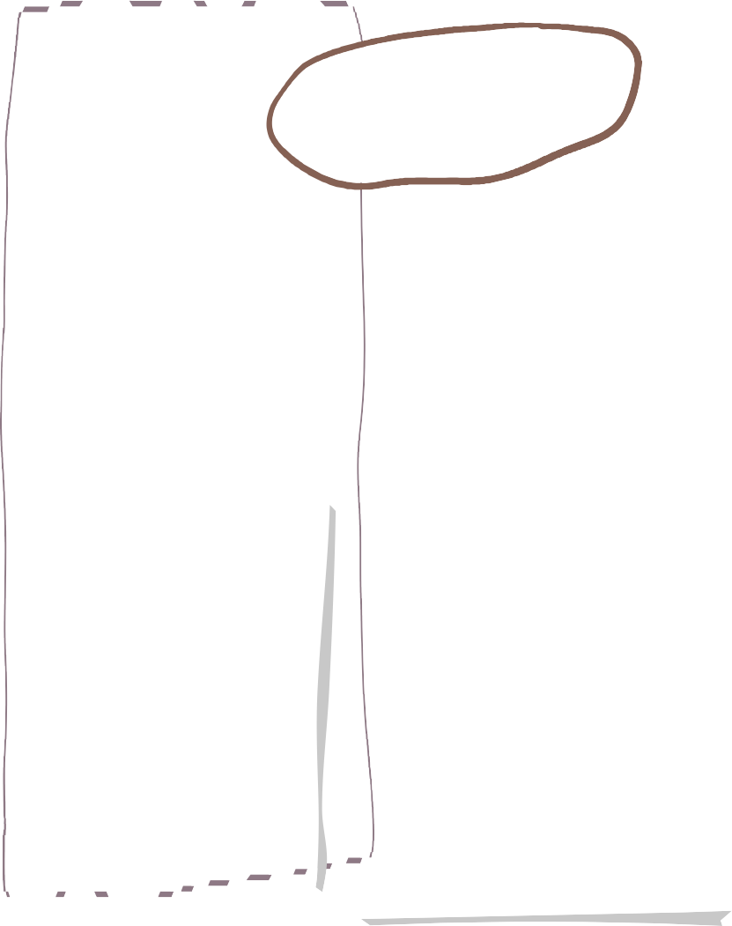




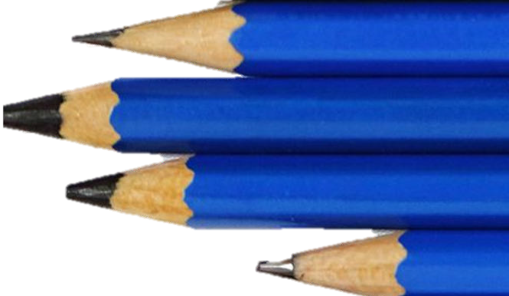
Year 4 Lapwings

We are reading…
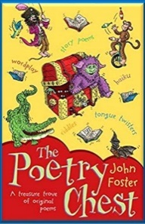
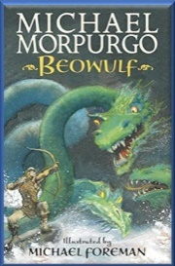
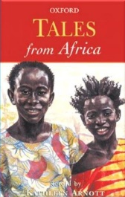

RE
Bahá’í
What is the best way for a Bahá’í to lead a good life?
Can I give examples of what I think it means to be a good human being?
Can I explain the Bahá’í beliefs about the human race?
Can I share how Bahá’í might try to lead a good life through treating people equally?
Can I share some ideas about how Bahá’ís might try to lead a good life?
Can I explain different ways I could lead a good life?

Science
Maths
English
Art

Inspired by the rainforest
One picture, four views
Creating patterns
Repeating patterns
Fabric designs
Can I define what solids, liquids and gases are?
Can I explain how different liquids behave?
Can I explain what a thermometer is used for?
Can I explain how materials change state?
Can I explain the water cycle?
Can I carry out a fair test to find out if all liquids evaporate?
Can I test how temperature affects the rate of evaporation?

Decimals
Tenths and hundredths on a number line, multiple and divide by tenths and hundredths.
Money
Write money using decimals, convert between pounds and pence. Estimate and calculate amounts.
Time
Years, months, weeks, hours, minutes and seconds. Convert between analogue and digital times.
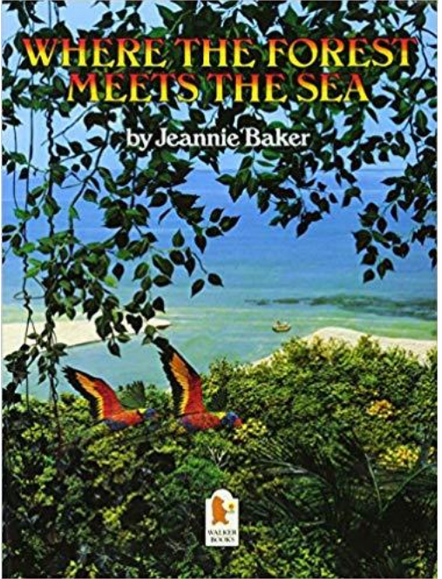
Use specific vocabulary e.g.
fruit bats, and some technical vocabulary e.g. nocturnal, mammal
• Write in present tense
• Use layout features e.g. questions to draw in the reader, headings and sub headings, paragraphs to group related ideas, diagrams



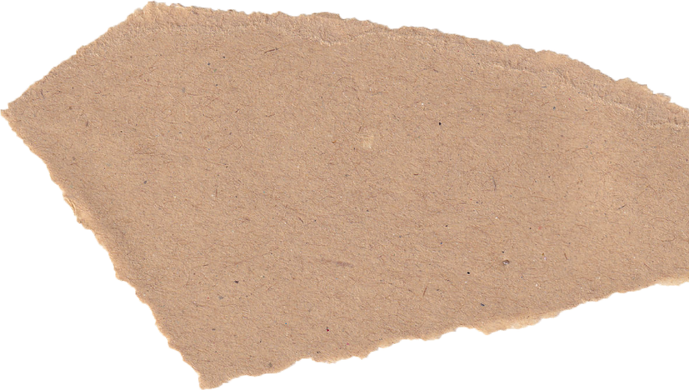



Can I recognise situations which can cause jealousy in relationships?
Can I identify someone I love and can express why they are special to me?
Can I tell you about someone I know that I no longer see?
Can I recognise how friendships change when I am older?

AMASING

Body and tuned percussion
Pitter patter raindrops
Rainforest body percussion
The rhythm of the rainforest
The loopy rainforest
Sounds of the rainforest
Explain the advantages and disadvantages of different types of fastening type.
Design a product to meet design criteria.
Make and test a paper template.
Assemble a book jacket.
Athletics
Javelin, standing triple jump, rolling races, Team race, sprinting
Orienteering
Point and return, face orienteering, point to point, cone orienteering, north, south, east, west.
PE
Computing
Geography
Music
D&T
Can I explain that the composition of a digital image can be changed?
Can I explain that colours can be changed in digital images?
Can I explain how cloning can be used in photo editing?
Can I explain that images can be combined?
Can I combine images for a purpose?
Can I evaluate how changes can improve an image?
Where in the world are tropical rainforests?

What is the amazon rainforest like?

Who lives in the rainforest?

How are the rainforests changing?

How is our local woodland used?

Personal Development

