
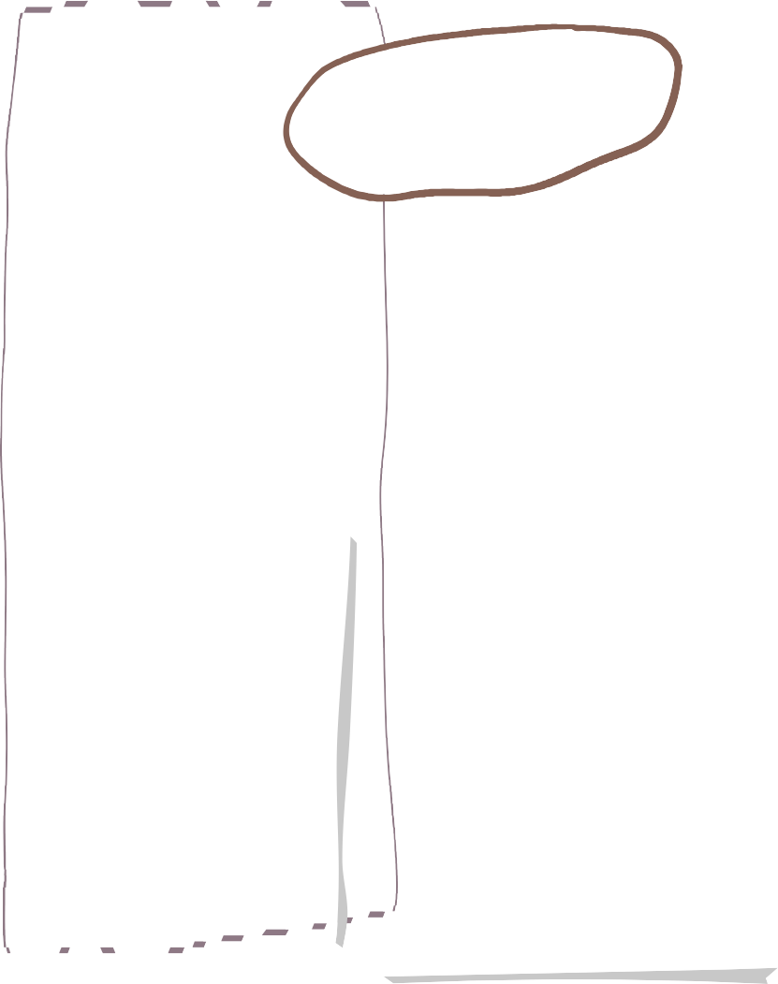





Year 2

Science
Can I write facts about endangered animals?
Can I write about an endangered animal?
Can I write a ‘Guide to Catch Wolves’ using conjunctions?
Can I write a set of rules for going into the woods, using contraction words?
Can I participate in performance, role play and improvisations to create a class poem?
Can I write a poem using a given structure?
Can I add suffixes -er and -est to adjectives?
Can I write a description of the woods?
Can I write a character description? (plan and edit and improve)
Can I write a diary entry? (plan and edit and improve)
Can I write a persuasive message using subordination?
Can I explore homophones in the story?
Can I write a set of directions?
Can I draw on knowledge and research to write facts about the importance of trees?
Can I investigate the features of a letter?
Can I plan a letter?
Independent write- Persuasive letter
Edit and Improve
Evaluate

Fractions
Can I notice parts and a whole? Can I find equal and unequal parts? Can I recognise and find a half? Can I recognise and find a quarter? Can I find and recognise a third? Can I find non-unit fractions? Can I recognise the equivalence of a half and two quarters? Can I find and recognise 3 quarters? Can I count in fractions?
Time
Can I tell the time to o’clock and half past on an analogue clock? Can I tell the time to quarter past and quarter to on an analogue clock? Can I tell time past the hour on an analogue clock? Can I tell time to the hour on an analogue clock? Can I tell time to 5 minutes on an analogue clock? Can I identify how many minutes in an hour or period of time? Can I identify hours in a day?

Can I explain how to show respect?
Can I consider some attributes that Muslims might believe that Allah has?
Can I explain the meaning of some of the 99 names of Allah?
Can I explain the ways a Muslim might show respect to Allah in their lives?
Can I tell you how I might show respect for other people?
Can I say what I do to show people who are special to me that I care?
Art
Painting and Mixed Media:
Life in Colour
Can I name primary and secondary colours?
Can I make choices about how to make colours lighter and darker?
Can I choose painting tools to recreate a texture?
Can I explain the word collage?
Can I mix colours to match something I see?
Can I compose a collage, choosing and arranging materials for effect?
Can I talk about how I would improve my work?
Artist focus: Romare Bearden
Maths
Living things and
their habitats
Can I decide if something is dead, alive or never been alive?
Can I understand what a microhabitat is?
Can I notice that habitats are different around the world?
Can I investigate what conditions woodlice prefer?
Can I identify how living things have adapted to their habitat?
Can I understand what a food chain is?

The Last Wolf
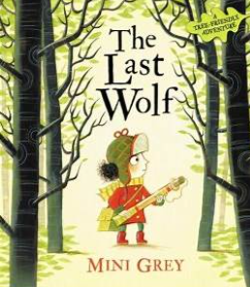
English
RE



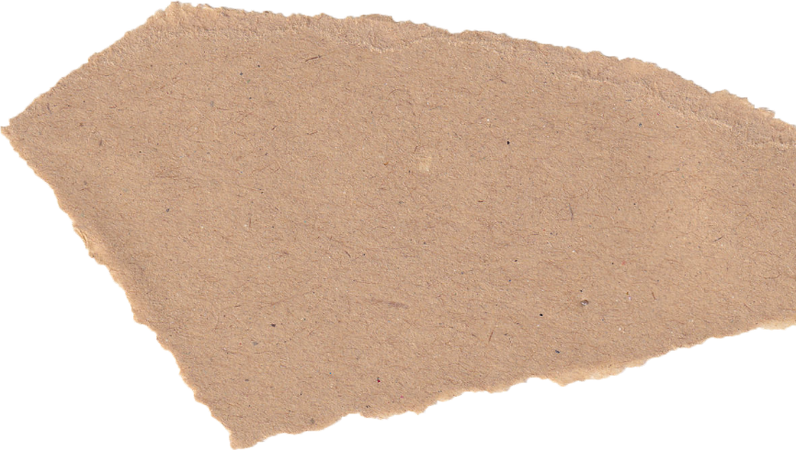



Mechanisms:
Making a moving Monster

Can I design a moving monster for a specific audience in accordance with a design criteria?
Can I make linkages using card for levers and split pins for pivots?
Can I experiment with linkages, adjusting the widths, lengths and thickness of card used?
Can I cut and assemble components neatly?
Relationships
Can I identify different members of my family and understand my relationship with each of them?
Can I understand that there are lots of forms of physical contact within a family and that some is acceptable and some is not?
Can I identify some of the things that cause conflict with my friends?
Can I understand that sometimes it is good to keep a secret and sometimes it is not?
Can I recognise and appreciate people who can help me in my family, my school and my community?
Can I express my appreciation for the people in my special relationships?

West African Call and Response
Can I create short sequences of sound?
Can I copy a short rhythm?
Can I learn a traditional song from Ghana?
Can I create rhythms based on call and response?
Can I add dynamics to a structure of rhythms?

Rackets, bats and balls
Can I hit a ball towards a target?
Can I successfully hit a target?
Can I apply greater power to my shots if a target is further away?
Can pupils work with a partner to score points?
Can I follow the rules and compete fairly when playing against a partner?
Can I continue to improve my accuracy?

Athletics- Sports Day Practise

Endangered!
Can I explain why Mary Anning is a significant person in history?
Can I sequence key events in Mary’s life?
Can I recall key figures in Mary’s story?
Can I use sources to find out people’s opinions of Mary?
Can I use evidence to prove that Mary really did such clever things?
Can I make links between Mary Anning and George Mottershed? (Local link and modern comparison)
Can I investigate who George Mottershed was and why he is significant?
Can I understand the significance of Chester Zoo to our locality?
Can I sequence the key events of Chester Zoo’s history into chronological order?

Data and Information- Pictograms
Can I recognise that we can count and compare objects using tally charts?
Can I recognise that objects can be represented as pictures? Can I enter data onto a computer?
Can I create a pictogram on a computer?
Can I select objects by attribute and make comparisons?
Can I recognise that people can be described by attributes? Can I choose a suitable attribute?
Can I explain that we can present information using a computer?

PSHE
Computing
History
Music
PE
D&T

