
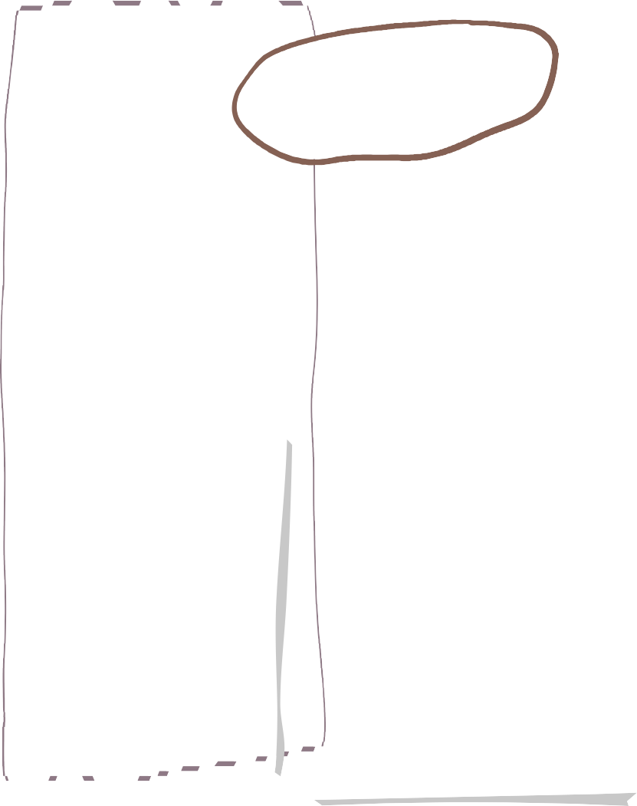




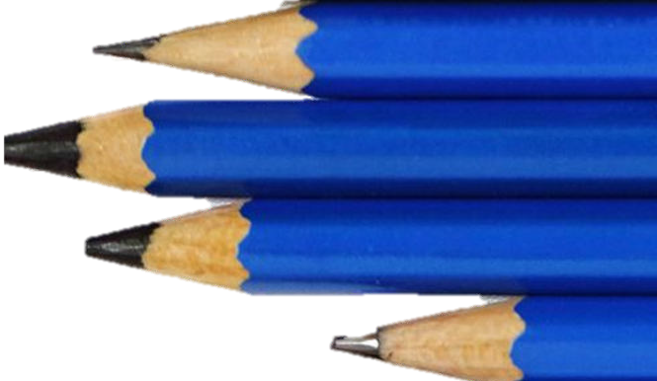
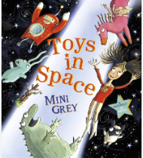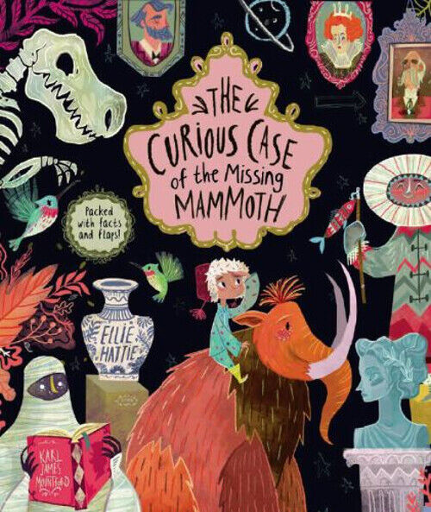
RE

In RE we will be looking at the Islamic religion, including their beliefs and religious practises.
Year 1
Summer 1
overview
Can I describe a character feeling using adjectives and the un- prefix.

Can I describe a story setting using un- prefix?

Can I use adjectives and verbs to describe a character?

Can I recall a part of a story using -ed suffixes?

Can I create a space monster?

Can I write a description about my space character?

Can I write a letter in the role of a character?

Can I write a party invitation using -ing?

Can I write a diary using -ed?

Can I plan a story using beginning middle and end?

Can I write my own fantasy creature story?

Art

Can I mix secondary colours?

Can I use knowledge of colour when mixing?

Can I mix colours when printing?

Can I mix at least 5 different secondary colours?

Can I recreate the work of an artist?
Multiplication and division
Can I count in 2’s 5’s and 10’s
Can I recognise and add equal groups?
Can I make arrays?
Can I make doubles?
Can I make and share equal groups?
Fractions
Can I recognise and find half of a shape/ object?
Can I recognise/ find half of a quantity?
Can I recognise/ find a quarter of a shape/ object?
Can I recognise/find a quarter of a quantity?
Geometry-
Can I describe a turn?
Can I describe left or right?
Can I describe forwards or backwards?
Can I describe above and below?
Can I understand ordinal numbers?

English

Plants:
Can I describe what a plant is?
Can I describe the parts of a plant?
Can I describe how plants grow?
Can I identify local wildflowers?
Can I understand different ways we can group plants?
Can I identify plants we can eat?
Can I understand the different types of trees?
Can I describe the purpose of a leaf?
We are reading…
Science
Maths
RE



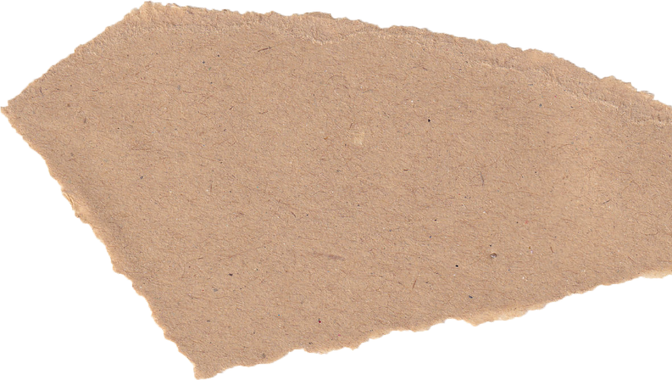



Can I identify family members and understand there are different types of families?

Can I understand what being a good friend means to me?

Can I understand appropriate ways of physical contact to greet my friends and know which I prefer?

Can I identify who can help me in my school community?

Can I recognise my qualities as a good friend and person?

Can I tell you why I appreciate people and why they are special to me?
Next term we will be looking at athletics with Miss Blythin and using rackets, bats and balls with our sports coach Mr Hayes.

Can I understand the concept of pitch?

Can I create a pattern using two pitches?

Can I understand the concept of tempo?

Can I create a superhero theme tune?

Can I perform confidently as part of a group?
Can I identify different types of fruit and vegetables?

Can I understand how fruit and vegetables grow?

Can I use a knife and fork to cut fruit ready to be put in a juicer?

Can I test and evaluate what fruit will go together to make a nice smoothie?

Can I create ingredients to make a smoothie?

Personal Development
Computing
D&T
History
Can I understand why the Wright Brothers are famous?

Can I understand why the Wright brothers were famous and sequence 6 major developments in flight over time?

Can I understand how we possibly know about their first successful flight, when it happened over 100 years ago now?

Can I recognize how flight changed because of the Wright brothers’ work?

Can I explain why still remember Amy Johnson?

Can I retell the story of how a secretary flew solo to Australia
Music
Can I open word processer?
Can I find and recognise keys on a keyboard?
Can I add and remove text and symbols using a keyboard?
Can I type capital letters?
Can I use the bold, italic and underline toolbar?
Can I double click to select and drag?
Can I change the font of text?
Can I use the undo button?
PE

