
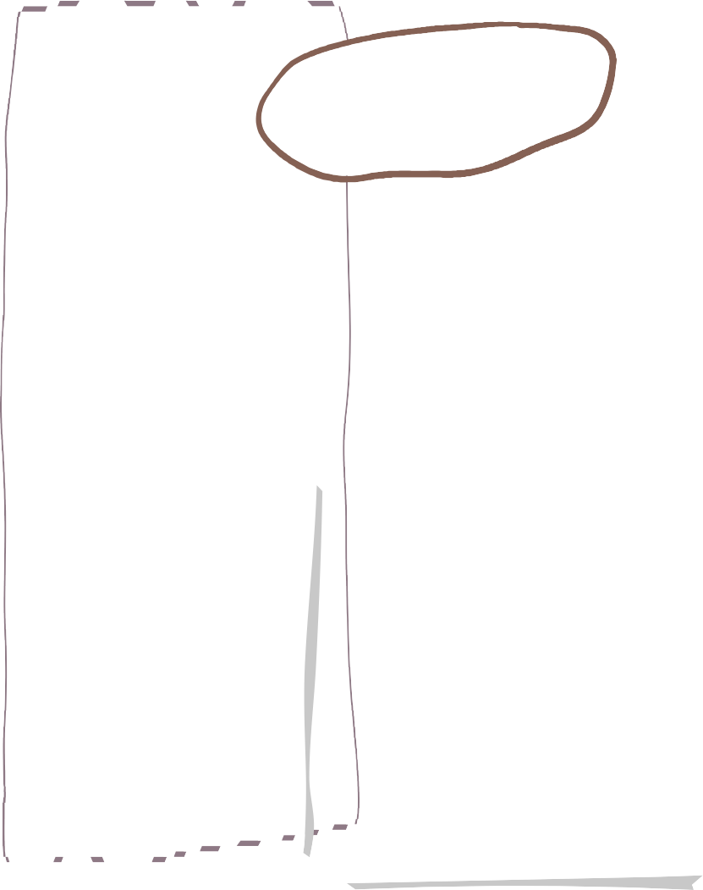




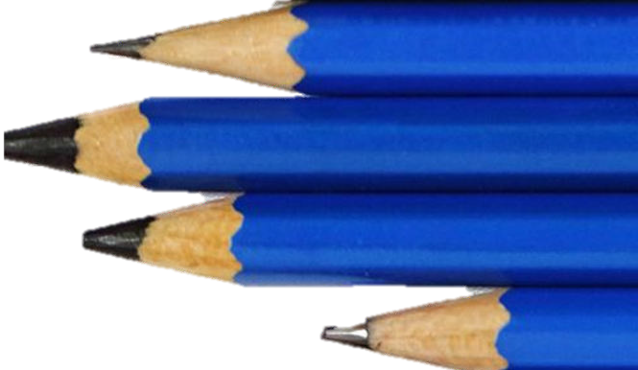

Spring 2- Year 5
Art

This term the children will be doing Artwork based on their History topic, Ancient Greece.
Can I explain what gravity is?
Can I identify the effect of friction between moving surfaces?
Can I plan different types of scientific enquiries to answer questions?
Can I identify the effect of air resistance?
Can I identify the effect of water resistance?
Can I recognise different types of forces?
Can I write a postcard?
Can I retell the scene?
Can I write a letter in role as Annie’s friend?
Can I write a short newspaper report?
Can I write a recount in role as Annie?
Can I plan a recount of a journey along the river?
Can I write a recount of a journey along the river?
Can I plan a series of diary entries?
Can I edit my diary entries?
We are reading…
Science
Maths
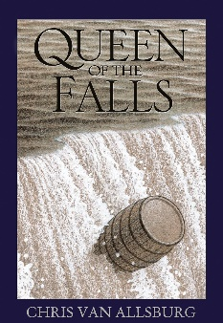
- Fractions, decimals and percentages
- Perimeter and area
- Statistics including line graphs, interpreting tables and timetables
Can I understand what Sikhs believe?
Can I understand who Guru Nanak is and how did he become a teacher and leader?
Can I understand how Sikhs demonstrate their views on equality and sharing?
Can I investigate the symbolism of the 5K’s?
Can I explore a range of values for an individual’s life as well as in the life of a Sikh?
English
RE



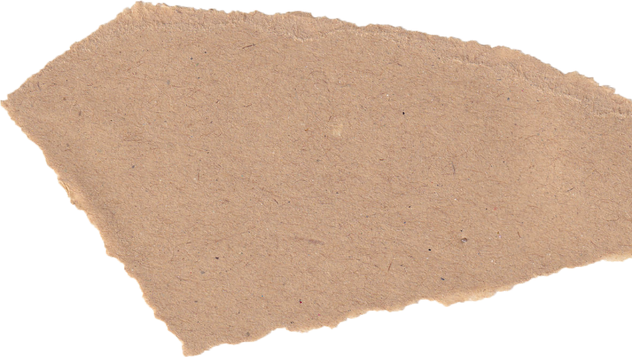


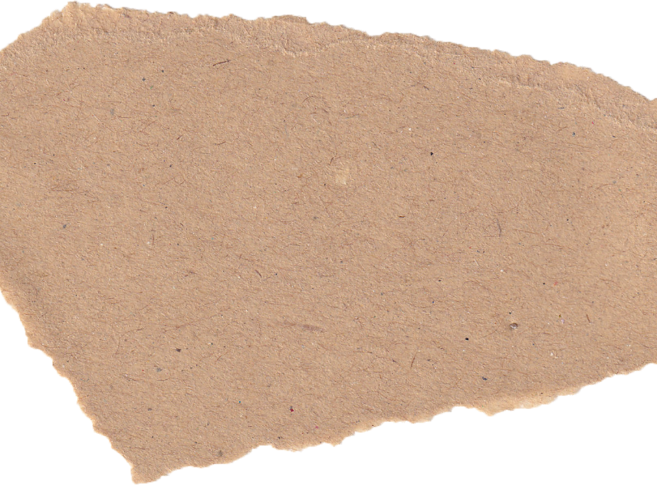
Can I create a microbit?
Can I combine output components?
Can I control with conditions?
Can I understand the follow of actions in algorithms and programs?
Tennis
Can I further practise and develop the ready position with agile footwork?
Can I further develop ball control using a tennis racket?
Can I return the ball using a forehand and backhand?
Can I confidently implement rules and tactics in competitive situations adhering to the values of the game?
Can I demonstrate honesty and fair play?
Gymnastics
Can I demonstrate a forward, backward and pike roll?
Can I do a lunge into a round off?
Can I confidently use equipment to vault in a variety of ways?
Can I perform a range of jumps including straddle, pike, half turn, cat leap, stag and split leap?
Can I select, adapt and perform sequences?
Can I perform jumps, shapes and balances fluently and with control?
Can I recognise the health risks of smoking and understand how tobacco affects the lungs liver and heart?
Can I put into practise basic emergency aid procedures?
Can I understand how the media, social media and celebrity culture promotes certain body types?
Can I describe the different attitudes people have to food and how this can be affected by external influences?
Can I determine what makes a healthy lifestyle?
Can I understand that music can be represented with colours?
Can I represent a piece of music as a graphic score?
Can I create a vocal composition based on a picture?
Can I create a piece of music inspired by a single colour?
Can I work as a group to perform a piece of music?

Computing
Geography
Personal Development
Can I design a pop-up book?
Can I follow my design brief to make my pop-up book?
Can I use layers and spacers to cover the working of mechanisms?
Can I create a high-quality product suitable for a target user?
Can I locate the Alps on a map?
Can I locate the physical and human characteristics of the Alps?
Can I describe the physical and human features of an Alpine region?
Can I investigate the recreational opportunities in my local area?
Can I understand similarities and differences between the local area and an Alpine area?
Can I understand the human and physical geography of the Alps?
PE
Music
D&T

