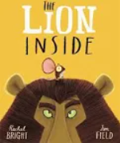
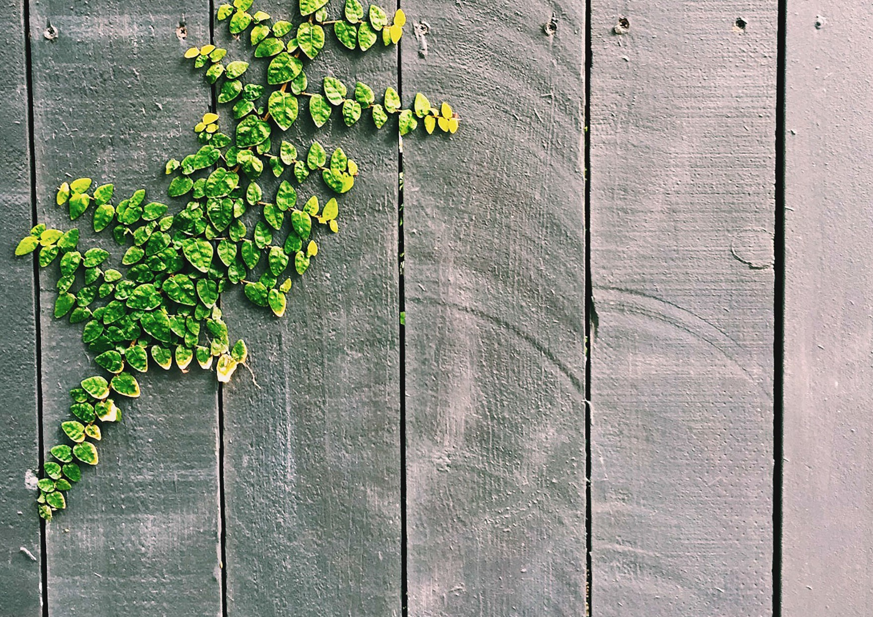
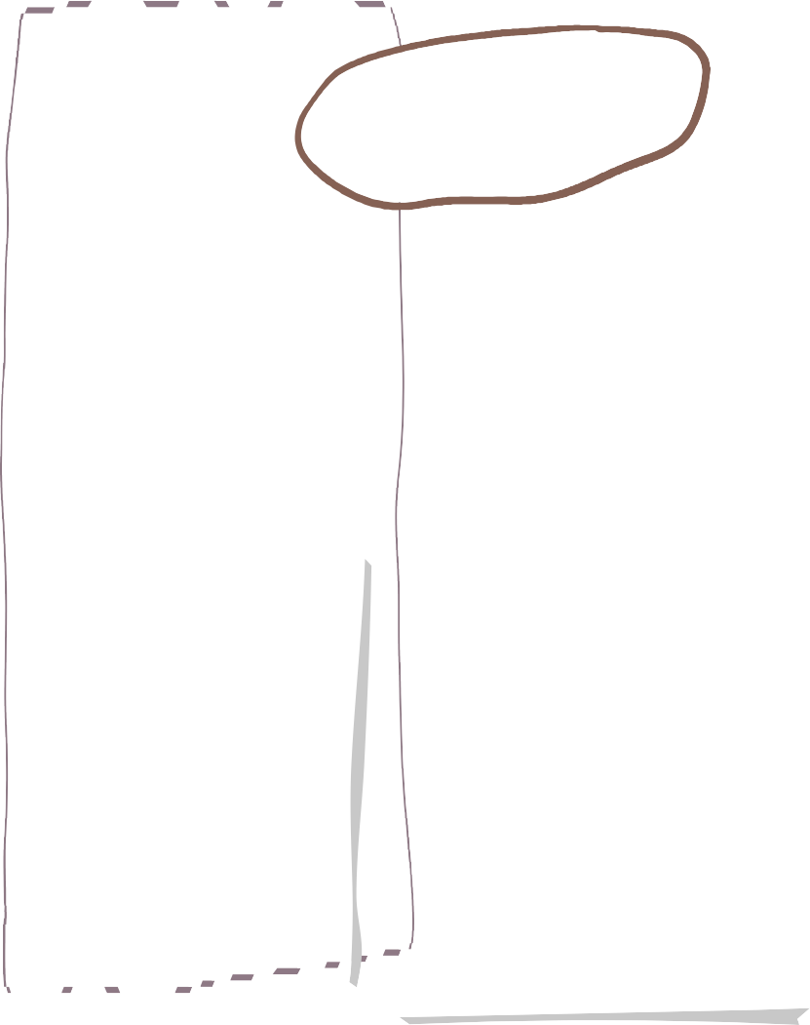
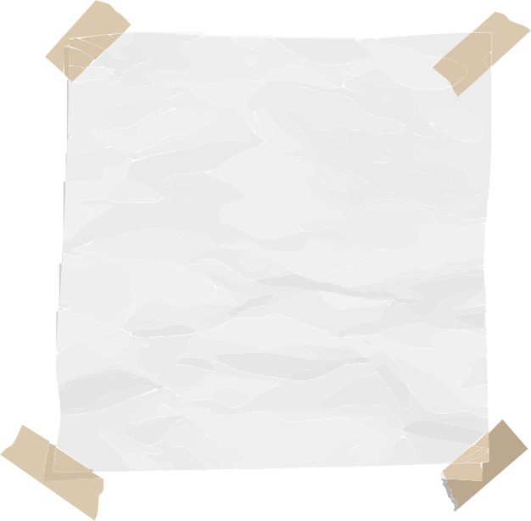
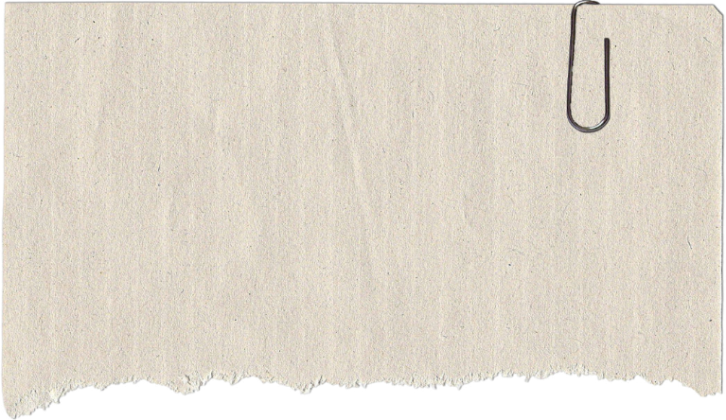
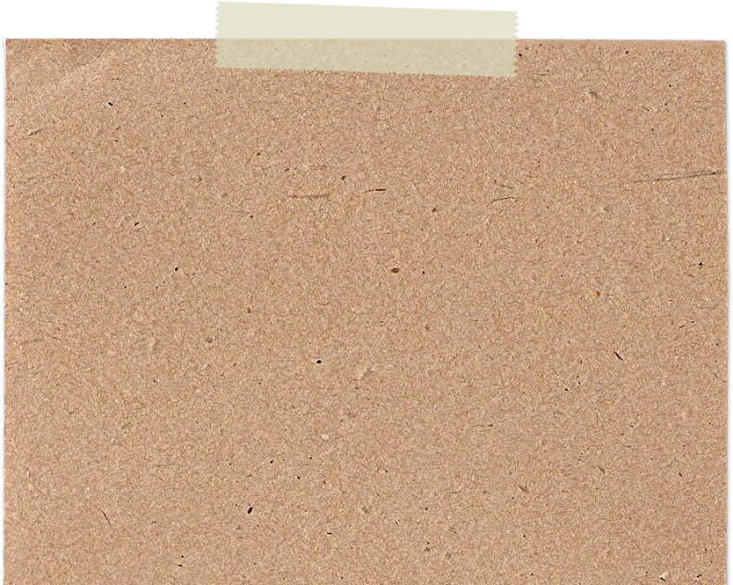
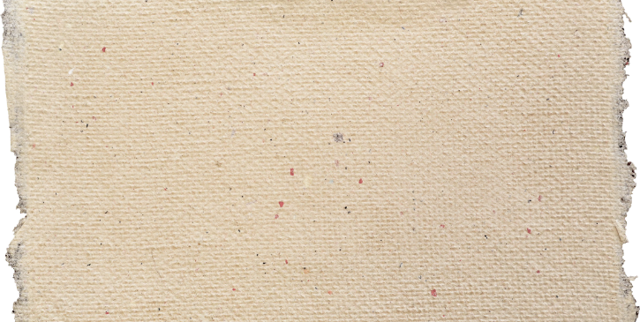
We are reading…
Our writing is inspired by…

Materials
- What are objects made of?
- What are the properties of materials?
- Sorting and classifying materials
- Investigating transparency
- Investigating floating and sinking

Seasonal change – Winter to Spring
Art
Science
Maths
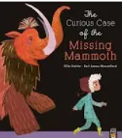
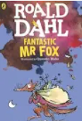
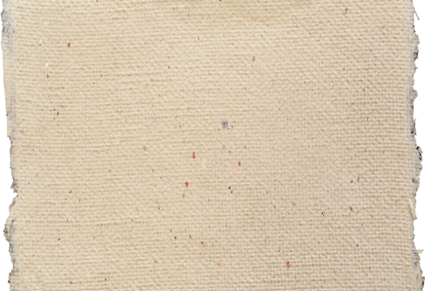
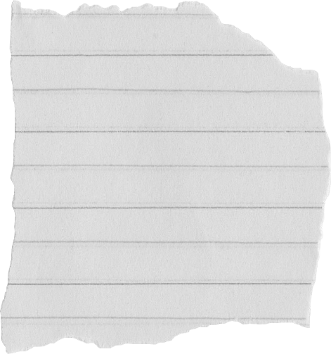
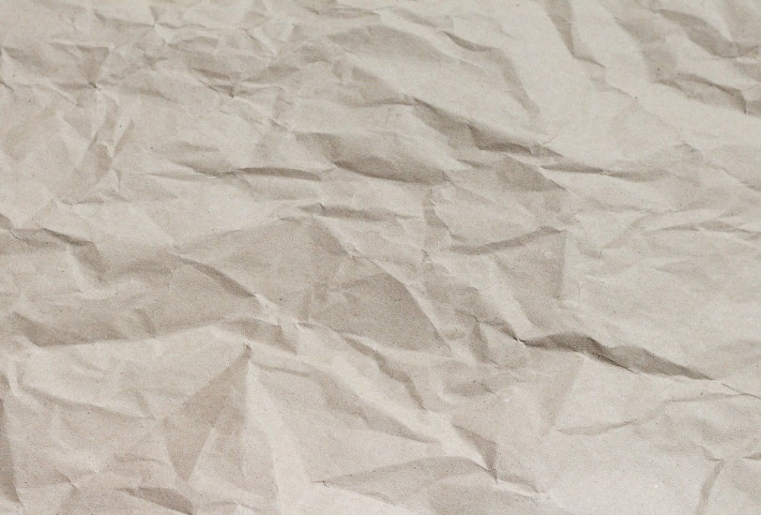
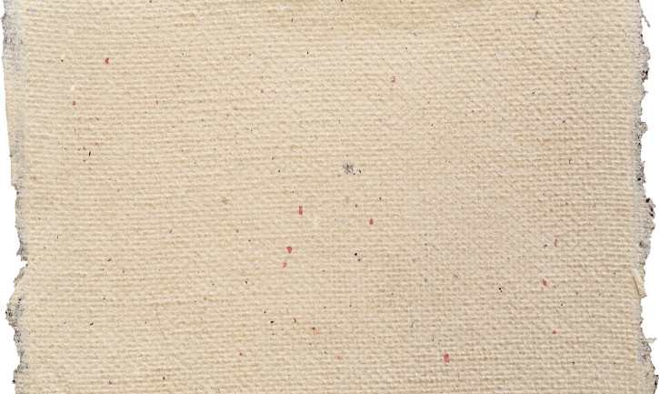
We are writing…
Descriptive sentences using nouns and adjectives
Using the Un- prefix
Using the –ing –ed –er and –est suffixes
Questions and exclamation ? !
An adapted narrative based off the story (change of character and/ or setting)

A range of high quality picture books and non-fiction books related to our topic and in daily story time

- Place Value within 20
- Addition and Subtraction within 20
- Place Value within 50
- Length and height
- Mass and Volume

Religious Education

Building structures- Windmills

D&T

What is the weather like in the UK?

Kings, Queens and Castles

Gymnastics- wide, narrow and tall

Ball Skills- feet
Programming- moving a robot
Grouping data

Rhythm and rhythmic patterns

Dreams & Goals- steps to success, teamwork, overcoming obstacles and celebrating success
Healthy Me- healthy choices, food, hygiene, road safety, medicine safety, mental health

Year 1 Spring Term Overview

Sculpture and 3D- Paper play

Art project based on topic theme

Islam- Who is God to Muslims?

Christianity- Why was Jesus welcomed like a King by the crowds on Palm Sunday?
History
Personal Development-

Computing

Music

PE

Geography

