

Welcome to Squirrels Pre-School at
Name:
__________________________________________
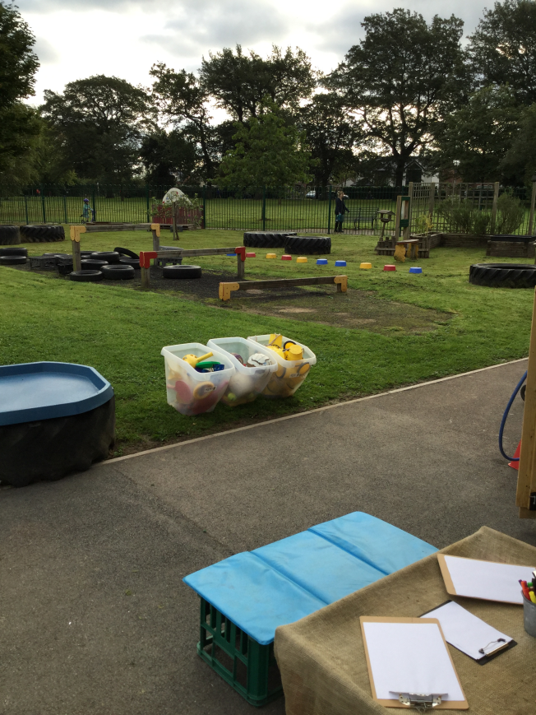
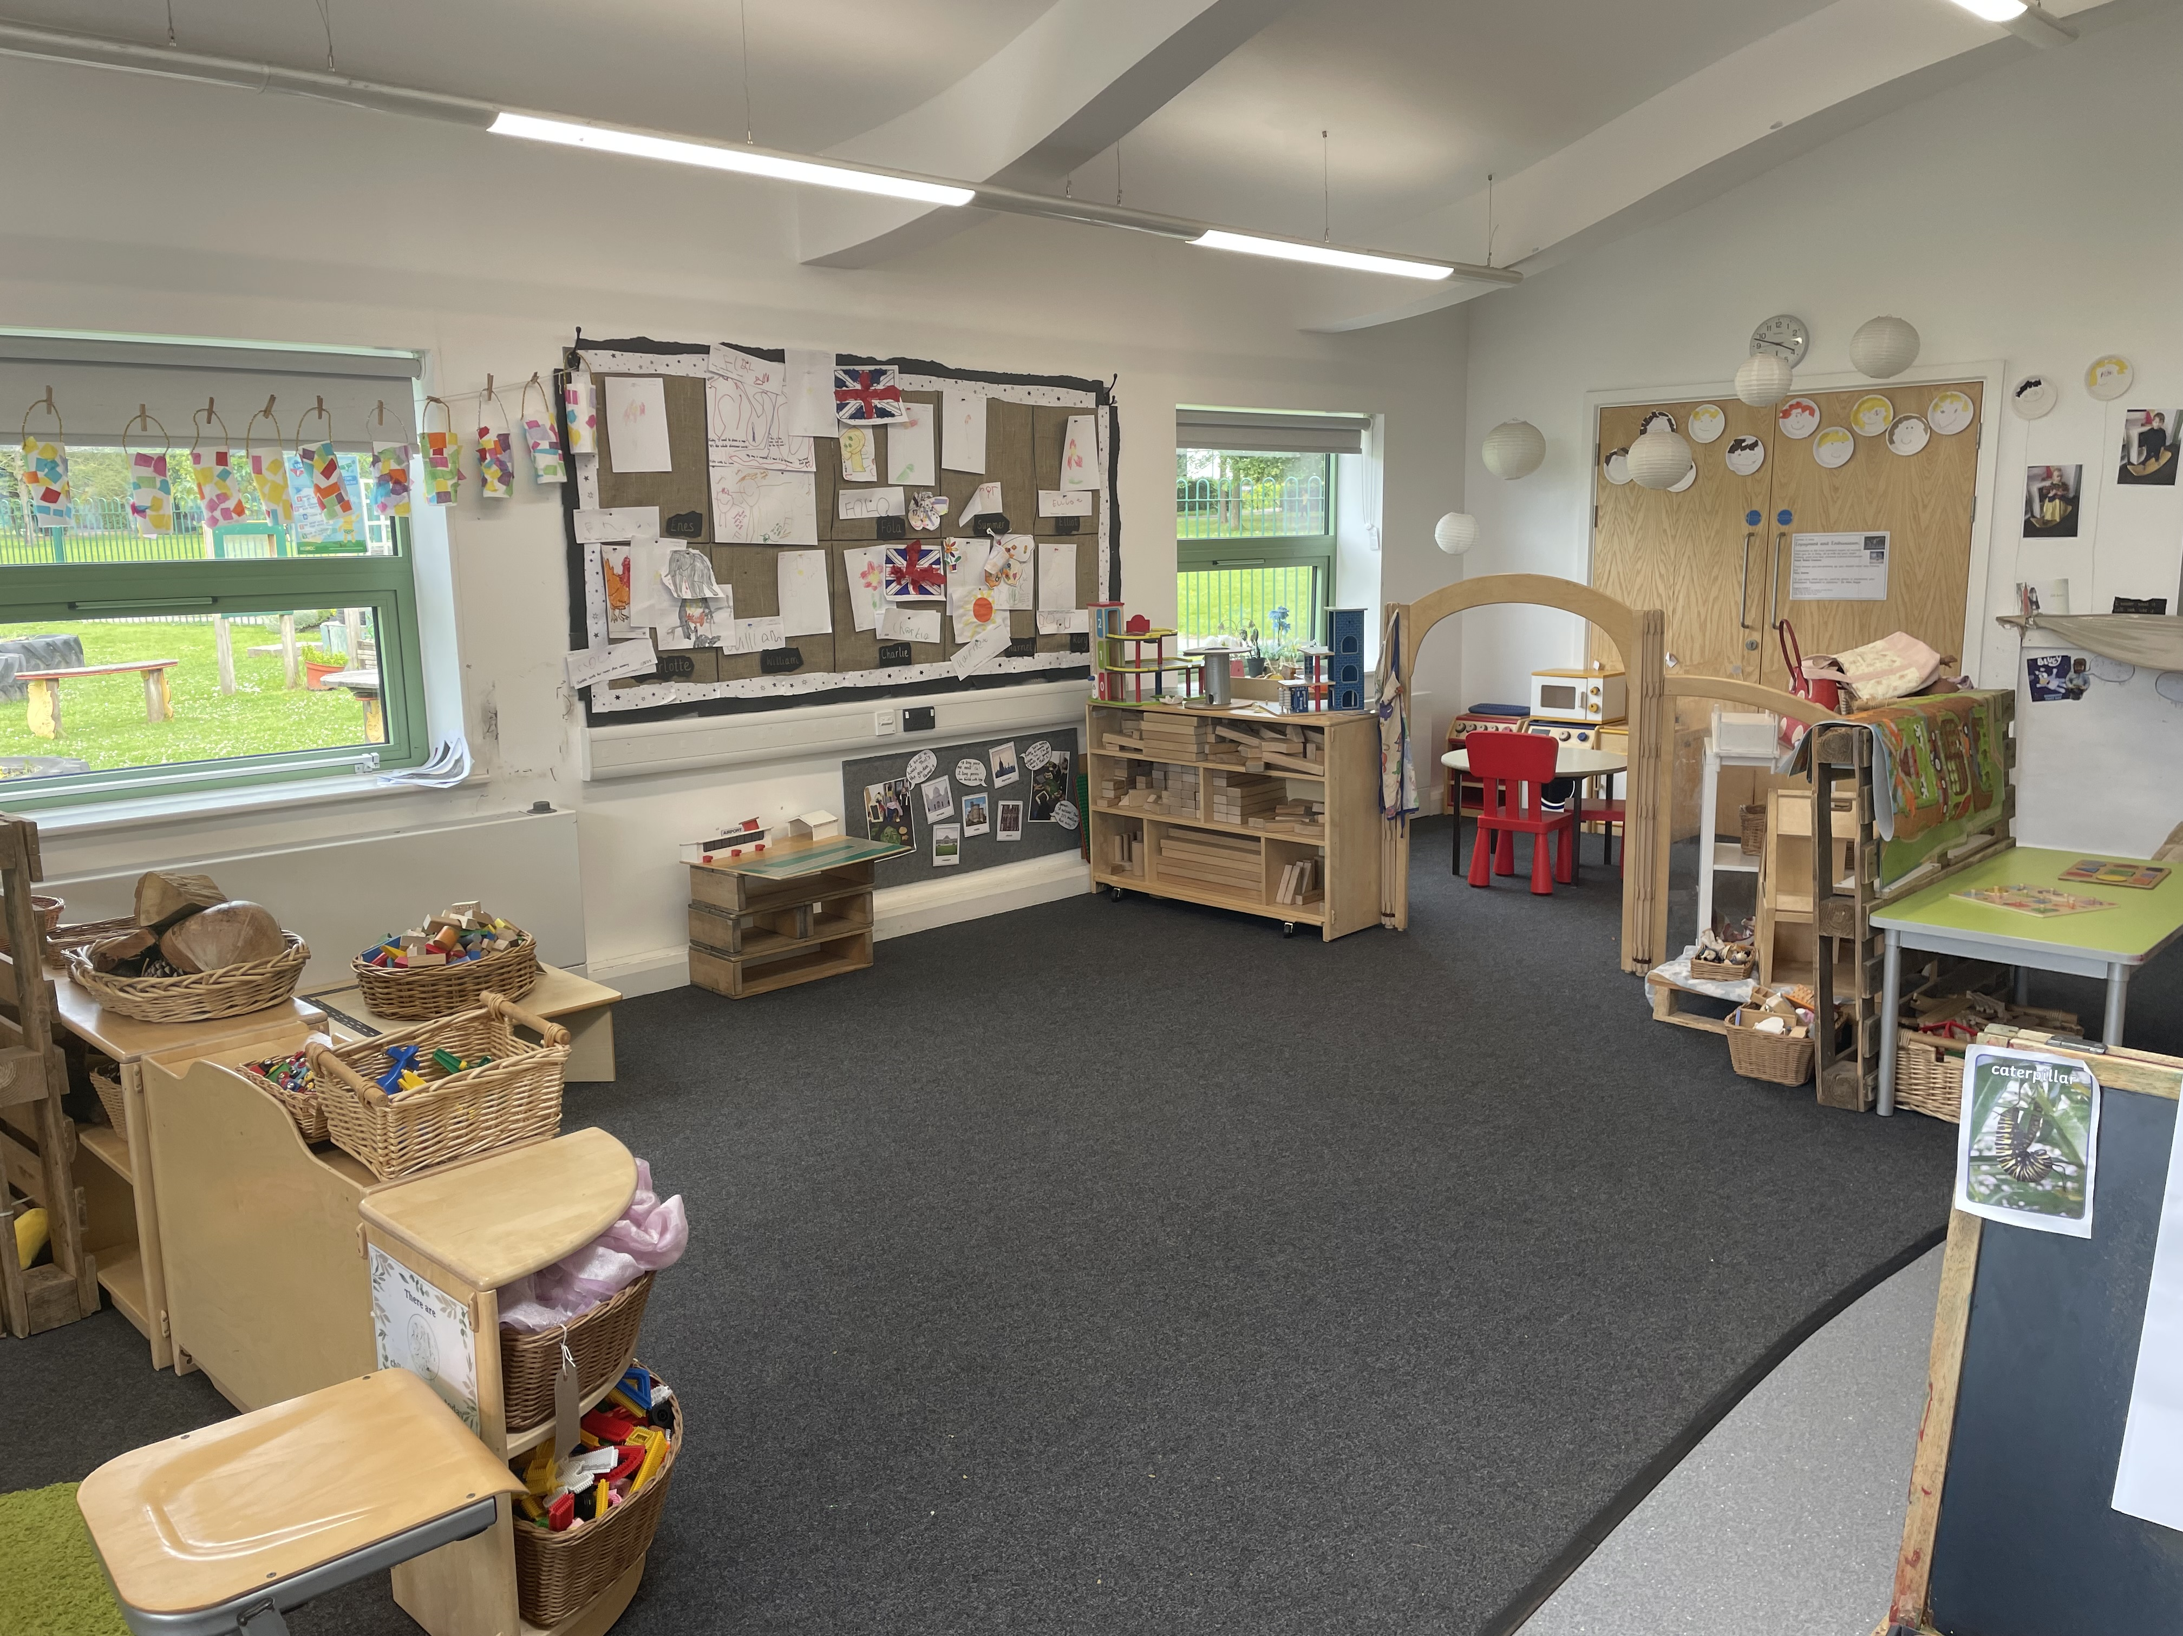
Your Classroom
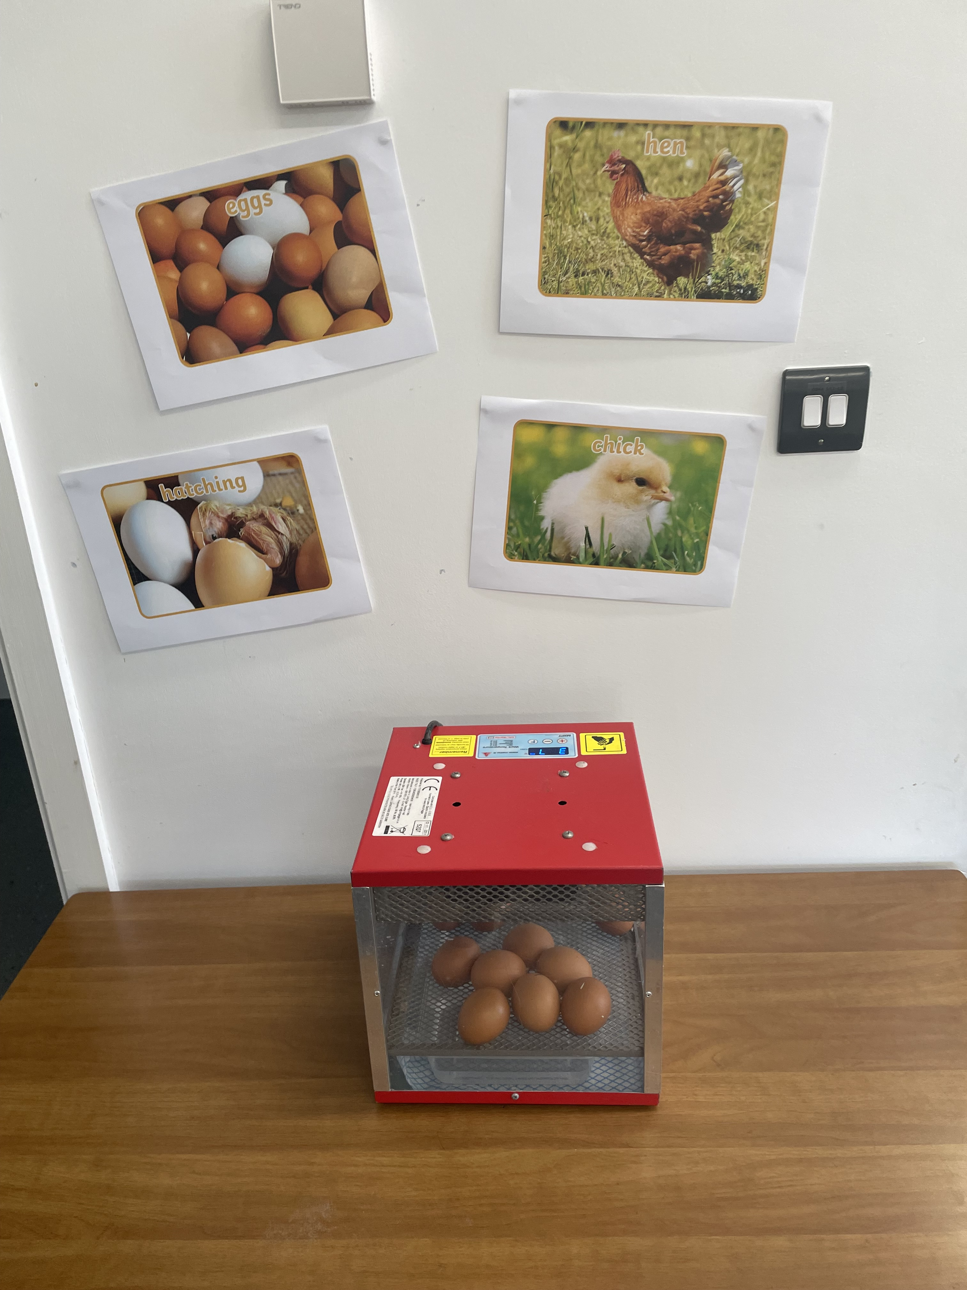
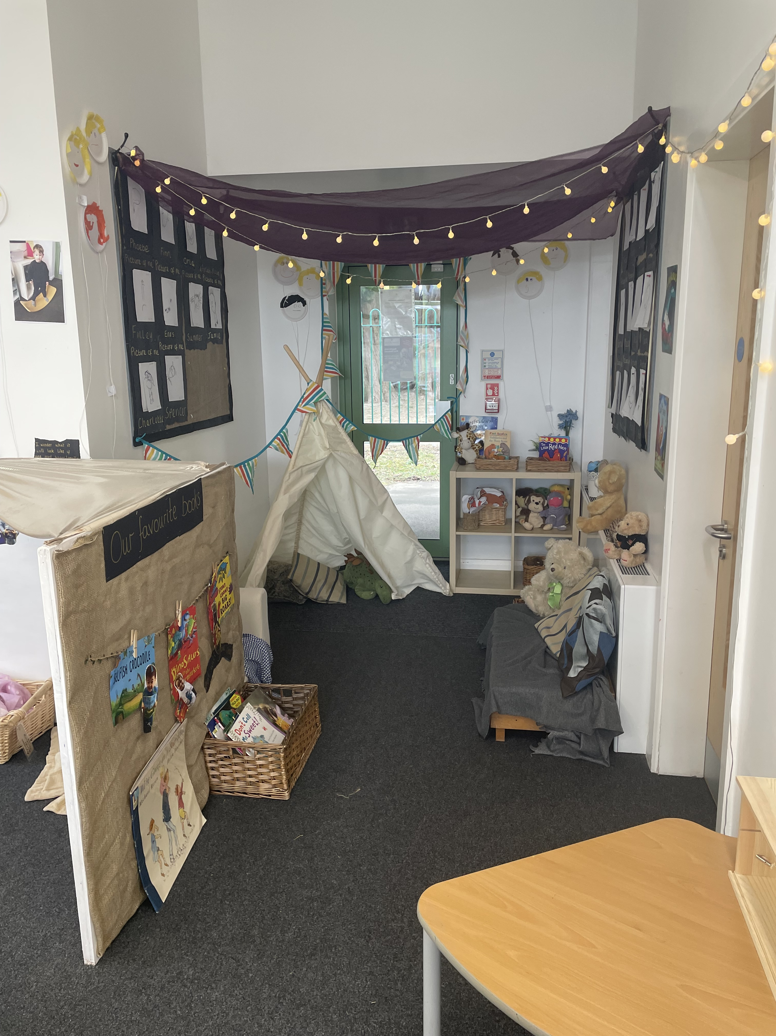
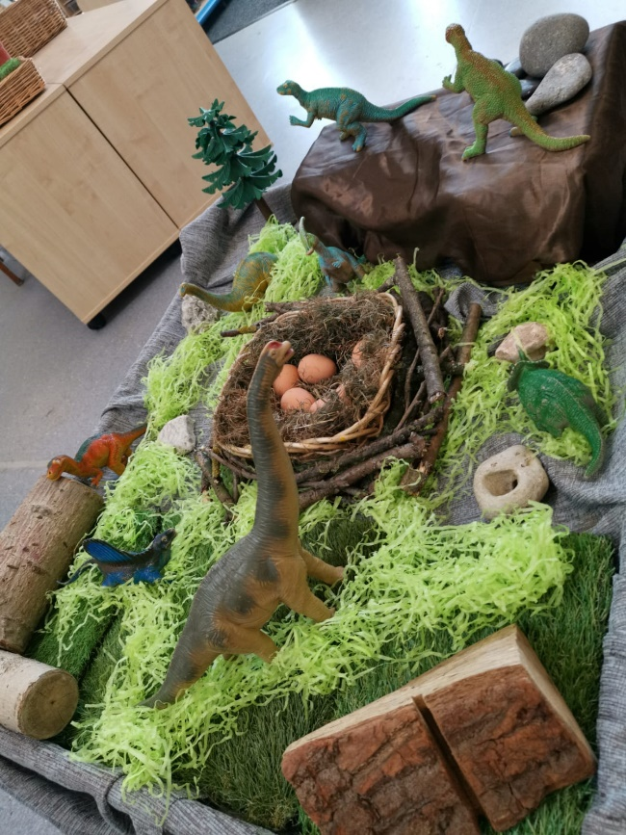
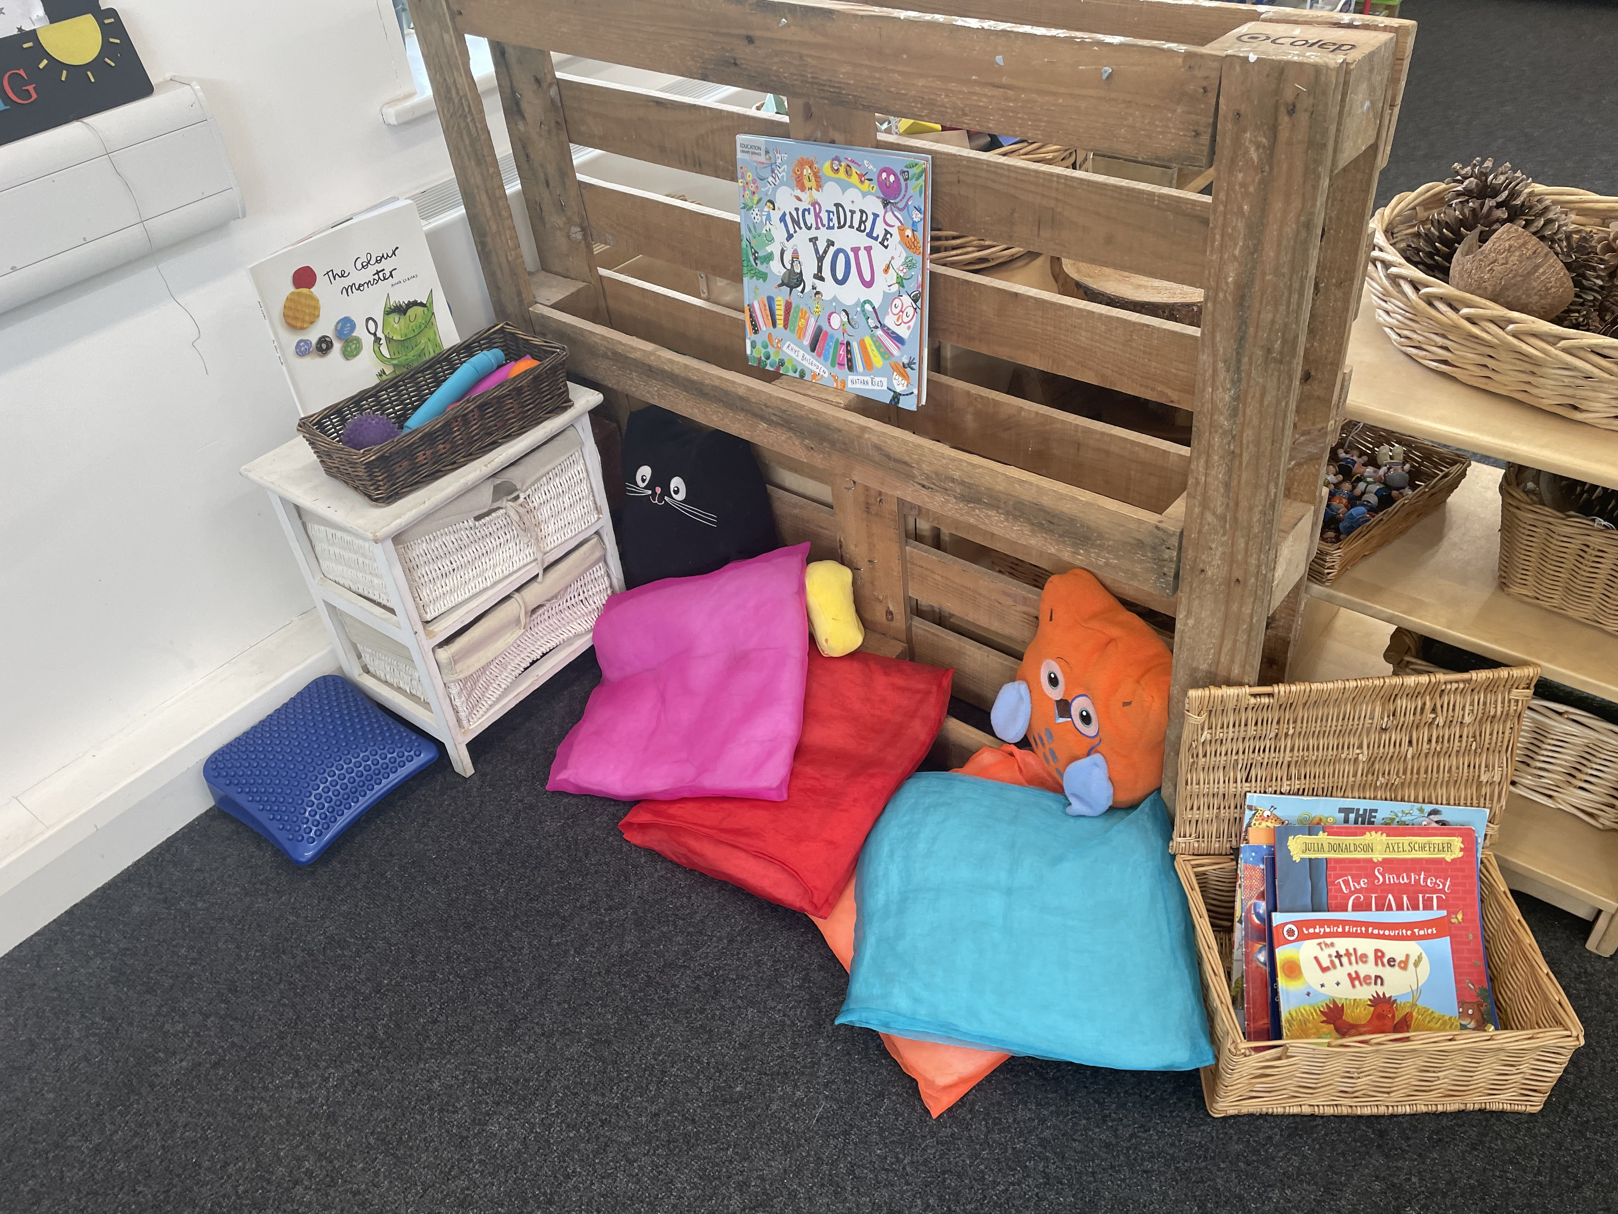
==
What To Bring
There is so much to think about when starting school. Everything is new and exciting but it can also be confusing at times! To help with the organisation of this, we have put together a list of items that you will need ready for September.
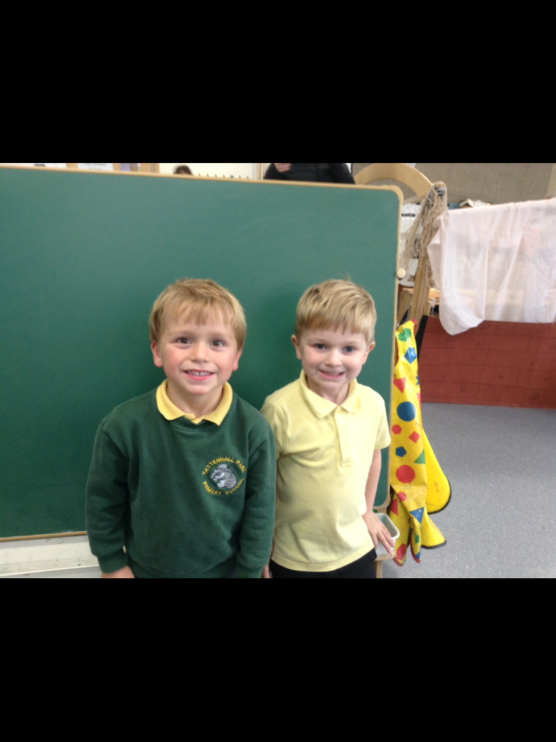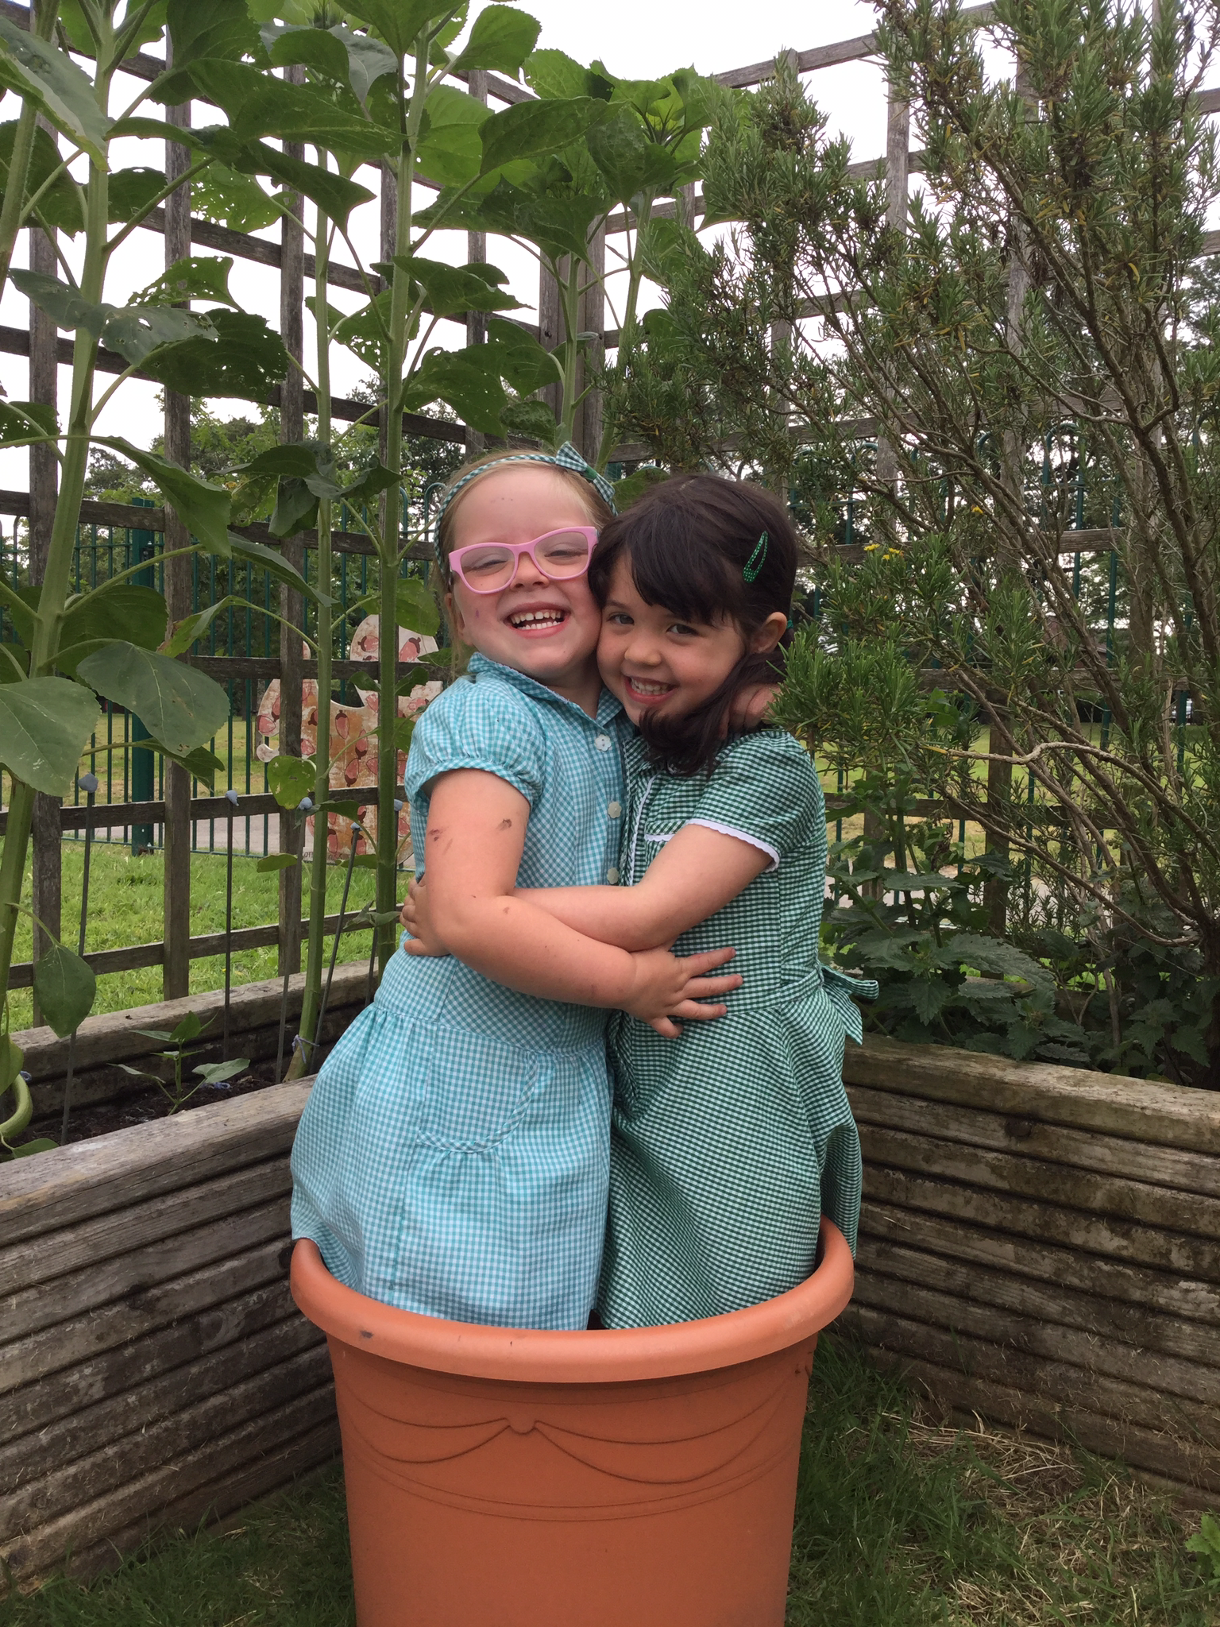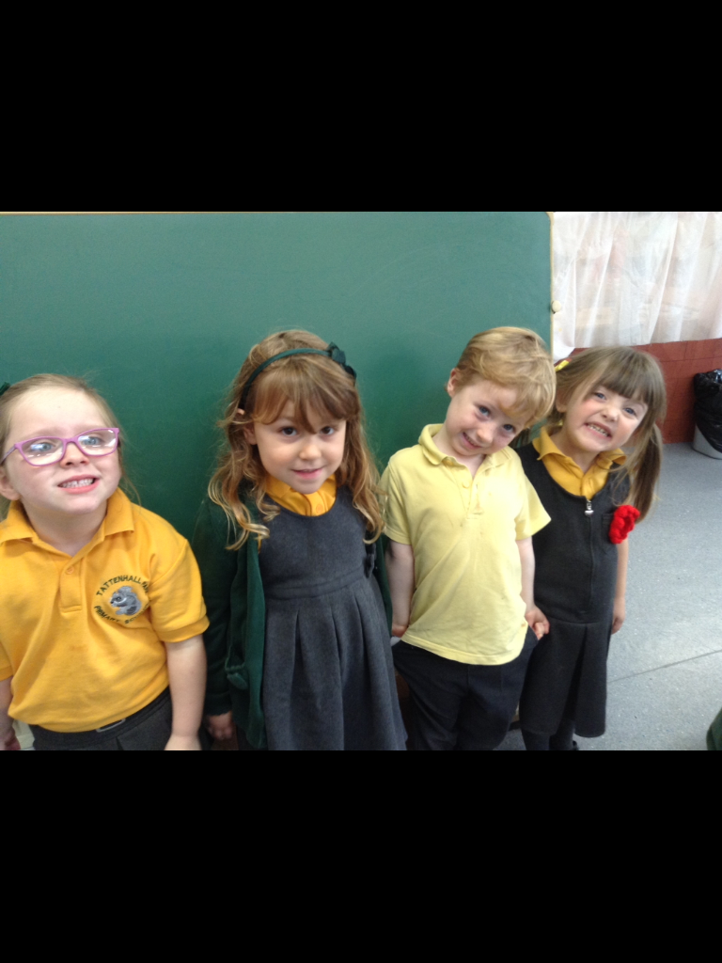

Uniform- In Pre-School, uniform is not compulsory, so you can choose to send your child into class either in their own clothes or school uniform.
If you would like to send your child in uniform, then our uniform consists of: Green sweatshirt/ cardigan, yellow polo shirt, grey trousers/ shorts, grey pinafore/ skirt, gingham dress, white/ grey socks, smart black shoes.
Coats- School fleece and reversible coats are available to order from school or you can wear a plain jacket/ coat.
Waterproof Jacket and Wellies- We go outside to play and learn in all weathers so please send in a pair of wellies and a warm puddle suit/ all in one that can be left in school all year round.
Hats- Sunhat/ cap for the summer and a warm woolly hat, gloves and scarf for winter.
Water bottles- Please send your child into school with a water bottle each day. Ideally, this needs to have water rather than squash or juice in. If this is going to be tricky, then please speak to a member of staff.
Lunches- You will need to provide a healthy packed lunch for your child each day.
Spare Clothes Bag- Please provide a bag with 2 sets of spare clothes in as we may need to get your child changed if they get wet or muddy or have an accident.
Book Bag- We will give you a school book bag in September. Please bring this in every day

PLEASE LABEL EVERYTHING!
School Day
8:40- Gates open. Put bags and coats away and settle into a morning play activity
9:15- Register and Carpet Time
9:30- Choosing time – adults will help us to learn through our play, both inside and outside.
10- Snack
11:30- Tidy Up Time and Carpet Time
12- Lunch Time in the classroom
1pm- Register and carpet time
1:20- Choosing time – adults will help us to learn through our play, both inside and outside.
2:40- Tidy Up Time
2:50- Story Time and Nursery Rhymes
3:15- Home Time
Tapestry
In Pre-School, each child will have their own online learning journey. You will be able to see what we have been getting up to in school here.
It is also a great opportunity for us to see what you have been getting up to at home or over the holidays. The children will then get the opportunity to share their experiences and achievements with the class.
Before you start in September, or in the first week back, please can you post the following photos on to your child’s Tapestry.
- Your house
- Your child
- Your family
- Activities during the summer
If you have not signed a Tapestry consent form and provided your email address yet, then please speak to a member of the Pre-School team.

Book Bag
We will give you a school book bag in September

This will need to come to school each day in case there are any important letters or drawings from our day! We will also send home one picture book / story each week for you to enjoy reading with your child at home. There will also be a little purple exercise book in the bag to accompany the story. You can encourage your child to draw a picture of their favourite part of the story in this purple book, or you can write a comment about what your child and you enjoyed about the book.
Please ensure that these books are looked after and returned to school each week as they belong to school or sometimes come form staff’s own book collection.
Many thanks

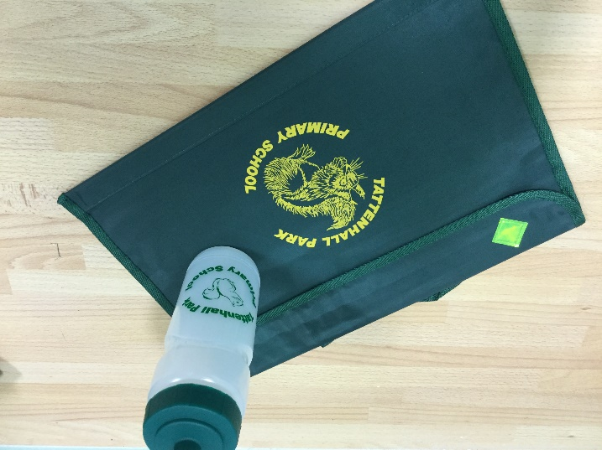



Lunches
You will need to provide a healthy packed lunch for your child if they are staying for a full day or a half day that includes lunch.
These can be a cold lunch such as sandwiches, pasta salad, quiche, crisps or fruit, or in the winter, if you would like to send a hot flask with soup or warm food then you re welcome to do so. Please note, we cannot warm up or cook food from your child’s lunchbox.
Please ensure that food such as grapes, cherry tomatoes and olives are cut in half and please note that we are a nut free school.
We don’t mind you sending a small chocolate treat like a mini roll, but please do not send sweets as these can be a choking hazard.
Please remember to send your child with their water bottle too.
School is a great opportunity for your child to try new foods as we find that because children see their friends eating a range of foods, then they are interested in trying them too, so feel free to let us know if you would like us to support them in trying something new that you have put in their lunchbox.
Understanding healthy eating is a part of our curriculum so lunches, along with cooking and food tasting activities provided by school, is a great opportunity to support your child’s understanding of this.

Thank you for all of your support with this.
Snack Time
During the morning your child will have the opportunity to have a healthy snack provided by school. There is a delicious choice every day whether it be apples, carrots, peppers or raisins.
We will also give them a choice of either milk or water to drink.
If your child is dairy free and you would like to provide your own dairy free milk alternative, then you are welcome to do so. Please speak to a member of the Pre-School team.
**Please note – we are a nut free school. We also have a child with a sesame allergy, please refrain from bringing in any food contain this food.**
How can I help my child before they start Pre-School?
Parents often ask how to help support their child in being ready for starting Pre-School and there are many ways in which you can do this.
- Read with your child- Sharing books with your child is probably the most important thing that you can do to support them. Sharing stories has so many benefits for your child such as developing language and vocabulary, improving cognitive skills and understanding, improving concentration time and patience, developing emotional intelligence and empathy (how is the character feeling and why? This helps children to regulate their own feelings), improving communication skills (explaining their favourite part or retell the story), improving problem solving (children think of ways the character can overcome a hurdle), developing imagination and creativity that children, and most importantly for you as parents, it strengthens the bond between parent and child. All of these (and so many more) are before we even talk about how it supports children in learning to read.
- Talk to them lots! Language and communication is key to supporting young children in their development. You can do this by chatting about what you see on a walk, doing activities such as cooking, asking them questions and their opinions, sharing books and stories, talking about your day at teatime, playing games like role play and small world activities, playing board games. The list is endless, but having conversations and giving the children the opportunity to hear adults speak is so important.
- Fostering their independence. Help them to practise putting on their shoes and coats, as well as hanging their bags and coats on a peg. Get them to practise going to the toilet, wiping their bottom and washing their hands. Also practise opening lunch boxes and tinfoil as this is often a new experience for them when they start with us.
- Practise asking for help. Model to them how they can ask a grown up for help or to tell us how they are feeling.
- Sing and dance- Songs and nursery rhymes are so important for developing rhyming knowledge and vocabulary, plus rhythm and patterns of movement. Plus it is really fun to sing and dance!!

How can I help my child before they start Pre-School? Cont..
- Encouraging turn taking, sharing and patience- Turn taking is so important (different from sharing), so playing board games, rolling/ kicking a ball back and forth between people, taking turns putting objects in a jar, having conversations and encouraging children to wait for things really helps them to develop these skills. Verbal cues like “my turn, your turn” are helpful.
- Tidying up! Teach children that things have a place and when they have finished playing with something, they need to tidy it away. Play games during tidy up time. We love “who will pick up the secret object?” and playing a tidy up song to support this transition.
- Physical Development- To support children in learning to hold. Pencil and write, there are many things that need to be developed first. Helping your child to build their gross motor (big movement) strength is key as this helps to strengthen their core muscles which are essential in helping children to write. You can do this through encouraging them to climb, balance, pull, push, ride bikes or scooters and make big movements with their arms which can be large painting movements outside with mud or waving flags. Fine motor (small movement) activities include things like playdough, picking up small objects with two fingers (pinching) or using tweezers, rolling objects, elastic bands, using scissors, colouring and painting.

- Maths and English- As you can see, this is at the bottom of the list as it is not the most important part of school readiness for a Pre-School child. All of the things above are so much more important for now as they are the building blocks for school life. But if you would like to support your child in these areas then you can do some of the following activities. We will work on these throughout the year and let you know when we are.
Share stories and books and talk about the beginning, middle and end, and show children how to correctly hold a book, recognise their name or the first letter of their name, sing number songs, count objects to 3, subitise to 3 (recognise an amount without needing to count it), colours and shapes, positional language such as ontop of and behind, explore patterns and familiar routes.

Other important information…
- All children are entitled to 15 free hours child care. You may also be entitled to 30 hours. Check via the Government Gateway website. You can also pay for additional hours or after school club using this website, which is great as the government will match a percentage of what you pay in to the account. Every little helps!
Please fill out a funding form for next term and return it to the school office before the end of the school year (Friday 18th July)
- Please get in touch with the office if you need to speak to anyone with regards to payment of fees.
- Payments need to be made electronically, via Parent Pay. You should receive a letter when your child starts with us on how to set this up. You should also receive a termly breakdown of the costs owed to school.

- Please report your child’s absence through the normal channels (office). If we do not hear from you by 9am, the office will have to contact you. 01244 667500
- Contact your class teacher via email between the hours of 8.30am and 3.30pm only. Please be mindful that they will be teaching during the school day and therefore will not be able to respond immediately.
- In an emergency please ring the school office and the message will be passed on.
Please go onto the website and click on the Nursery class page for the latest newsletter. This will give you more information about our class and the activities we are doing.
We endeavour to update Tapestry regularly to let you know what we have been learning throughout the week.

Your child will have a wonderful day learning and exploring both indoors and outdoors, having lots of fun through play and making friends. We will have a range of exciting enrichment activities throughout the year such as visits from our ‘Grand-Friends’ at Gifford Lea retirement village, hatching chicks at Easter, visitors into school and the Christmas Nativity performance!

Please go onto the website and click on the Nursery class page for the latest newsletter. This will give you more information about our class and the activities we are doing. There are also lots of links to useful websites and information.

We endeavour to update Tapestry regularly to let you know what we have been learning throughout the week.
We will also communicate with you via the ‘School Spider’ app which we will set you up on when you start.

Please complete the ‘All About Me’ booklet to help us support your child in the best possible way.

Many thanks for your continued support and we are looking forward to an exciting year together
The Squirrels Pre-School Team

