Year 4 Autumn Term Overview

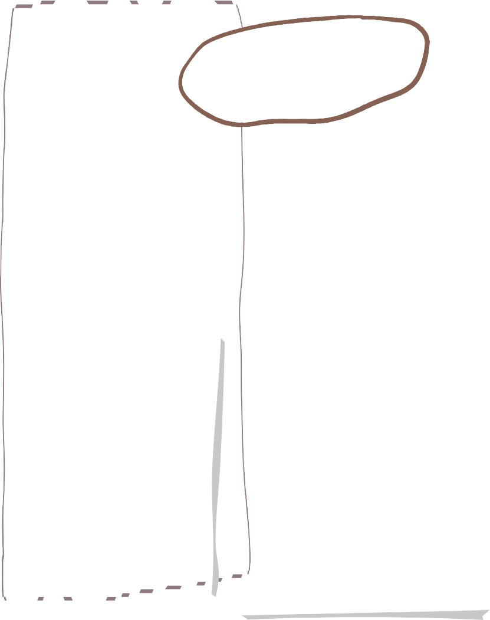



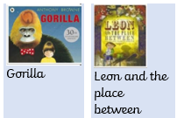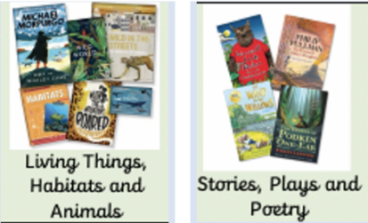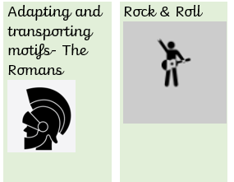

Computing

**Living things & their habitats**

* The seven life processes
* Vertebrates and Invertebrates
* Living things in our local area
* Classification keys

**Sound**

* Making sounds
* What is inside your ear?
* Pitch and volume
* Materials that muffle sound

The internet & audio

Being me in my own world & Celebrating Difference

PE

Personal Development

Art

We are writing…

* Narratives
* Non-chronological reports
* Diary entries
* A recount
* Character descriptions

Our writing is inspired by…

English

We are reading…

|  |  |
| --- | --- |
| Painting- Light & Dark | Art Project based on text or topic |

Art based on History and Geography topic.

Cricket

Swimming

Tag Rugby

Cross Country

Building structures

DT

History

Music

RE

Place Value

Addition and Subtraction

Multiplication and Division

Arrival on the shores of Britain: The Celts and the Romans

Volcanoes and Earthquakes

Geography

Science

Maths

**Curriculum, Homework and Spellings:**

Please see the curriculum overview on the reverse of this page or on our class page on the school website to see our texts, units and wider curriculum learning this term.

**Homework** will be given every Friday and is to be returned by the following Wednesday. The purpose of homework is to embed any learning from the week before, whilst training the children to have a disciplined attitude towards home learning in preparation for their next educational steps. Homework will be combination of SPaG / Reading, Maths and Spellings each week. We do not wish for homework to be a worry for anybody in the class, so please let us know if we can provide additional support.

**Spellings** will be set each Friday and tested the following Friday. The spellings will consist of spelling pattern rules for the Year 4 curriculum, but may recap spellings from Year 2 and 3. Spellings are to be practised in homework books to support children in consistently applying these words in their writing, alongside their preparation for weekly spelling tests. Consistent practice of spellings will also aid handwriting progress.

Children should be **reading** frequently at home. Evidence of reading at home should be noted in reading diaries and initialed by a parent/guardian. It is essential that children are reading aloud to adults at home to build verbal comprehension and inference skills, as well as supporting oracy and reading fluency.

**PE, Communication and Key Dates:**

Our **PE days** are Wednesdays and Fridays, but please ensure that kits are in school every day of the week. The kit should include clothing that is appropriate for all weather, including a thin waterproof or a jumper and tracksuit bottoms. Please ensure that trainers fit children appropriately, so that they can participate in lessons to the best of their ability.

**Communication** – please know that you can always contact us with any questions or concerns. My email is [rholland@tattenhallpark.cheshire.sch.uk](mailto:rholland@tattenhallpark.cheshire.sch.uk)

**Key Dates:**

Provisional date for Year 4 Romans Trip – Wednesday 22nd October

Parents’ Evening – Wednesday 12th and Thursday 13th November

Year 3 and 4 Christmas Performance – Monday 15th December 1:45pm and Tuesday 16th December at 9:30am

PE days, Homework days, Reading expectations and Important Dates for your class for the term ahead, including christmas, trips and parents evening.