
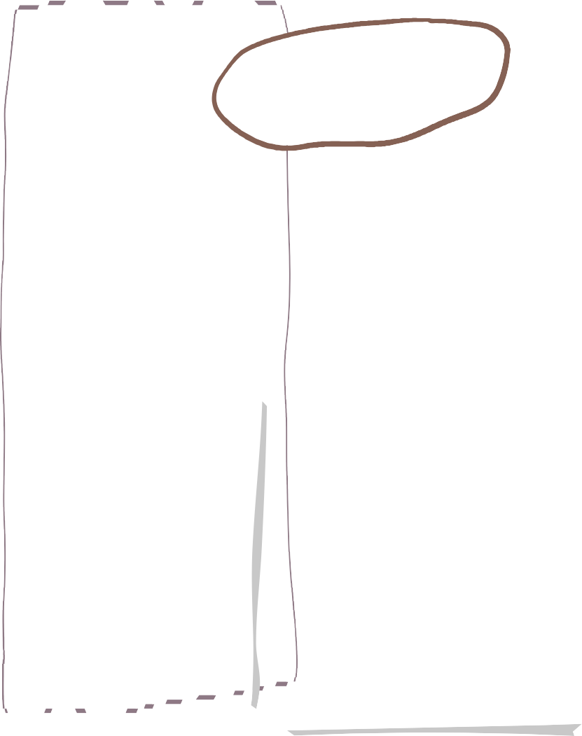




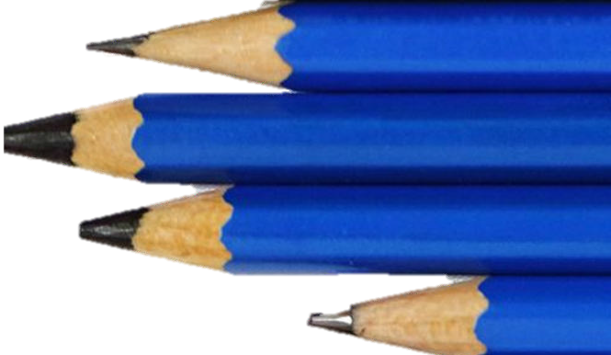


Pre-School- Autumn Term
Communication and language skills that we will be working on this term include:
- Talking about themselves, families and home events
- Listening to different sounds in the environemnt
- Expanding vocabulary through stories and conversations
- Listening to stories, songs and rhymes
- Singing songs
- Speaking in longer sentences of four to six words
- Talking to new friends and adults

Literacy
- Listen to and discuss a
wide range of stories
- Begin to recognise
their name
- Begin to make marks
and write some familiar letters

Communication and Language
- Opportunities to be expressive using a range of creative resources, including natural resources such as leaf printing
- Colour mixing
- Creating small worlds using building blocks, animals, people and natural resources
- Singing a wide range of songs and learning new songs
- Dancing and playing instruments

- Talk about their families, school and village and begin to understand
their sense of belonging
- Talk about different celebrations e.g. Christmas, Hanukah
Diwali and Harvest and begin to develop a positive attitude about
different people
- Discuss place they have been to and begin to understand
about different countries

Understanding of the World
Expressive arts and design
Physical Development
- Developing large movements e.g running, skipping, hopping, jumping, crawling, riding and balancing
- Develop fine motor movements e.g snipping with scissors, making marks with crayons or chalks, threading and using tweezers
- Be increasingly independent putting on coats and shoes and opening lunch boxes
- Begin to make healthy choices about food and drink- trying fruit and vegetables from our garden
Some stories we will read:
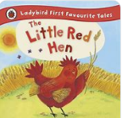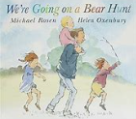

Maths
Daily singing of number rhymes and songs
Colours, sorting and matching
Patterns
Numbers 1-3
- Becoming more confident in a new setting
- Introducing routines and rules
- Playing with others, learning to take turns and others’ ideas
- Choosing appropriate resources
- Working on meeting own care needs e.g. toileting, washing hands, putting on shoes and coats
- Beginning to talk about and understand their feelings and the feelings of others
Personal, Social and Emotional Development








Computing
History
Personal Development

PE
Music
D&T

