Team Parks
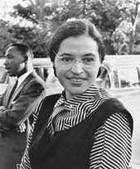
Lucas
Safa
Ameera
Abdur-Rahman
Ezel
Sonny
Aaliyah
K’Ayub

