Different types of materials
wood  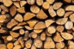 | paper  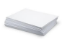
plastic  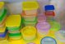 | fabric  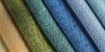
glass  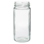 | clay  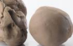
metal  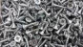 | foil  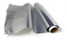
water  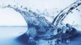 | cardboard  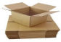
rock  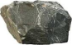 | rubber  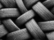
brick | wool

Everyday materials – Year 1
Key vocabulary to describe materials
material – all objects are made from one or more materials.
hard | soft
Stretchy | stiff
bendy | floppy
waterproof | absorbent
breaks | tears
rough | smooth
shiny | dull
see through | not see through

Spoons can be
made of wood,
metal or plastic.
Significant scientists
Charles Macintosh (1766-1843) | Scottish chemist and Inventor of  waterproof fabric.  The mackintosh  raincoat is named  after him.
Martin Brock – Nanotechnology engineer and XelfleX inventor
Martin works with a team of scientists developing smart fabrics. They were first created for sports people to wear.

Sorting and grouping materials
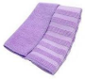
This cloth is very
absorbent and soaks up
the most water.
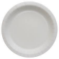
This paper plate would
be the best for a party
because it is very stiff.
Waterproof materials
These
materials
do not let
water pass
through
them.

© ECM Education Consultants 2019

