Subject Specific Vocabulary |  | 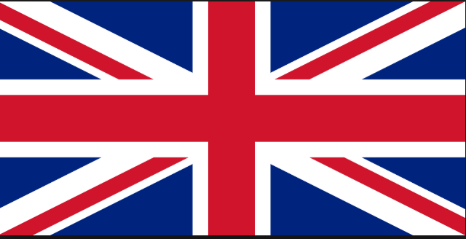  How is Our Country changing? | Exciting Books  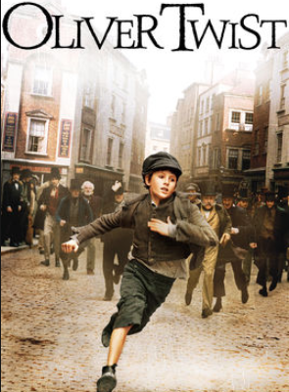  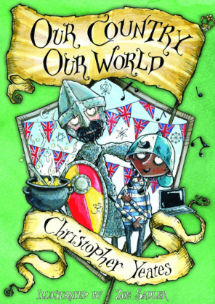  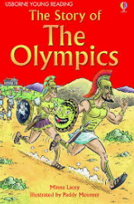
Ordnance Survey (OS) grid references | The UK is covered by a grid of maps that are given letters.
physical feature | Naturally occurring, e.g. rivers, mountains, lakes.
seasons | A time of year marked by certain conditions: spring, summer, autumn, winter.
tourism | A worldwide industry based on travel for leisure, pleasure, business, and other reasons that provides information, amenities, attractions, accommodation etc.
migration | The movement of people or animals from one place to another.
man-made | Something built by humans.
North, South, East, West | Compass points, locational vocabulary. | Sticky Knowledge - | - Spon Street, a medieval street which managed to avoid significant damage during the Blitz. Following the war, many other medieval timber framed buildings were relocated to Spon Street in order to preserve them.
The United Kingdom of Great Britain and Northern Ireland | Political union of England, Scotland, Wales and Northern Ireland. | - The United Kingdom is the world’s 22nd-most populated country, with some 64 million inhabitants.  . | - Changes were continual – wartime events caused rapid change, but the city was developing before the war, and has evolved ever since.
Great Britain | The island consisting of England, Scotland and Wales. | - World War II changed the West Midlands region. | - Environmental and sustainability perspective involved in future development.
country | A political area defined by physical, human, or cultural features. | - The 2012 Olympics and Paralympics aimed to be ‘the sustainable games’ – and for future development of the site to be sustainable too. | - ‘Change’ isn’t limited to a fixed period, and that places constantly change and develop.
city | A large town. | - The development of the 2012 Olympic and Paralympic Park is planned to continue until 2030 and beyond. | - London, the capital city, covers the third-largest urban area in Europe.

