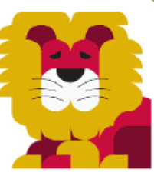

Rossmore School
Core Principles of Science Teaching

- We are excited and engaged by science and find our learning useful.

- Children and adults find science fun.

- Science is ‘Hands-On’ and ‘Child-Led’.

- We can learn by investigating and exploring.

- We can explain and develop our reasoning skills when we talk about what we have done.

