• Recognition board
• Think sheets- to be used when poor choice behaviour is repetitive
• Voice choice cards/lights- signal the level of noise required
• Safe space- is to be used for children to self-regulate using calming down techniques.

Teacher should take time to offer understanding and provide strategies.
Key information
• Attitudes to learning- these require consistent reinforcement and correction.
‘Are the children doing their best?’
• Perserverance- are the pupils challenging themselves?

Impositions
• Payback time lost in learning
• Work to be completed that evening at home and counter-signed by parents and returned the next morning

End of Breaks
Whistle 1- stop what you’re doing and stand still
Whistle 2- put away play equipment and walk to your class line

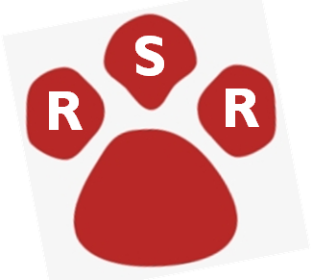
Morning Ritual
1- Welcome smile and individual hello.
2- Register
3- R, S, R

ENVIRONMENT

PUPILS

Friday
Whole school acheivement assembly

READY, SAFE, RESPECTFUL

Be kind. Be humble. Be nice.

Do’s Don’ts
• Keep calm •Public shaming- names on board, child stood up,
• Be positive made an example of
• Notice improvement •Children sent to other classes for punishment
•Child sent to another teacher/Headteacher for
punishment
•Showing anger towards a child/ staff member
•Highlighting negative behaviour to other staff in
front of a child

STAFF
Key Information
•Monitor and support language
• Over emotional responses to inappropriate behaviour will frighten many children
• Children who see shouty, unfair adults as adults who lack control. They are either frightended or find it funny
• Be proportionate
• Persevere
The Five Pillars of Pivotal Practice:
- Consistent, calm adult behaviour
- First attention to best conduct
- Relentless routines
- Scripting difficult interventions
- Restorative follow up

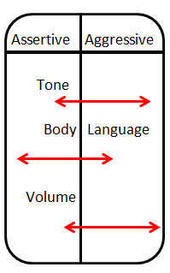
TROGS
T: Time and Task
Give the time and deadline before the task starts
R: Resources
What will the pupils require for the task?
O: Outcomes
What will it look like at the end?
G: Grouping
Silence? Pairs? Groups?
S: Stop Signal
A 3,2,1 reminder, clapping

Phrases
Wonderful walking
Lovely listening
Superb sitting
Tremendous transition
Scripts
I’m noticing ……………….. (expected behaviours)
Are you telling me that to be helpful or hurtful?
What would be helpful is …….
Tell …… I don’t like it when you …….

Key Messages
• Visible consistency

• Visible kindness

• How we behave is more important
than how they behave

• Praise in public.
Coach in private.

• Be deliberately bothered

