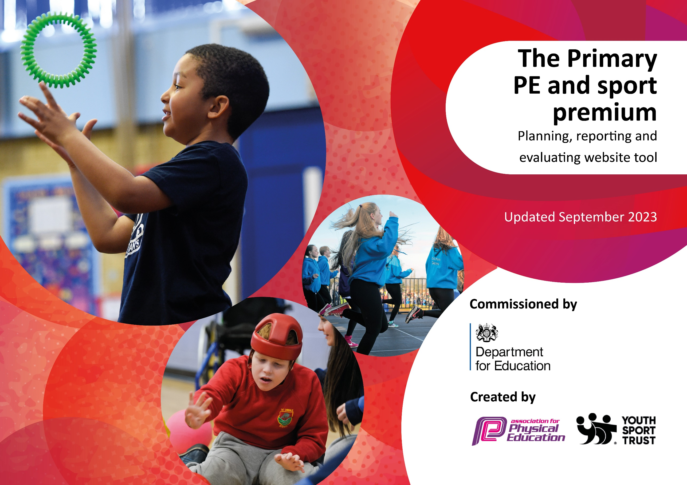

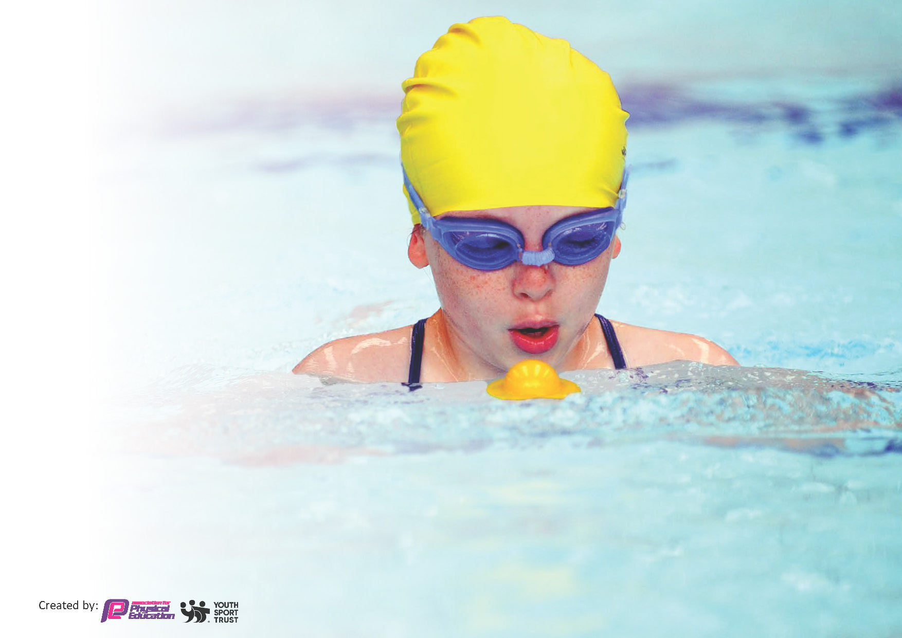
This template can be used for multiple purposes:
by:
- It enables schools to effectively plan their use of the Primary PE and sport premium
- It helps schools to meet the requirements (as set out in guidance) to publish information on their Primary PE and sport premium
- It will be an effective document to support Ofsted inspections enabling schools to evidence progress in Physical Education (PE) and evidence swimming attainment, which forms part of the PE National Curriculum. We would recommend schools consider
the Intent, Implementation and Impact of any spend, as examined within the Education Inspection Framework.

It is important that your grant is used effectively and based on school need.

Schools must use the funding to make additional and sustainable
improvements to the quality of the PE, School Sport and Physical Activity (PESSPA)
they offer. This means that you should use the Primary PE and sport premium to:

- Build capacity and capability within the school to ensure that improvements made now will benefit pupils joining the school in future years
- Develop or add to the PESSPA activities that your school already offers.

The Primary PE and sport premium should not be used to fund capital spend projects; the school’s core budget should fund these. Further detail on capital expenditure can be found in the updated Primary PE and sport premium guidance.

The Primary PE and sport premium guidance, outlines 5 key priorities that funding should be used towards. It is not

necessary that spending has to meet all the key priorities, you should select the priorities that you aim to use any funding towards.

Although completing this template is not a requirement for schools, schools are required to publish details of how they spend this funding. Schools must also outline what the impact this funding has had on pupils’ PE and sport participation and attainment and how any spending will be sustainable in the future. All funding must be spent by 31st July 2026.

The Department for Education has worked closely with the Association for Physical Education (afPE) and the Youth Sport Trust (YST) to develop this template and encourages schools to use it. This template is an effective way of meeting the reporting requirements of the Primary PE and sport premium.
Review of last year’s spend and key achievements (2024/2025)

Please see the separate documentation reviewing the 2024/2025 PE premium spend. This is shared on our website.

Key priorities and Planning 25-26
This planning template will allow schools to accurately plan their spending.

Potential spending categories to be considered. | Actions based on the categories and who does it impact? | Key indicator to meet | Impacts and how sustainability will be achieved? | Cost linked to the action
CPD  - External training courses  - Swimming CPD  - Internal learning and development  - Inter-school development sessions  - Online training/ resource development  - External coaches supporting coaching | -Membership of the School Sports Partnership (SSP) to provide CPD, competitions, wider sporting opportunities and much more.  - Complete PE teaching resource  - Supply teacher cover to allow staff the opportunity to attend CPD. | Key indicator 1 – Increase confidence, knowledge, and skills of all staff in teaching PE and sport.  Key indicator 2 – increase engagement of all pupils in physical activity.  Key indicator 3 – The profile of PE and sport is raised across the school as a tool for whole school improvement.  Key indicator 4 – Broader and more equal experience of a range of sports and physical activities offered to all pupils. | Ongoing membership which has provided our staff/pupils with training which is then implemented into school providing opportunities for all.  Complete has provided higher quality PE lessons at Rossmore for several years now. | £500 associated with CPD  £175  See figure in external events
Internal activities  - Extra-curricular opportunities  - Internal sports competitions  - Top-up swimming  - Active travel  - Internal equipment and resources  - Internal membership fees  - Educational platforms and resources | -Swimming top -up using ‘pools for schools’ to target non-swimmers in KS2.  Use data and assessment to support targeting pupils.  -Review, replenish and replace equipment for PE and playtime games. Use this equipment to create ‘My Personal Best’ targets for pupils of all ages.  -Well-being days:  2/3 days off timetable where well-being is through physical exercise is the driver. A range of sports, coaches, new experiences to encourage physical and mental well-being.  -Sports day  - Teach active to promote physical activity in maths and English lessons.  - Pupil voice informed extra-curricular clubs. | Key indicator 2 – increase engagement of all pupils in physical activity.  Key indicator 4 – Broader and more equal experience of a range of sports and physical activities offered to all pupils.  Key indicator 3 – The profile of PE and sport is raised across the school as a tool for whole school improvement. | If this program continues to be successful then it will be implemented every year with more pupils meeting the end of key stage requirements for swimming.  This will support more pupils meeting their daily physical activity goal and encourage more pupils to take part in PE and sport activities.  This is an annual event providing a lasting legacy of sport and mental well-being at Rossmore school.  Our sports day has always been successful and well supported. This will continue this opportunity for all stakeholders.  More pupils meeting their daily physical activity goal.  Pupils will experience sports which will lead to lifelong opportunities and love of sport. | 6/7 of the pool and staff hire plus costings for electricity and water.  £5,000  £2,500 budget.  Coaches, equipment and other costs associated:  £2,500.  £200 for prizes and resourcing  Renewal cost: £1,275  £200 for equipment
External activities  - External coaching  - Activities by SGO | -Membership of the School Sports Partnership (SSP) to provide CPD, competitions, wider sporting opportunities and much more.  - Supply teacher cover to allow staff the opportunity to attend sporting fixtures with pupils. | Key indicator 4 – Broader and more equal experience of a range of sports and physical activities offered to all pupils.  Key indicator 5 – Increased participation in competitive sport. | Ongoing membership which has provided our staff/pupils with training which is then implemented into school providing opportunities for all.  Staff knowledge for higher quality teaching of PE at school.  Pupils’ confidence and self-esteem. | £800 of the cost associated with opportunities for pupils.  1 afternoon’s supply cover at approximately £120 x 30 events = £3,600
External activities/ | Contribution to the cost of maintenance of the school minibus | Key indicator 4 – Broader and more equal experience of a range of sports and physical activities offered to all pupils.  Key indicator 5 – Increased participation in competitive sport. | Our minibus is one of the key reasons we can attend such a wide and range of sports events. Our children have so many opportunities as the minibus allows us to enter the majority of events hosted by the SSP. | £832

Signed off by:

Head Teacher: | Sue- Davis McCoy
Subject Leader or the individual responsible for the Primary PE and sport premium: | Tom Podmore – PE Lead
Governor: | Mark Poole
Date: | 2/10/25

