
Rossmore School’s Science Policy
2026-2028
Intent
At Rossmore, we encourage children to be inquisitive throughout their time at the school and beyond. The Science curriculum fosters a healthy curiosity in children about our universe and promotes respect for the living and non-living. We believe science encompasses the acquisition of knowledge, concepts, skills and positive attitudes. Throughout the programmes of study, the children will acquire and develop the key knowledge that has been identified within each unit and across each year group. The key knowledge identified by each year group is informed by the National Curriculum and builds towards identified phase ‘end points’ in accordance with NC expectations. Key skills are also mapped for each year group and are planned carefully through knowledge organisers so that the learning and knowledge taught is progressive throughout the school. These too ensure systematic progression to identified skills end points which are in accordance with the working scientifically skills expectations of the National Curriculum. The curriculum is designed to ensure that children are able to acquire key scientific knowledge through practical experiences; using equipment, conducting experiments, building arguments and explaining concepts confidently. Cross curricular opportunities are also identified, mapped and planned to ensure contextual relevance. Children are encouraged to be scientists; to ask questions and be curious about their surroundings and to see the value of scientific understanding.
Implementation
Teachers create a positive attitude to science within their classrooms and reinforce an expectation that all pupils are scientists and are capable of achieving high standards in science. Our whole school approach to the teaching and learning of science involves the following:
● Science will be taught in planned and arranged topic blocks by the class teacher following a mastery structure designed by teachers to have a knowledge and project-based approach. This is a strategy to enable the achievement of a greater depth of knowledge.
● Existing knowledge is checked at the beginning of each topic, as part of the KWL strategy (What I know, What I would like to Know and What I have Learned). This ensures that teaching is informed by the children’s starting points and that it takes account of pupil voice, incorporating children’s interests.
● Through our planning, we involve problem solving opportunities that allow children to apply their knowledge, and find out answers for themselves. Children are encouraged to ask their own questions and be given opportunities to use their scientific skills and research to discover the answers. This curiosity is celebrated within the classroom. Planning involves teachers creating engaging lessons, often involving high-quality resources to aid understanding of conceptual knowledge. Teachers use precise questioning in class to test conceptual knowledge and skills, and assess pupils regularly to identify those children with gaps in learning, so that all pupils keep up. Tasks are selected and designed to provide appropriate challenge to all learners, in line with the school’s commitment to inclusion.
● We build upon the knowledge and skill development of the previous years. As the children’s knowledge and understanding increases, they become more proficient in selecting, using scientific equipment, collating and interpreting results, they become increasingly confident in their growing ability to come to conclusions based on real evidence.
● Working Scientifically skills are embedded into lessons to ensure that skills are systematically developed throughout the children’s school career and new vocabulary and challenging concepts are introduced through direct teaching. This is developed through the years, in keeping with the topics.
● Teachers demonstrate how to use scientific equipment, and the various working scientifically skills in order to embed scientific understanding. Teachers find opportunities to develop children’s understanding of their surroundings by accessing outdoor learning and workshops with experts.
● Children are offered a wide range of extra-curricular activities, visits, trips and visitors to complement and broaden the curriculum. These are purposeful and link with the knowledge being taught in class. Rossmore School is strengthening links with local high schools which will allow us to use their site, resources and expertise to enhance our curriculum and staff knowledge further.
● At the end of each topic, key knowledge is reviewed by the children and rigorously checked by the teacher and consolidated as necessary.
Science Principles Statement
Our intent and implementation strategies are presented to the children in the form of our science principles statement. This is a child-friendly document created by teachers and children outlining the values that underpin science teaching and learning at Rossmore. It is visible on all science learning walls and displays and is referred to by adults and pupils during lessons.

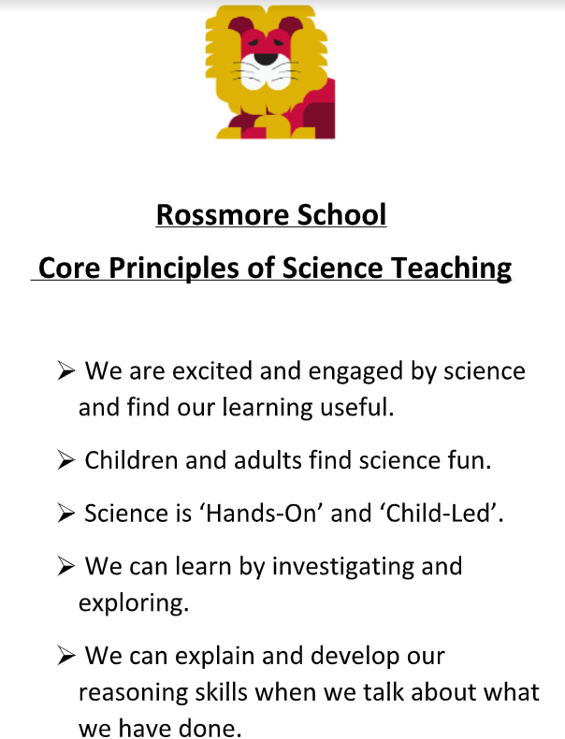

Impact
The successful approach at Rossmore results in a fun, engaging, high-quality science education that provides children with the foundations and knowledge for understanding the world. Our engagement with the local environment ensures that children learn through varied and first-hand experiences of the world around them. Frequent, continuous and progressive learning outside the classroom is embedded throughout the science curriculum. Through various workshops, trips and interactions with experts, children have the understanding that science has changed our lives and that it is vital to the world’s future prosperity. Children at Rossmore enjoy science and this results in motivated learners with a sound scientific understanding.
Assessment
As part of the introduction to each new science topic, teachers review what the children know already and identify what they would like to learn. This informs the programme of study so that it takes account of children’s starting points as well as their specific interests. Lessons are planned to ensure that key knowledge is developed over time, over the course of each science block and in the correct sequence. Key knowledge is reviewed by the children and rigorously checked and consolidated by the teacher at the end of each unit of work. Six lessons within each unit are also planned to ensure the systematic development of the key identified skills across the school. By the end of each key stage, pupils are expected to know, apply and understand the matters, skills and processes specified in the relevant programme of study as set out in the National Curriculum. These are set out as statutory requirements. We also draw on the non-statutory requirements to broaden children’s understanding and provide an appropriate level of challenge. Teacher assessment informs planning and allows teachers to plan relevant and useful sequences of lessons. Teachers use Arbor to record assessment. Children are guided towards achievement of the main objective through the use of process-based ‘success criteria’, provided by and explained by the teacher. Children refer to these during the lesson and they precede outcomes of work in children’s books. Ongoing assessment also includes:
● Observing children at work, individually, in pairs, in a group, and in classes.
● Questioning, talking and listening to children
● Considering work/materials / investigations produced by children together with discussion about this with them.
In EYFS, we assess the children’s Understanding of the World according to the Development Matters statements.
Equal Opportunities
At Rossmore School, we are committed to providing a teaching environment which ensures all children are provided with the same learning opportunities regardless of social class, gender, culture, race, special educational need or disability. Teachers use a range of strategies to ensure inclusion and also to maintain a positive ethos where children demonstrate positive attitudes towards others.
Inclusion
Science teaching considers the needs of different individuals and groups for learners and tasks are designed and differentiated as appropriate to ensure a sufficient level of challenge. Supporting adults are also deployed effectively to ensure focused support where this is necessary. Teachers use a range of inclusion strategies, including the mastery approach, paired work, open questions and direct, differentiated questioning and the activation of prior knowledge and contextual learning. This supports the inclusion and motivation of all learners ensuring that optimum progress is made throughout each part of the lesson.
Date of Policy: September 2026
Policy Review Date: September 2028

