EARLY YEARS

EYFS Addition
Early learning goals:
- Count reliably with numbers from 1 to 20, place them in order.
- Say which number is one more than a given number.
- Using quantities and objects, they add two single-digit numbers and count on to find the answer.
Recognise numbers up to 20 and understand the meaning of each number by recognising and knowing their clusters |  | Count on in ones and say which number is one more than a given number using a number line or number track to 20. |  | Begin to relate addition to combining two groups of objects using practical resources, role play, stories and songs. | Know that counting on is a strategy for addition. Use numbered number lines to 20.
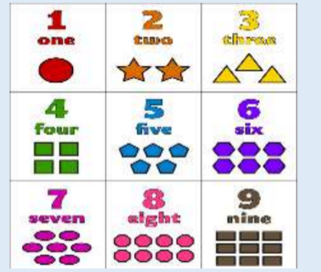  Numicon shapes are introduced straight away and be used to:  • identify 1 more/less  • combine pieces to add  • find number bonds  • add without counting  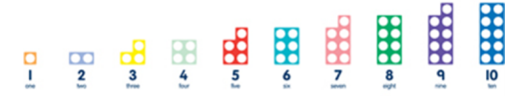 |  | 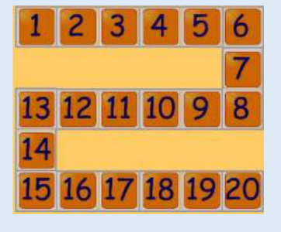  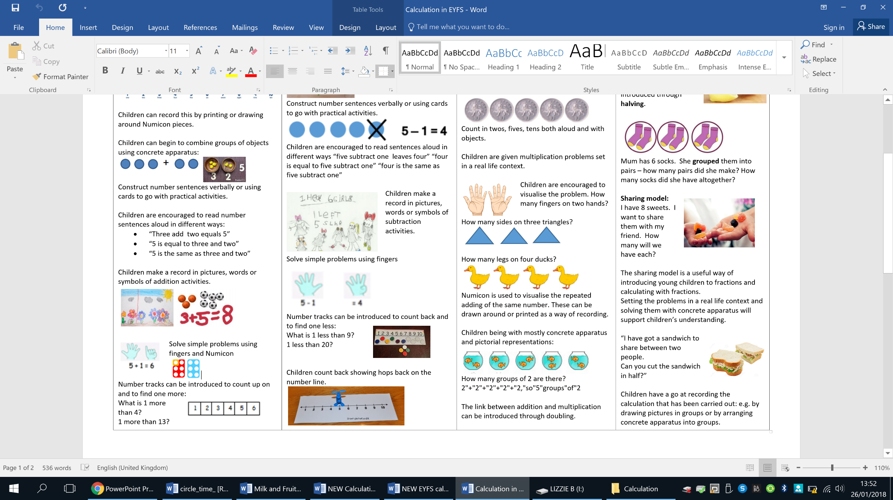 |  | 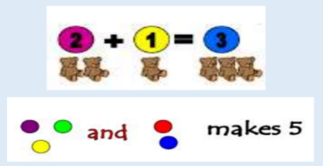  Children can begin to combine groups of objects using concrete apparatus:    Construct number sentences verbally or using cards to go with practical activities.  Children are encouraged to read number sentences aloud in different ways:  - “Three add two equals 5”  - “5 is equal to three and two”  - “5 is the same as three and two”  Children make a record in pictures, words or symbols of addition activities. | 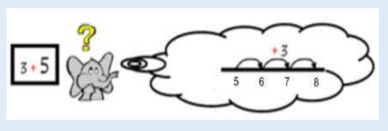
EYFS Subtraction
Early learning goals:
- Say which number is one less than a given number.
- Using quantities and objects, they subtract two single-digit numbers and count back to find the answer.
Say which number is one less than a given number using a number line or number track to 20. | Begin to count backwards in familiar contexts such as number rhymes or stories. |  | Begin to relate subtraction to ‘taking away’ using concrete objects and role play. |  |  |  | Count backwards along a number line to ‘take away’
Number tracks can be introduced to count back and to find one less:  What is 1 less than 9?  1 less than 20?  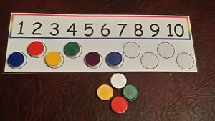 | 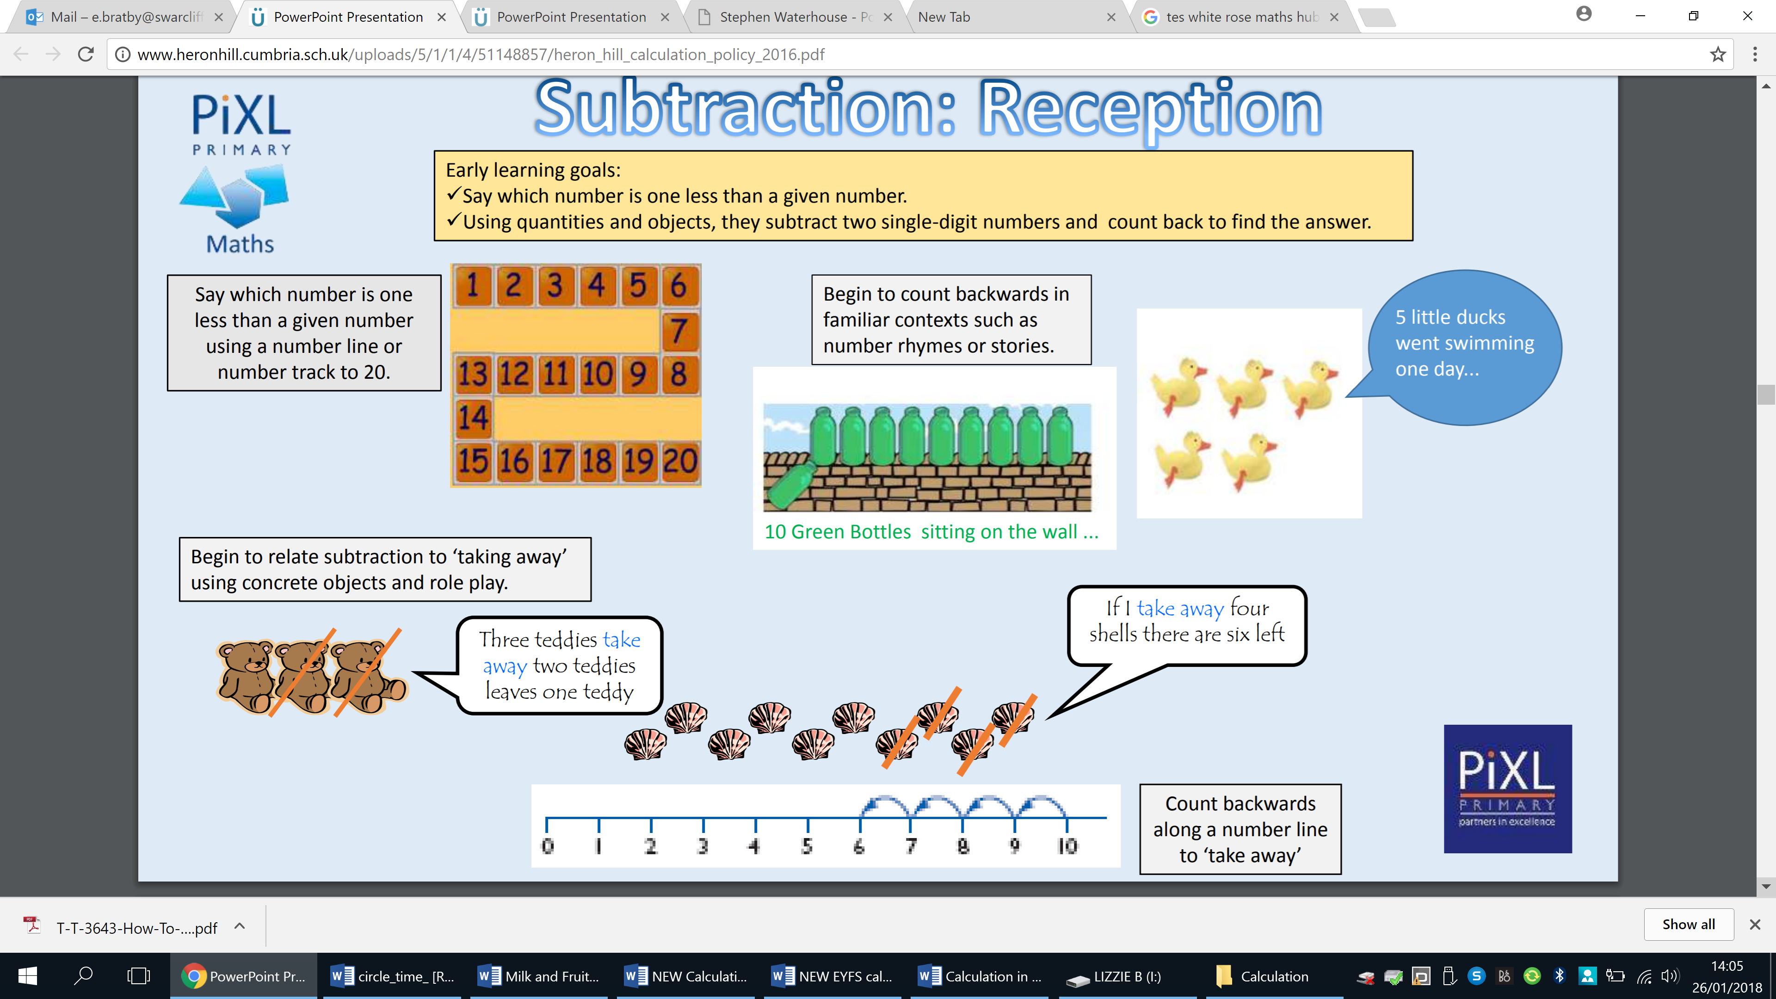  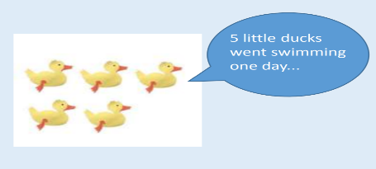  Children make a record in pictures, words or symbols of subtraction activities.  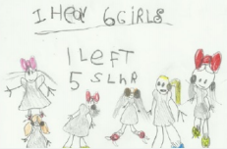 |  | Concrete apparatus is used to relate subtraction to taking away and counting how many objects are left.  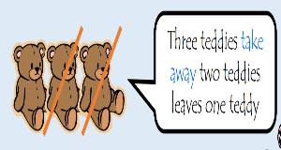  Concrete apparatus models the subtraction of 2 objects from a set of 5.  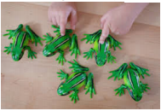  Construct number sentences verbally or using cards to go with practical activities.    Children are encouraged to read sentences aloud in different ways “five subtract one leaves four” “four is equal to five subtract one” “four is the same as five subtract one”  Solve simple problems using fingers  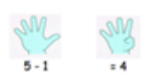 |  |  |  | 
EYFS Multiplication and Division
Early learning goals:
- They solve problems, including doubling, halving and sharing
- They solve problems, including halving and sharing.
Use pictorial representations and concrete resources to double numbers to 10. |  | Use concrete sources, role play, stories and songs to begin counting in twos, fives and tens. |  | Use pictorial representations and concrete resources to halve numbers to 10. |  | Begin to share quantities using practical resources, role play, stories and songs.
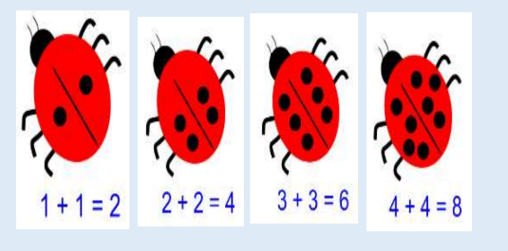  The link between addition and multiplication can be introduced through doubling.  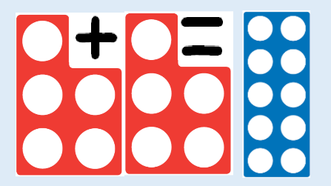 |  | 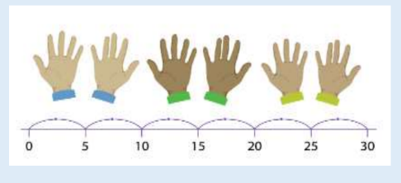  ‘I have 5 pairs of socks on this line. How many socks do I have altogether? ‘  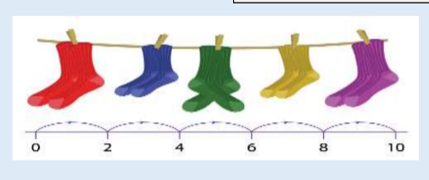 |  | 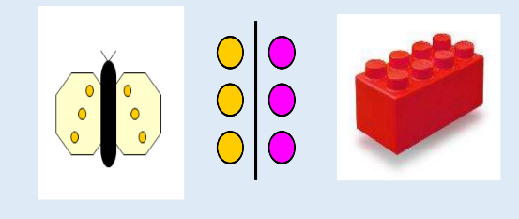  “I have got a sandwich to share between two people.  Can you cut the sandwich in half?”  Children have a go at recording the calculation that has been carried out: e.g. by drawing pictures in groups or by arranging concrete apparatus into groups. |  | 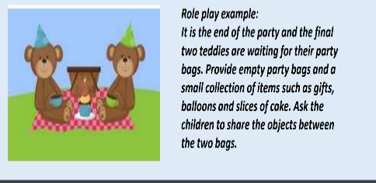  Sharing model:  I have 8 sweets. I want to share them with my friend. How many will we have each?  

Key Stage 1 and 2

Addition | Year 1 | Year 2 | Year 3
Addition | Pupils memorise and reason with number bonds to 10 and 20 in several forms. | Practice addition to 20 and become increasing fluent in deriving facts. | I can add numbers with up to three digits using formal written methods.
Addition | Complete the part whole models by drawing the counters then writing the numerals. Linking to bar modelling in Year 1.  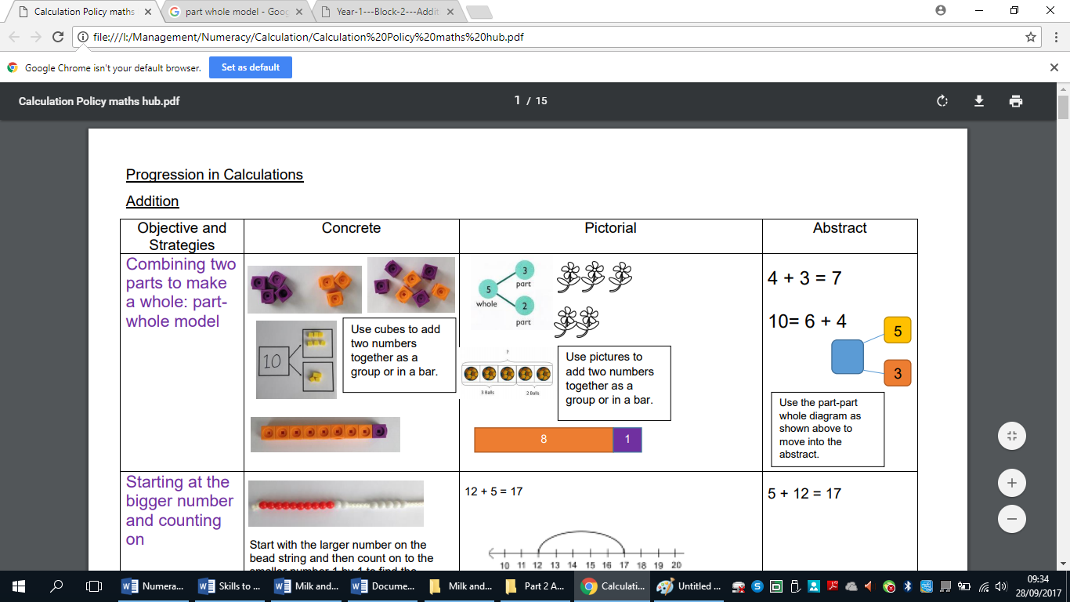  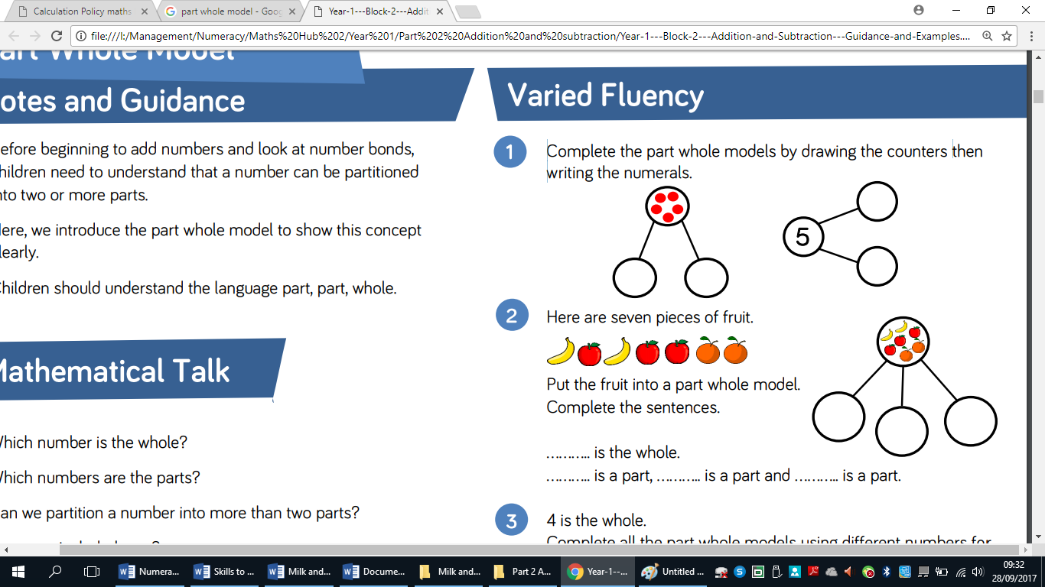  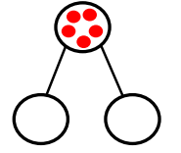  Understanding of counting on with a numbertrack and using numicon.  Understanding of counting on with a number line (supported by models and images).  7+4  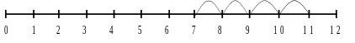  Ten frames to be used for addition, specifically number bonds.    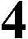  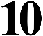  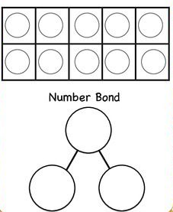 4 + ? = 10 | Methods taught in Year 1 should continue to be used to consolidate learning and understanding in Year 2.  Continue to use number lines to develop understanding of:  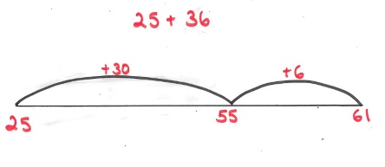  Partitioning and bridging through 10.  The steps in addition often bridge through a multiple of 10  e.g. Children should be able to partition the 7 to relate adding the 2 and then the 5.  8 + 7 = 15  Use of diene to add 2 two digit numbers  47+25=  47 + 25 = 72  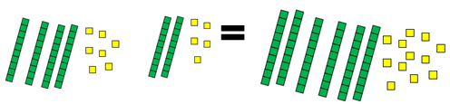  Children work towards using column method:  E.g. 28+7=  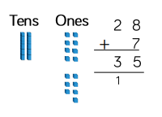 | Pupil needing to use number lines from Year 2 into 3 should continue to do so depending on their ability.  Using base 10 apparatus for addition:  E,g 245+7=    Using number lines:  E.g 346+7=  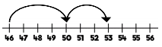  Towards a Written Method  Introduce column addition modelled with place value counters or Dienes.  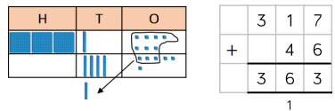  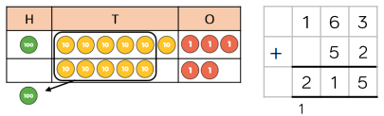
Addition | Year 4 | Year 5 | Year 6
Addition
  Pupils continue to practise mental methods with increasingly large numbers using models and images to help them. | Children practise mental calculations with increasingly large numbers to aid fluency (12,462 +2300 = 14,762) using models and images to help them. | Undertake mental calculations with increasingly large numbers and more complex calculations using models and images to help them.
  Pupils continue to practise mental methods with increasingly large numbers using models and images to help them. | Children practise mental calculations with increasingly large numbers to aid fluency (12,462 +2300 = 14,762) using models and images to help them. | Undertake mental calculations with increasingly large numbers and more complex calculations using models and images to help them.
  Pupils continue to practise mental methods with increasingly large numbers using models and images to help them. | Children practise mental calculations with increasingly large numbers to aid fluency (12,462 +2300 = 14,762) using models and images to help them. | Undertake mental calculations with increasingly large numbers and more complex calculations using models and images to help them.
Addition | Children can draw a pictorial representation of the columns and place value counters to further support their learning and understanding.  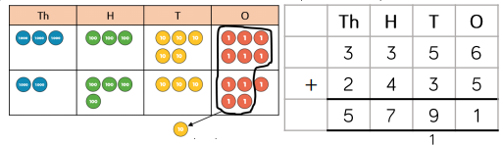  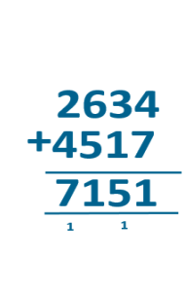  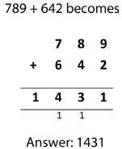  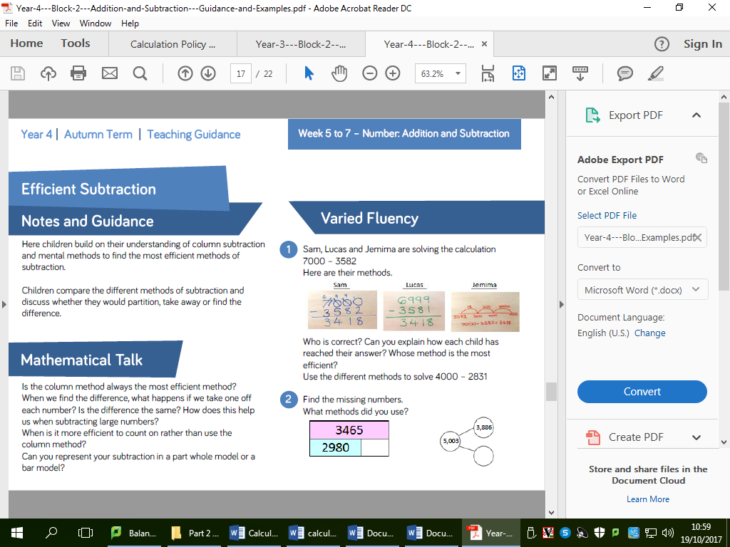  Extend to up to two places of decimals (same number of decimals places) and adding several numbers (with different numbers of digits). | Written methods (progressing to more than 4-digits)  As Year 4, progressing when understanding of the expanded method is secure, children will move on to the formal column method for whole numbers and decimal numbers as an efficient written algorithm.  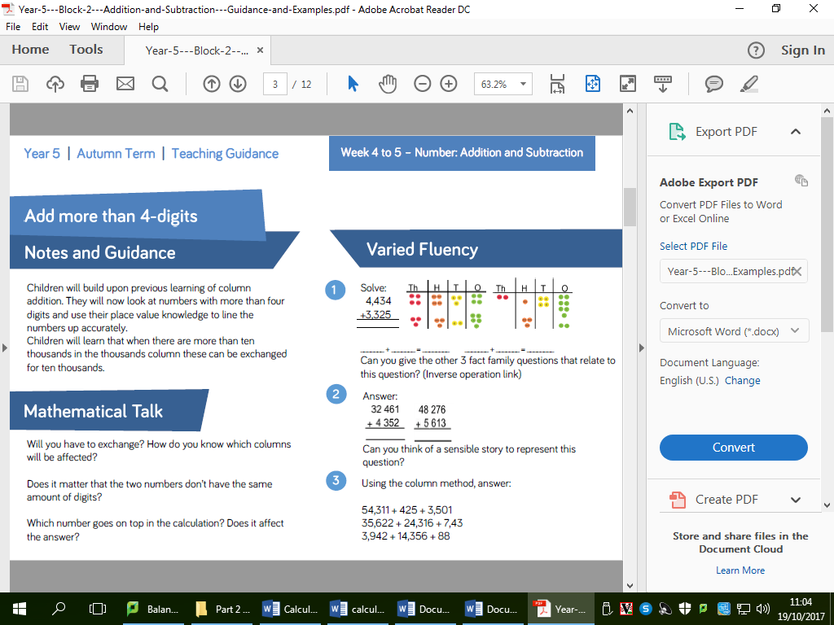  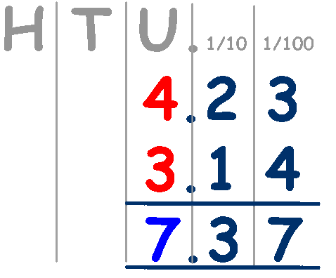 | Written methods  As Year 5, progressing to larger numbers, aiming for both conceptual understanding and procedural fluency with columnar method to be secured.  Continue calculating with decimals, including those with different numbers of decimal places  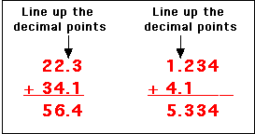  Pupils will also learn to add three decimal numbers.  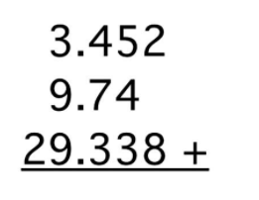

Subtraction | Year 1 | Year 2 | Year 3
Subtraction | Pupils memorise and reason with number bonds in several forms (16 - 7 = 9 7 = 16 – 9) | Practise subtraction to 20 becoming increasingly fluent in deriving facts (such as; 10 - 7 = 3 7 = 10 – 3 to calculate 100 – 70 = 30 70 = 100 - 30 ) | Practise solving varied subtraction questions – calculations with two digit numbers, the answers exceed 100.
Subtraction | Missing number problems e.g. 7 = □ - 9; 20 - □ = 9; 15 – 9 = □; □ - □ = 11; 16 – 0 = □  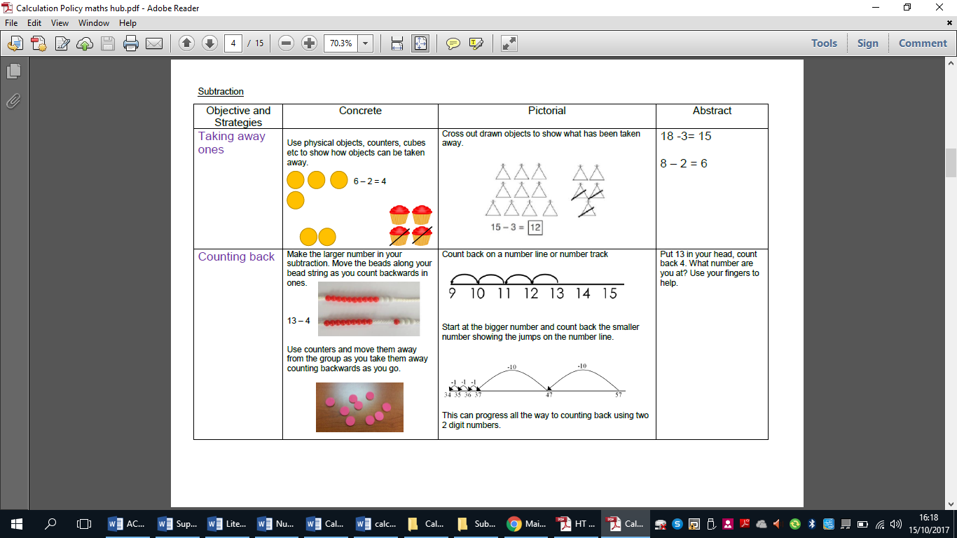  4 – 2 = 2  Understand subtraction as take-away:  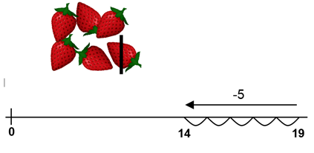  Understand subtraction as finding the difference: | Missing number problems e.g. 52 – 8 = □; □ – 20 = 25; 22 = □ – 21; 6 + □ + 3 = 11  20 - ? = 13  Use number lines to model take-away and difference. E.g.  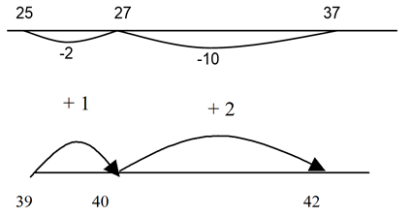  Written methods (progressing to 2-digits)  Introduce column subtraction modelled with place value counters or Dienes.  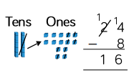  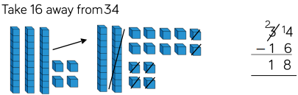 | Pupil needing to use number lines from Year 2 into 3 should continue to do so depending on their ability.  Using base 10 apparatus for subtraction:  E.g. 321-4=    Using number lines:  E.g.132-4=  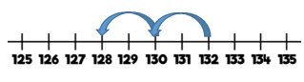  Written methods (progressing to 3-digits)  Introduce column subtraction modelled with place value counters or Dienes.  e.g. 255-28=  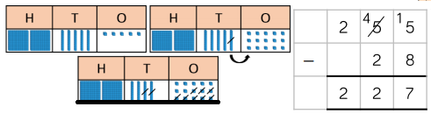  e.g. 434-72=  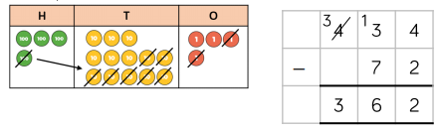
  20
  ? | 13
Multiplication | Year 1 | Year 2 | Year 3
  Subtraction | Year 4 | Year 5 | Year 6
  Subtraction | Pupils continue to practise mental methods with increasingly large numbers using models and images to help them. | Children practise mental calculations with increasingly large numbers to aid fluency (12,462 -2300 = 10,162) using models and images to help them. | Undertake mental calculations with increasingly large numbers and more complex calculations using models and images to help them.
  Subtraction | 1  Missing number/digit problems: 456 + □ = 710;  1□7 + 6□ = 200; 60 + 99 + □ = 340; 200 – 90 – 80 = □; 225 - □ = 150; □ – 25 = 67; 3450 – 1000 = □; □ - 2000 = 900  The formal method should be seen as a more streamlined version of the expanded method, not a new method.  Written methods (progressing to 4-digits)  Expanded column subtraction with decomposition, modelled with place value counters or dienes, progressing to calculations with 4-digit numbers.  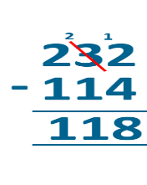  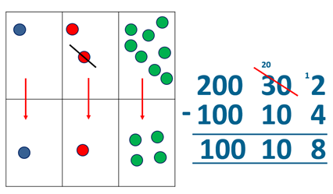  or  Insert 4 digit column subtraction  If understanding of the expanded method is secure, children will move on to the formal method of decomposition, which again can be initially modelled with place value counters or dienes. | Missing number/digit problems: 6.45 = 6 + 0.4 + □; 119 - □ = 86; 1 000 000 - □ = 999 000; 600 000 + □ + 1000 = 671 000; 12 462 – 2 300 = □  Written methods (progressing to more than 4-digits)  When understanding of the expanded method is secure, children will move on to the formal method of decomposition, which can be initially modelled with place value counters or dienes.  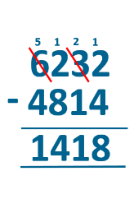  The subtraction symbol can be on the left or the right of the calculation.  1  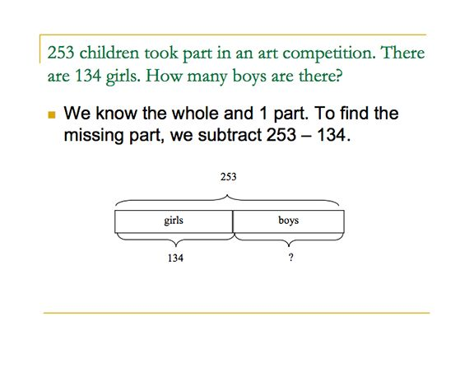  Progress to calculating with decimals, including those with different numbers of decimal places. | Missing number/digit problems: □ and # each stand for a different number. # = 34. # + # = □ + □ + #. What is the value of □? What if # = 28? What if # = 21  10 000 000 = 9 000 100 + □  7 – 2 x 3 = □; (7 – 2) x 3 = □; (□ - 2) x 3 = 15  Written methods  As year 5, progressing to larger numbers, aiming for both conceptual understanding and procedural fluency with decomposition to be secured.  3 1 7 1  1422 78162  - 870 - 3421  552 74741  Continue calculating with decimals, including those with different numbers of decimal places.
 | Through grouping and sharing small quantities, pupils begin to understand doubling numbers and quantities. The children can count in twos, fives and tens. | Children practise and become fluent in the 2, 5 and 10 multiplication tables. They connect the 10 multiplication table to place value. | Practise their recall of multiplication tables and through doubling they connect the 2, 4 and 8 multiplication tables.
 | 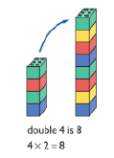  Understand multiplication is related to doubling and combing groups of the same size (repeated addition)    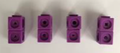  Washing line, and other practical resources for counting. Concrete objects. Numicon; bundles of straws, bead strings  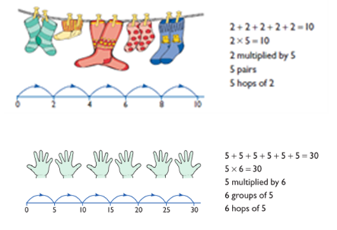  Problem solving with concrete objects (including money and measures. Use cuissenaire rods and numicon to develop the vocabulary relating to ‘times’ –  Pick up five, 4 times. Use arrays to understand multiplication can be done in any order (commutative)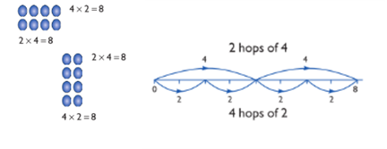 | Expressing multiplication as a number sentence using x  Using understanding of the inverse and practical resources to solve missing number problems.  7 x 2 = = 2 x 7  7 x = 14 14 = x 7  x 2 = 14 14 = 2 x  x ⃝ = 14 14 = x ⃝  Develop understanding of multiplication using array and number lines (see Year 1). Include multiplications not in the 2, 5 or 10 times tables. Begin to develop understanding of multiplication as scaling (3 times bigger/taller).  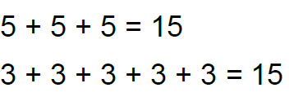  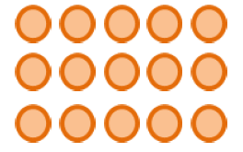  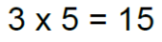  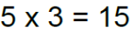  Towards written methods  Use jottings to develop an understanding of doubling two digit numbers.  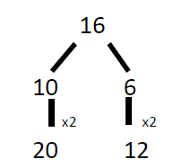 | Doubling 2 digit numbers using partitioning – using jottings from Year 2.  Written methods (progressing to 2d x 1d)  Developing written methods using understanding of visual images.  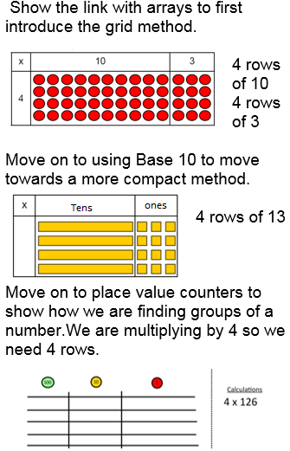  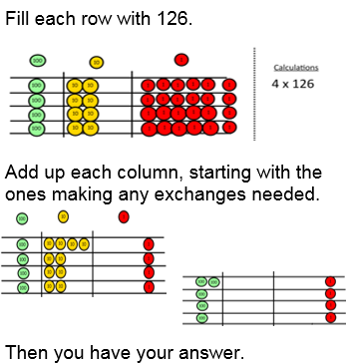
Multiplication | Year 4 | Year 5 | Year 6
Multiplication | Recall all multiplication facts up to 12 x 12. Counting in multiples of 6, 7, 9, 25 and 1000, and steps of 1/100. Solving practical problems where children need to scale up. Relate to known number facts. (E.g. how tall would a 25cm sunflower be if it grew 6 times taller. | Identify multiples and factors and factor pairs of numbers. Know and use prime numbers and prime factors. Recognise squared and cubed numbers (using the correct notation). | Undertake mental multiplications with increasingly hard numbers and decimals. Continue to use all multiplication facts to aid fluency.
Multiplication | Begin by using counting objects and resources.  126x3= 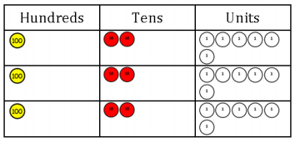  Then use this to lead into grid multiplication  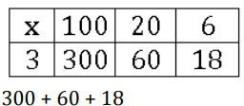  Leading to expanded vertical method  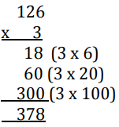  Compact vertical method  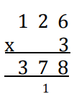  It is important at this stage that they always multiply the ones first and note down their answer followed by the tens which they note below. | Begin with grid method  47x36=  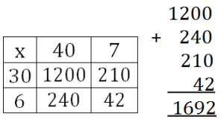  Leading to expanded vertical  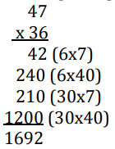  Notice that we start by multiplying the digit in the one’s place first.  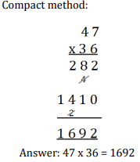 | Multiply multi-digit numbers up to 4 digits by a two-digit whole number using the efficient written method of long multiplication.  Start with long multiplication, reminding the children about lining up their numbers clearly in columns.  Compact Vertical Method  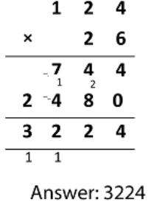  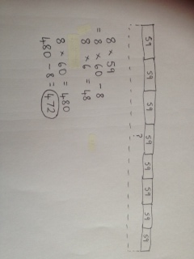  Bar modelling and number lines can support learners when solving problems with multiplication alongside the formal written methods.  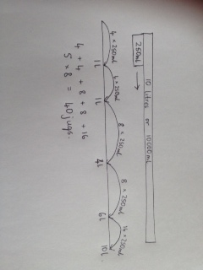
Division | Year 1 | Year 2 | Year 3
Division | Through sharing small quantities, children begin to understand division, and finding simple fractions of amounts and quantities. | Children practise and become fluent in their recall of the 2, 5 and 10 division facts. | Children practise and become fluent in the recall of the 2, 3, 4 and 8 division facts.
Division | Children must have secure counting skills- being able to confidently count in 2s, 5s and 10s. Children should be given opportunities to reason about what they notice in number patterns.  Group AND share small quantities- understanding the difference between the two concepts.  Sharing  Develops importance of one-to-one correspondence.  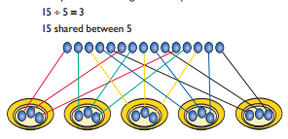  Grouping  Children should apply their counting skills to develop some understanding of grouping.  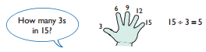  Arrays  Use of arrays as a pictorial representation for division. 15 ÷ 3 = 5 There are 5 groups of 3.  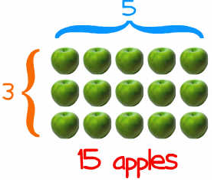 | Sharing using a bar model  12÷ 3=?  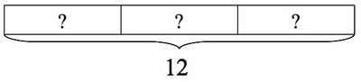  Grouping on a number line  Group from zero in jumps of the divisor to find our ‘how many groups of 3 are there in 15?’  15 divided by 3  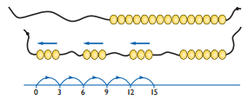  Arrays  Continue work on arrays. Support children to understand how multiplication and division are inverse. Look at an array – what do you see?  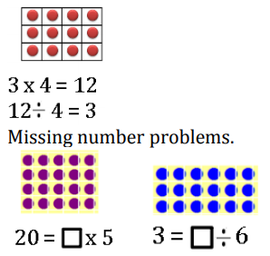 | Becoming more efficient using a number line  Children need to be able to partition the dividend in different ways.  48 ÷ 4 = 12  40 8  2 groups  10 groups  0 40 48  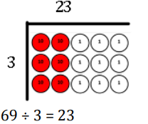Extending divisions to resemble written method of short division.  Progressing to the formal written method of short division:  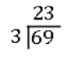
Division | Year 4 | Year 5 | Year 6
Division | Children should know all the division facts up to 12 x 12 | Undertake mental divisions with increasingly hard numbers and decimals. | Undertake mental divisions with increasingly hard numbers and decimals.
Division | Use base 10 blocks to divide by 10  140÷ 10 = 14  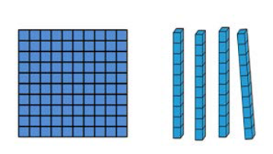  Grouping/sharing counters are used to make the link with short division  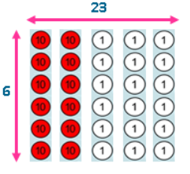  Leads directly onto:  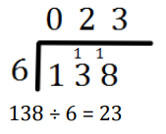 | Showing remainder as a whole number:  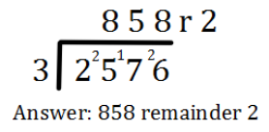  Showing remainder as a fraction:  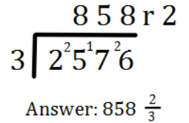  HTU ÷ TU (Using factor pairs as divisors)  558 ÷ 18 =  Step 1: Identify a pair of factors for the divisor e.g. 18 = 3 x 6  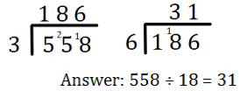Step 2: Divide by one of the factors.  Step 3: Divide the answer by the other factor.  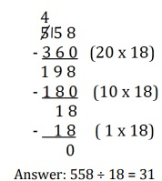HTU ÷ TU (beginning to look at chunking as a precursor to long division) | ÷ = signs and missing numbers  Continue using a range of equations but with appropriate numbers  Sharing and Grouping and using a number line  Children will continue to explore division as sharing and grouping, and to represent calculations on a number line as appropriate.  Remainders should be expressed as decimals and fractions.  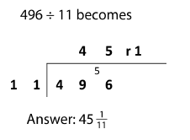  Long Division  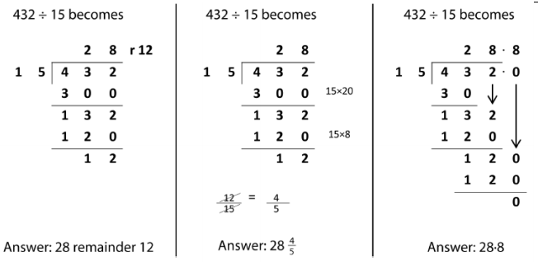

Subtraction | Year 4 | Year 5 | Year 6
Subtraction
  Pupils continue to practise mental methods with increasingly large numbers using models and images to help them. | Children practise mental calculations with increasingly large numbers to aid fluency (12,462 +2300 = 14,762) using models and images to help them. | Undertake mental calculations with increasingly large numbers and more complex calculations using models and images to help them.
  Pupils continue to practise mental methods with increasingly large numbers using models and images to help them. | Children practise mental calculations with increasingly large numbers to aid fluency (12,462 +2300 = 14,762) using models and images to help them. | Undertake mental calculations with increasingly large numbers and more complex calculations using models and images to help them.
  Pupils continue to practise mental methods with increasingly large numbers using models and images to help them. | Children practise mental calculations with increasingly large numbers to aid fluency (12,462 +2300 = 14,762) using models and images to help them. | Undertake mental calculations with increasingly large numbers and more complex calculations using models and images to help them.
Subtraction | Children can draw a pictorial representation of the columns and place value counters to further support their learning and understanding.  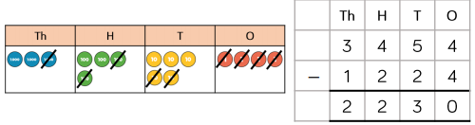  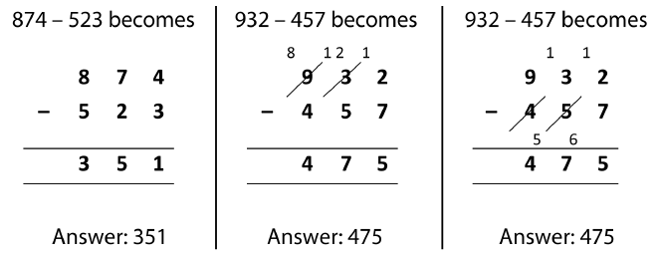  Extend to up to two places of decimals (same number of decimals places) and adding several numbers (with different numbers of digits).  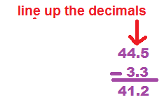 | Written methods (progressing to more than 4-digits)  As Year 4, progressing when understanding of the expanded method is secure, children will move on to the formal column method for whole numbers and decimal numbers as an efficient written algorithm.  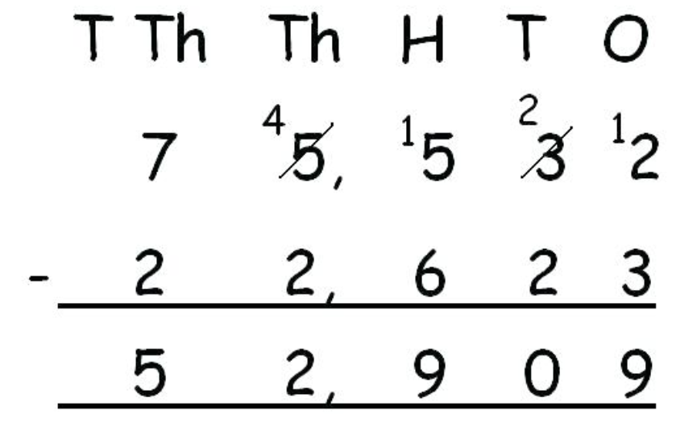  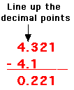 | Written methods  As Year 5, progressing to larger numbers, aiming for both conceptual understanding and procedural fluency with columnar method to be secured.  Continue calculating with decimals, including those with different numbers of decimal places

