
Rossmore School’s Reading Policy

Intent
At Rossmore, we believe the development of Literacy skills across the curriculum is crucial to a high- quality education and will give our pupils the tools they need to participate fully as a member of society. All teachers have a responsibility to develop pupils’ competence in Reading to ensure all pupils can access the curriculum effectively to achieve their potential. We provide children with lifelong skills to ensure they can be fluent, confident readers. All staff strive to promote a love of reading by exposing children to language-rich literature, non-fiction and poetry. Our children understand reading is a transferable skill that applies to our wider curriculum and will ensure that our pupils have the opportunity to experience rich texts that broaden their knowledge about their communities and the wider world. Rossmore School wants all pupils to fulfil their reading potential and aims to provide an environment and a quality of teaching in which that can be made possible.

Implementation
Teachers will use a variety of consistent strategies to ensure pupils are receptive and engaged with the fundamental skills and competencies of reading. We use a wide variety of quality, language-rich texts and resources to motivate and inspire our children. This includes Literacy Counts units; Read to Write and Steps to Read as well as carefully chosen texts that link to our wider curriculum and whole school concepts: Identity, Community, Power, Courage, Choices and Change.
Early reading is taught during daily Phonics lessons in Reception and KS1 and reading books are matched to children’s phonic abilities. All children will take home a reading book that is matched to their reading ability as well as a reading for pleasure book from their class library.
We use a Reading Model in KS1 (which allows all children to read with an adult in a small group through guided reading) and move towards whole class shared reading sessions throughout KS2 where children have the opportunity to develop reading strategies and discuss texts in detail.
In KS2, children will receive whole class wider curriculum lessons and class novel lessons where the teachers teach skills through a range of questioning, different question types and through different reading strategies such as choral, echoing, partnered, one-one and class reading.
Additionally, independent reading provides time for both assessment and one-to-one teaching. DEAR time (Drop Everything And Read) is used across the school to provide time for children to read independently daily and each class hear a much-loved class novel at the end of each day. We use the Accelerated Reader programme to track and assess individual reading beyond phonics. We promote a love of reading through DEAR, by taking home reading for pleasure books weekly, by having regular readathons, Secret Readers, Story Sacks in Reception and a school library to read in.

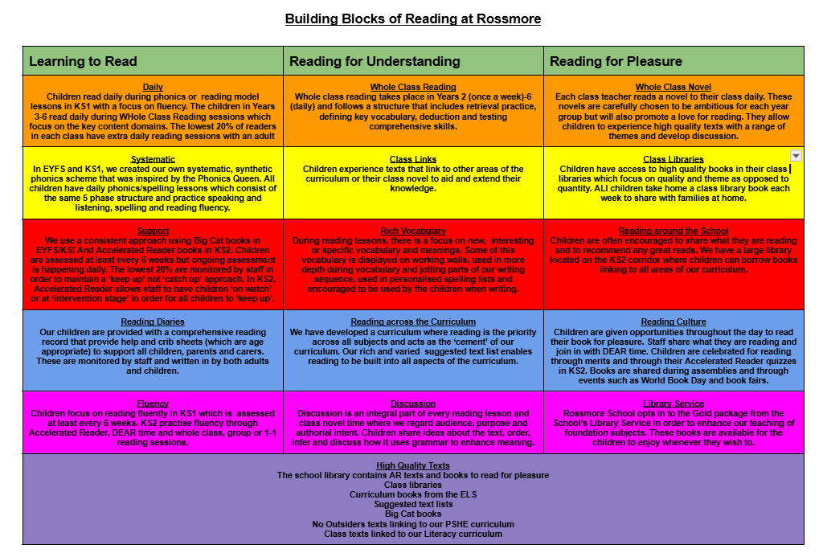

Impact
We will see an increase in rates of progress and attainment in Reading. All children will be successful, confident readers who can apply their skills to many different contexts. All children will have the essential reading skills to transition confidently to the next year group. Children will apply their skills across the whole curriculum so they develop a deeper understanding of a range of subject areas as well as gaining confidence and fluency. Reading responses will be of high quality which will be evidenced in reading journals and pupil voice.

Assessment
Attainment in Reading is measured consistently throughout the year. We use Arbor for our summative assessments and to track progress and attainment. Teachers assess daily reading lessons using objectives from the National Curriculum. Teachers use daily observations and Phonics assessments to challenge children and support them to catch up through targeted interventions. Star Reading assessments are carried out half termly to assess children’s individual reading skills. This is a personalised test as questions are adapted based on children's responses to accurately measure their knowledge and ability. Teachers use both this information as well as termly NFER tests to inform interventions, planning and to ensure the lowest 20% are receiving daily support.

Equal Opportunities and Inclusion
At Rossmore we value everybody equally:

- whether or not they are disabled
- whatever their ethnicity, culture, national origin or national status
- whatever their gender and gender identity
- whatever their religious or non-religious affiliation or faith background
- whatever their sexual identity
- whatever their economic or social background.
We therefore act to ensure that each and every member of the school community:
- experiences equality of opportunity
- feels a full and respected member of the school community
- has high expectations of themselves, their peers, staff, and others with regard to fair treatment
- develops an understanding of race, ethnicity and multiculturalism alongside an appreciation of their importance in Britain today
- develops an understanding and appreciation of disability and the contribution of disabled people in the community and UK
- develops an awareness that disability can be both seen or unseen and that people with learning and other disabilities (eg Autism, Asperger's syndrome) have the same rights to reasonable and appropriate adjustments as those with more obvious needs.

This policy will be reviewed every two years by the English team lead. The Reading and Phonics leads will monitor teaching and learning in the subject at Rossmore School ensuring that the content of the national curriculum is covered across all phases of pupils’ education. Any changes made to this policy will be communicated to all teaching staff.

Date of review: July 2026
Date of next review: July 2028

