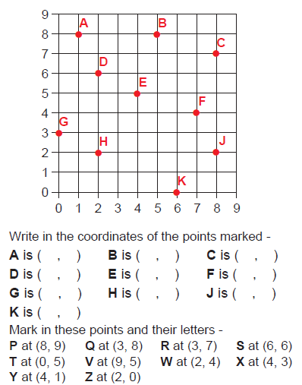
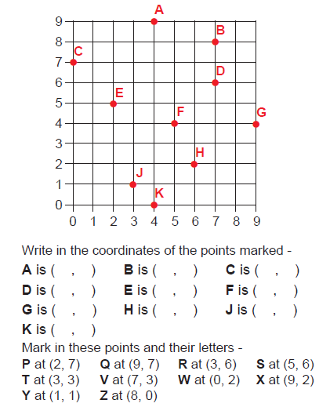
Coordinates in the First Quadrant
2)
1)
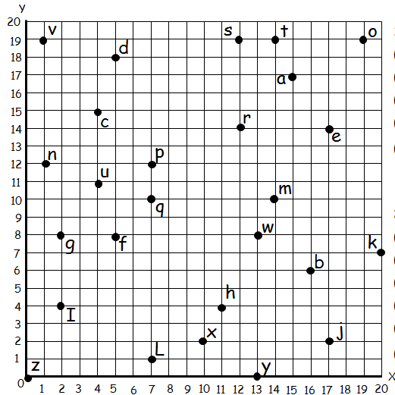
Use the coordinates to find out the artist and song hidden in the grid
(17, 14) (5, 18)
(12, 19) (11, 4) (17, 14) (17, 14) (12, 14) (15, 17) (1, 12)
(12, 19) (11, 4) (15, 17) (7, 12) (17, 14)
(19, 19) (5, 8)
(13, 0) (19, 19) (4, 11)
3)

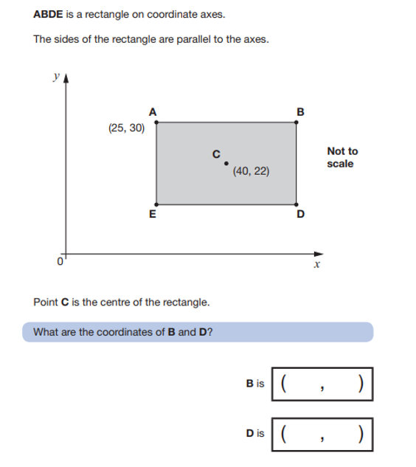
4)

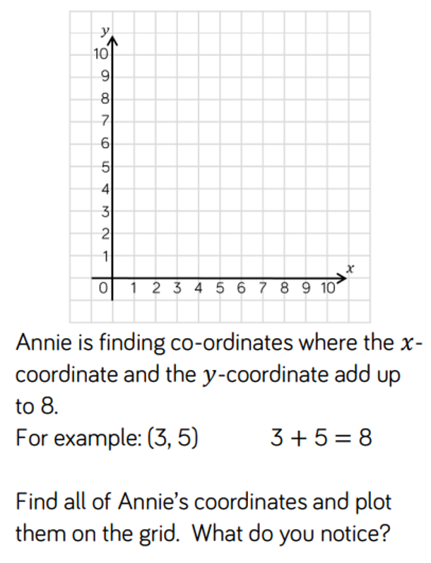
5)

