

Timetables
Create a timetable for a typical weekday before lockdown and a typical weekday during lockdown. Use the grids below or create you own.



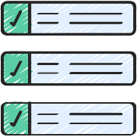
Compare the two timetables, using the following to help:
- What time do you get up? Is it the same/different on each timetable?
- Is your morning routine the same?
- How much time do you spend doing schoolwork on each timetable?
- What time do you go to bed? Do you get more or less sleep on the lockdown timetable?
- Which timetable has the most routine?
- Which timetable would you prefer as your typical weekday?

During lockdown
Before lockdown

Time

Activity

Time

Activity

