VE Day – UKS2
The project this week aims to provide opportunities for you to learn more about the area you live in.
Choose one or more a day to explore. Be creative about how you present your work.
Understanding World War Two  On 8 May 1945 Britain celebrated the end of World War Two. To understand why VE Day was so important, you need to understand WW2. Research what happened during WW2. When did it start? Why did it start? Who fought? Where did fighting take place? What happened during the Battle of Britain? What happened on D-Day? What was rationing? What was evacuation? What happened during the Blitz? You may present this information in any way you choose.  https://www.bbc.co.uk/bitesize/guides/z9s9q6f/revision/1 | Plan your own street party  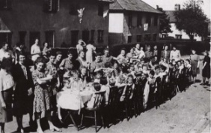  On 8 May 1945, Britain began to rejoice. People ran out onto the streets, church bells rang, bunting and banners were hung up and people brought food to eat at street parties. Plan your own street party. Where would it be? What games would be played? What decorations would be put up? What food would be eaten? | 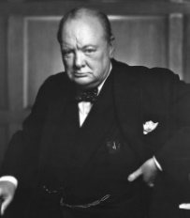  Research Winston Churchill  Winston Churchill was the Prime Minister in 1945. Research and make a fact file about who Churchill was. Consider why he was important, his personality, his family, his hobbies and his jobs.
Postcard task  Write a ‘Postcard from the Past’. Imagine you were at the first VE day and heard the news that the war had ended.  What might you tell your family about what you heard? What did you do? What did you eat? Who else was there? What games did you play? What decorations were made and hung up? Use the link below find out more about VE Day  https://www.bbc.co.uk/teach/class-clips-video/history-ks2-ve-day/z7xtmfr  https://www.bbc.co.uk/teach/ve-day-How-did-the-british-plan-to-celebrate/zndn7nb | Flag task  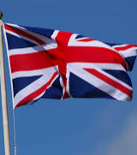  During World War Two, countries that were part of the British Empire fought alongside the British. Some of these countries were: Canada, USA, Bermuda, Jamaica, The Bahamas, Australia, New Zealand, Kenya, Mauritius, Seychelles, Trinidad and Tobago, India and Cyprus. Find and draw the flags for these countries. Can you find other countries that fought alongside the British in WW2 and find and their flags too? | 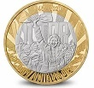  Design your own VE coin or medal  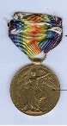  8 May 1945, now known as VE Day, saw the beginning of the end of the Second World War – the conflict that claimed the lives of millions and reshaped the future of countries and continents. The Royal Mint have designed a commemorative coin to remember VE Day. Your task is to design your own commemorative coin or a VE Day medal. You could think about the following ideas when designing yours: the years of the war; the colours of the ally flags or a reference to how the war was fought (land, air and sea).
Remembering VE Day in Crawley  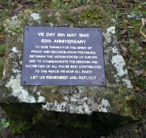  In Tilgate Park in Crawley, there is a memorial plague for VE Day. It says “VE Day 8 May 1945 50th anniversary. To give thanks for the spirit of peace and reconciliation prevailing between the nation states of Europe and to commemorate the heroism and sacrifices of all those who contributed to the peace we now all enjoy. Let us remember and reflect”. Now we are celebrating the 75th anniversary, design your own memorial plague and write your own message on your plague. | Music    To link with VE day we are going to discover some music from the 1930s and 40s. · Listen to the song ‘In the Mood’ and make a list of the instruments that are playing in the Big Band.  - Can you name the most famous Big Band of that time?  - What do you notice they do when it is their turn to play the solo section?  - Research some other songs from this era and make a list. | VE reflections  Now you know more about VE Day, answer these questions to sum up your learning on VE Day.  - Why do you think it is important to celebrate and recognise VE Day?  - How do you think VE Day should be celebrated in the future?

