

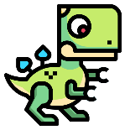
My Favourite Toy

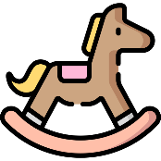
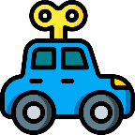

Picture

What is the toy? ___________________________________________

What does it look like? ______________________________________
________________________________________________________

When and where did you get it? ______________________________
________________________________________________________

How does it work or how do you use it to play? ___________________
________________________________________________________

Why is it your favourite toy? _________________________________
_________________________________________________________

