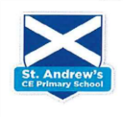
Year 3 Writing Overview 2025-26
 | Autumn 1  8 weeks | Autumn 2  7 weeks | Spring 1  6 weeks | Spring 2  6 weeks | Summer 1  5 weeks | Summer 2  7 weeks
Cross curricular links | Achievements of the earliest civilizations- Ancient Egypt  RE- Multi faith week | UK – Settlements  Geography – Climate change  PHSE- Valuing differences | Overview study of Ancient Civilisations | Geography – Climate change | Changes in Britain from Stone age- Iron age | Climate Zones  RE/Art- Spirited Arts week
Class Novel/Fiction | The Egyptian Cinderella  Shirley Climo  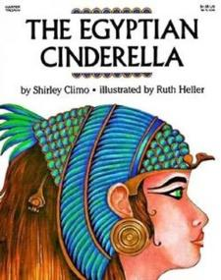  Egyptian Story | Flood  Alvaro F. Villa  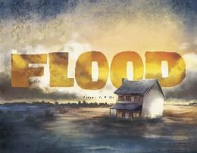  Tragedy | The Sound Collector  Roger McGough  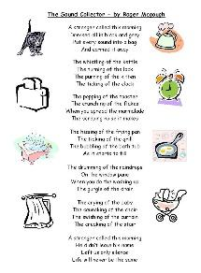  Poetry |  | Stone Age Boy  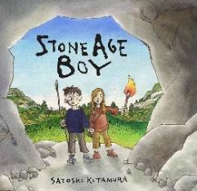  Satoshi Kitamura | The Blue Umbrella  Pixar  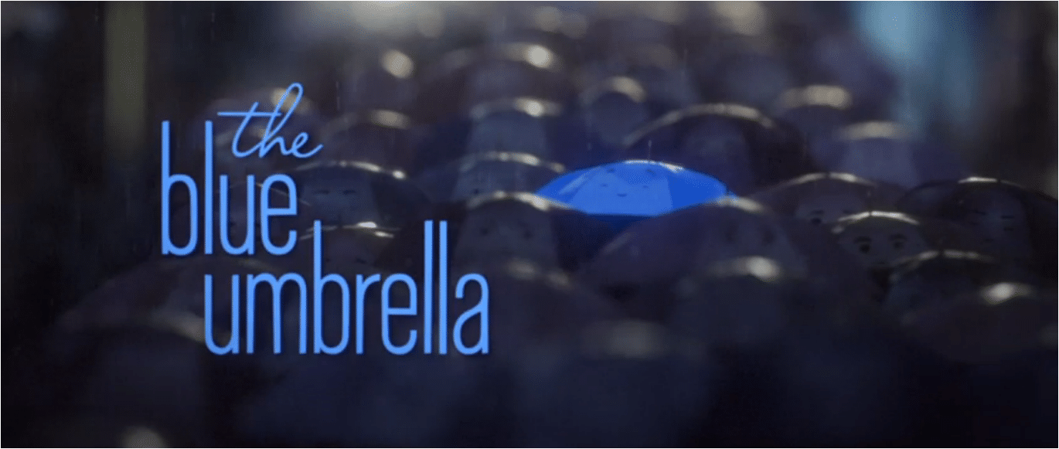  Romance
Class Novel/Non-Fiction | An Anthology of Intriguing Animals  Ben Hoare  Non-chronological  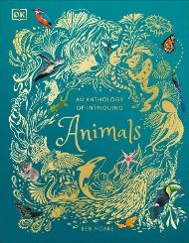  Report | My Strong Mind  Niels Van Hove  Instructions  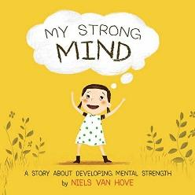 |  | The Gardener  Sarah Stewart  Letter  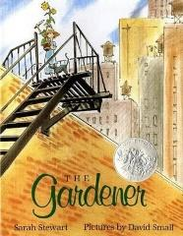  Climate Action  Georgina Stevens  Magazine Article  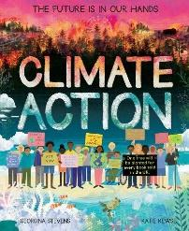
Unit & skills | The Egyptian Cinderella  Traditional Tales  3-4 Weeks  Outcome:  To write a traditional tale based on The Egyptian Cinderella, retelling the story from another character’s point of view.  Skills:  To develop ideas through experience-days that build imaginative engagement (e.g., handling a red-rose slipper as a hook).  To identify and use key traditional-tale features such as magic, setting, good and bad characters, and a happy ending.  To explore and reuse vocabulary-rich language from the text—especially expanded noun phrases, prepositional phrases, and similes—to enhance description.  To plan writing using narrative structure tools (e.g. story maps or plot points): clear setting, characters, problem, and solution  To express time, place, and cause using conjunctions, adverbs, and prepositions in structured sentences.  To punctuate direct speech accurately with inverted commas in context and dialogue writing. | Assessment Week  Flood  Tragedy Narrative  3–4 Weeks  Outcome:  To write a tragedy narrative inspired by Flood, exploring the emotional journey of a family affected by a natural disaster.  Skills:  To explore and collect emotive and atmospheric vocabulary to convey mood (e.g. fear, tension, loss, hope).  To use expanded noun phrases and prepositional phrases to describe setting and weather effects.  To create tension through sentence variety – short, dramatic sentences alongside longer descriptive ones.  To use fronted adverbials to signal time, place and cause.  To write in the past tense, maintaining consistency throughout.  To punctuate direct and reported speech accurately to show reactions and dialogue.  To organise ideas into clear paragraphs: build-up, event, aftermath, resolution/reflection.  To use conjunctions to express cause and effect (because, so, therefore, as a result).  To edit writing for impact – focusing on vocabulary and sentence rhythm to enhance tragedy. | The Sound Collector  Poetry  2–3 Weeks  Outcome:  To write a poem inspired by The Sound Collector, using sound-based imagery to create atmosphere and mood.  Skills:  To listen to, read, and respond to the poem, identifying its structure, rhythm, and rhyme.  To collect and use onomatopoeia, alliteration, and repetition to create sound effects.  To use expanded noun phrases and adjectives to add vivid detail.  To experiment with line breaks, stanzas, and white space for effect.  To use similes and personification to enhance imagery.  To sequence ideas in a logical or thematic order (e.g., sounds of home, school, or nature).  To read poetry aloud with appropriate intonation, tone, and volume for performance.  To draft, edit, and refine poems for rhythm and impact. | Assessment Week  The Gardener  Letter Writing  2–3 Weeks  Outcome:  To write an informal letter inspired by The Gardener, expressing feelings and recounting events in a personal voice.  Skills:  To identify the features of a letter: address, date, greeting, paragraphs, closing/sign-off.  To write in the first person and use past tense to recount events.  To include emotive language to express feelings and opinions.  To use fronted adverbials (with commas) to organise time and place.  To expand noun phrases to add detail and description.  To use conjunctions to extend ideas and show cause and effect (because, so, therefore).  To punctuate sentences accurately with commas in lists and apostrophes for possession.  To organise writing into paragraphs that follow a logical sequence (introduction, main message, closing).  To proofread for grammar, spelling, and punctuation accuracy before sending. | Stone Age Boy  Narrative Writing  3-4 Weeks  Outcome:  To write a narrative inspired by Stone Age Boy, using a clear structure, imaginative detail, and a strong sense of character and setting.  Skills:  To plan their story by talking about what will happen in each part.  To experiment with different words and phrases when describing characters, places, and actions.  To write sentences in order to build a story that makes sense from beginning to end.  To use simple dialogue to show how characters feel or react.  To add details about what characters see, hear, or do to make the story vivid.  To read back their writing and check that it makes sense and sounds interesting.  To share ideas with a partner or teacher to improve the story before writing more.  To make changes to their writing, adding words or sentences to make it clearer.  To read their finished story aloud with confidence, showing expression and clarity. | Assessment Week  The Blue Umbrella  Narrative Writing / Storytelling  3 -4 Weeks  Outcome:  To write a story inspired by The Blue Umbrella, focusing on character, emotion, and descriptive settings.  Skills:  To talk through their story ideas before starting to write.  To plan the sequence of events and decide what happens at the beginning, middle, and end.  To describe characters’ feelings and actions using precise and imaginative words.  To write sentences in order, building a story that flows logically and engages the reader.  To experiment with short dialogue or thoughts to show what characters are thinking.  To include details about the setting, using what they see, hear, or imagine to create mood.  To read back their writing to check it makes sense and captures the story’s emotion.  To read their finished story aloud with expression, making the characters and events come alive.
 | An Anthology of Intriguing Animals  Non-chronological Report  3–4 Weeks  Outcome: To write an informative non-chronological report about a chosen animal, inspired by An Anthology of Intriguing Animals.  Skills:  To explore and collect rich, subject-specific vocabulary from the text to describe appearance, habitat, diet, and behaviour.  To identify the key features of a non-chronological report: headings, subheadings, paragraphs, fact boxes, and diagrams.  To use organisational devices to structure information effectively.  To use a range of sentence types including statements, questions, and exclamations for engagement.  To write in the present tense and third person, maintaining a formal and informative tone.  To use fronted adverbials to sequence and organise information.  To expand noun phrases to add precision and detail.  To use possessive apostrophes accurately.  To proofread and edit writing for clarity, accuracy, and audience appeal.  . | My Strong Mind  Instructions  2–3 Weeks  Outcome: To write a clear and engaging set of instructions inspired by My Strong Mind, helping others develop positive habits for a resilient mindset.  Skills:  To identify and use the key features of instructions: title, introduction, numbered steps, bullet points, imperative (bossy) verbs, and clear layout.  To collect and use subject-specific vocabulary linked to mindfulness and positive habits.  To write in the present tense and second person (you) to address the reader directly.  To use time adverbials (first, next, after that, finally) to sequence steps.  To use conjunctions for clarity (and, but, so, because).  To include adverbs to show how actions should be carried out (carefully, slowly, calmly).  To use commas in a list correctly.  To organise writing with clear sections and appropriate layout devices (subheadings, bullet points, diagrams if needed).  To proofread and edit for clarity, accuracy, and ease of following the instructions. |  | Climate Action  Magazine Article  2–3 Weeks  Outcome:  To write a magazine article inspired by Climate Action, presenting information persuasively and engaging readers with facts, opinions, and solutions.  Skills:  To identify and analyse the key features of a magazine article: headline, introduction, subheadings, paragraphs, images/captions, conclusion, and call to action.  To write in a formal yet engaging voice, appropriate for a magazine audience, balancing facts and opinions.  To summarise and paraphrase information from a source text while maintaining accuracy.  To use persuasive techniques such as rhetorical questions, emotive language, and direct address to engage the reader.  To organise ideas logically using paragraphs that move from general information to specific examples and solutions.  To use fronted adverbials and cohesive devices to link ideas and guide the reader through the article.  To expand noun phrases and use precise subject-specific vocabulary (e.g., climate change, carbon footprint, renewable energy) to add clarity and impact.
Writing opportunities | Scaffolded  Diary Entry: Write as an Egyptian child describing daily life along the Nile, including chores, festivals, or schooling.  Independent  Information Text: Research a pharaoh, god, or animal sacred in Ancient Egypt and present facts for a classroom magazine. | Scaffolded  DT: Instructions how to make Pheumatic toys.  Independent  Trip Recount  Christmas poems  Nativity story | Scaffolded  Music: Tap, Clap, Click  Independent  Group work:  Group poem to present in front of the class. | Scaffolded  Persuasvie Poster  Write short, punchy sentences to persuade people to save energy, reduce waste, or plant trees.  Independent  Recycled Material Art | Scaffolded  Iron Age Assembly  Story:  Imagine being a villager in an Iron Age settlement—describe daily life, tools, or festivals.  Independent  Tatton Park trip recount  Brochure for Tatton park | Scaffolded  Features of a city.  Mystery stories  Newspaper reports  Independent  Fact file for my new teacher
Enrichments | Bolton Museum - Ancient Egyptian TBA  Jewish Musuem TBA | Create an Egyptian mask (Instructions)  Book Fair | Children’s Mental Health Week  Comedy Workshops | World Book Day  Shakespeare Company TBA  Y3 Community cleanup stall TBA |  | Spirited Arts Week  Book Fair

