
The3churches Easter Sunday bulletin for Croston, Bretherton & Mawdesley w Bispham


Brothers and sisters
Under these very testing times I hope that you are able to keep safe and well. There can be no doubt that we are living through extraordinary times – all our routines have been turned upside down - we can’t socialise, meet friends and family in the normal way – so we must adapt to a new way of life and we are all used that mantra from Government now – Stay home- Protect the NHS – Save Lives - and it’s so important that we all follow that very simple and straightforward advice. At this very challenging time it can be all too tempting to become negative, even fearful of what the future may hold and that is quite normal but we mustn’t let that fear be all consuming.
It must have been a fearful time way back when Jesus’s friends who had followed him during Holy Week, who had seen all their hopes of Palm Sunday turn to jeers of rejection, humiliation, trials, pain, suffering and even the death of the very one who was to be their liberator.
So as we sing alleluia on Easter Day it will be a very strange feeling for us all I expect, perhaps even tinged with fear as we reflect upon the staggering number of deaths recorded each day.
The women who ran to the tomb that first Easter morn were right to be afraid for they did not understand what was happening – their world had been turned upside down by the death of Jesus and now an empty tomb!
But in the midst of all this turmoil they were given a commission to spread the news. And no safety for us either, if the light pierces through our lives and into our hearts today, but a life committed to the truth. Perhaps we should be more afraid, in order to hear the risen Jesus speaking to us: “Do not be afraid; go and tell.”
It’s ok for us to be worried and fearful about what the future may hold for us – we are after all only human and it can also be a time when we might question even our faith in God.
All that’s ok because whatever the state of our faith in God, thankfully we can be sure that God has faith in us. To all who are in despair, to all who are caught by guilt, to all who doubt, here and in all the world, the message of the resurrection is this: God’s love is stronger. Even death cannot defeat God, then anything is possible for God. There is always hope, there is always a future to look forward to, because God’s love is stronger even than death itself, and that is where our hope lies.
So at this unusual Easter time may our hope in the risen Christ transform you, may the love of the risen Christ give you peace and may your faith in the risen Christ strengthen you this and every day. Amen
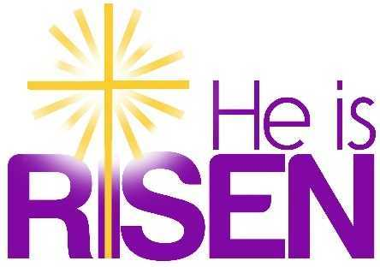
With love and prayers at this Easter time, but remember
stay home, protect the NHS, and save lives.
Jesus has done that for us we must do that for one another.
Michael (Rector)
Tel: 01772 600548 mobile: 07960309005,
email: revmwoods@gmail.com

Coronavirus Village support groups
Croston COVID-19 Croston Village Support Group
Mawdesley Mawdesley - Coronavirus help each other out.
Bretherton Via Bretherton WI (01772 601495)
email bethertoonwi@btinternett.com
Facebook Pages
There will be a Worship Video on Sunday mornings at 10 am and during Easter week there will be worship every day at 7 pm using the night prayer resource on the Church of England Website at:
https://www.churchofengland.org/prayer-and-worship/join-us-service-daily-prayer
Or you can download the ‘Daily Prayer’ App to your phone or tablet.
https://www.facebook.com/St-John-the-Baptist-Church-Bretherton-439088266487676/
https://www.facebook.com/StMichaelAllAngelsChurchCroston/
https://www.facebook.com/St-Peters-Mawdesley-w-Bispham-442669382795886/?ref=bookmarks

Resources - Easter
Attached to this email are:
1)The prayer and worship at home for Easter Sunday which includes some daily readings
2) The 3 readings for Easter Sunday that we would have on our normal pewsheet.
3) Our usual Easter Holy Communion order of service
(we may need this for some time to come)

#LiveLent: - This should continue through Easter (it might get renamed)
Daily reflections / resources will continue to be posted on Facebook.

