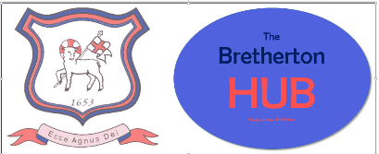
ICT Acceptable Use Policy (AUP) – Visitors

To be signed by any adult working in the school for a short period of time.
This includes student teachers, supply teachers, volunteers, visitors, etc.

1. I will take responsibility for my own use of any technologies, making sure that I use them
safely, responsibly and legally.
2. I will not browse, download/upload or distribute any material that could be considered
offensive, illegal or discriminatory.
3. I will not use any external device to access the school’s network e.g. pen drive.
4. I will respect copyright and intellectual property rights.
5. I will ensure that images of children and/or adults will be taken, stored and used for professional purposes in line with school policy and with written consent of the
parent/carer or relevant adult. I will not distribute images outside the school network without the prior permission of the parent/carer, or person/s in the image. Permission can only be given by the Head Teacher/Deputy
6. I will abide by the school’s rules for using personal mobile equipment, including my mobile phone, at all times.

- visitors will not use mobile phones or other similar electronic devices during their visit unless agreed by the headteacher or DSL.
- Mobile phones must not be out within school in any area children are present or could be present. Preferably, they should be kept in a closed bag or handed into the office.

7. I understand that network activities and online communications are monitored, including
any personal and private communications made using school systems.
8. I will not install any hardware or software onto any school system.
9. I understand that these rules are designed for the safety of all users and that if they are not followed, school sanctions will be applied and disciplinary action taken.

User Signature

I have read and agree to follow this code of conduct and to support the safe use of ICT
throughout the school.

Signature …………………………..………………….………………………………………………………………………..
Date …………….…………….…………………………………………………………………………………………………...
Full Name ………………………………..………………………………………………………………..………… (PRINT)
Position/Role ……………………………………………………………………………………..…………………………….

