Bretherton Endowed Primary School
South Road, Bretherton. PR26 9AH
01772 600431
Bursar@bretherton.lancs.sch.uk
Head@bretherton.lancs.sch.uk

Key People
We are committed to safeguarding and meeting the needs of all our children including under the Prevent strategy.
Any allegations or concerns should be reported to the Head Teacher or in her absence the Assistant Head Teacher.
If the concerns are about the Head Teacher, please inform the Chair of Governors.
Designated Safeguarding Lead and Prevent Lead
Mrs J Clarke Head Teacher
Designated Safeguarding Deputy
Mrs R Gardiner, Mrs S Allchurch
Mrs S Allchurch
Chair of Governors
Mrs Pam Aspden

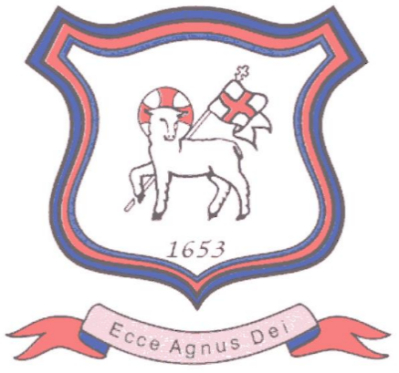
Parent Brochure on Bretherton Endowed’s Prevent Duty

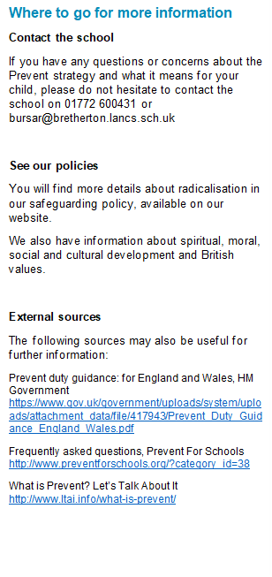
What is the Prevent strategy?
Prevent is a government strategy designed to stop people becoming terrorists or supporting terrorist or extremist causes.
The Prevent strategy covers all types of terrorism and extremism, including the extreme right wing, violent Islamist groups and other causes.
How does the Prevent strategy apply to schools?
From July 2015 all schools (as well as other organisations) have a duty to safeguard children from radicalisation and extremism.
This means we have a responsibility to protect children from extremist and violent views the same way we protect them from drugs or gang violence.
Importantly, we can provide a safe place for pupils to discuss these issues so they better understand how to protect themselves.

Frequently Asked Questions
How does Prevent relate to British values?
Schools have been required to promote British values since 2014, and this will continue to be part of our response to the Prevent strategy.
British values include:
- Democracy
- The rule of law
- Individual liberty and mutual respect
- Tolerance of different faiths and beliefs
Isn’t my child too young to learn about extremism?
The Prevent strategy is not just about discussing extremism itself, which may not be appropriate for younger children. It is also about teaching children values such as tolerance and mutual respect.
The school will make sure any discussions are suitable for the age and maturity of the children involved.
Is extremism really a risk in our area?
Extremism can take many forms, including political, religious and misogynistic extremism. Some of these may be a bigger threat in our area than others.
We will give children the skills to protect them from any extremist views they may encounter, now or later in their lives.

Updated Sept 2026
KEY TERMS
Extremism – vocal or active opposition to fundamental British values such as democracy, the rule of law and tolerance of different faiths and beliefs
Ideology – a set of beliefs
Terrorism – a violent action against people or property, designed to create fear and advance a political, religious or ideological cause
Radicalisation – the process by which a person comes to support extremism and terrorism

What does this mean in practice?
Many of the things we already do in school to help children become positive, happy members of society also contribute to the Prevent strategy.
These include:
- Exploring other cultures and religions and promoting diversity
- Challenging prejudices and racist comments
- Developing critical thinking skills and a strong, positive self-identity
- Promoting the spiritual, moral, social and cultural development of pupils, as well as British values such as democracy
We will also protect children from the risk of radicalisation, for example by using filters on the internet to make sure they can’t access extremist and terrorist material, or by vetting visitors who come into school to work with pupils.
Different schools will carry out the Prevent duty in different ways, depending on the age of the children and the needs of the community.

