Class 2 pupil questionnaire
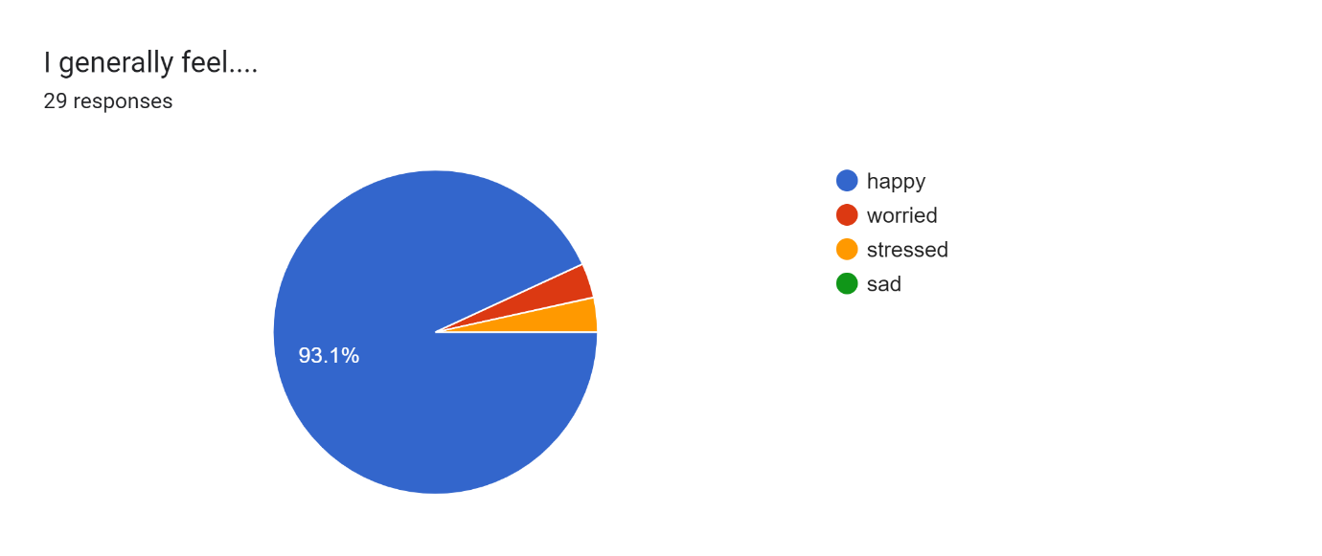
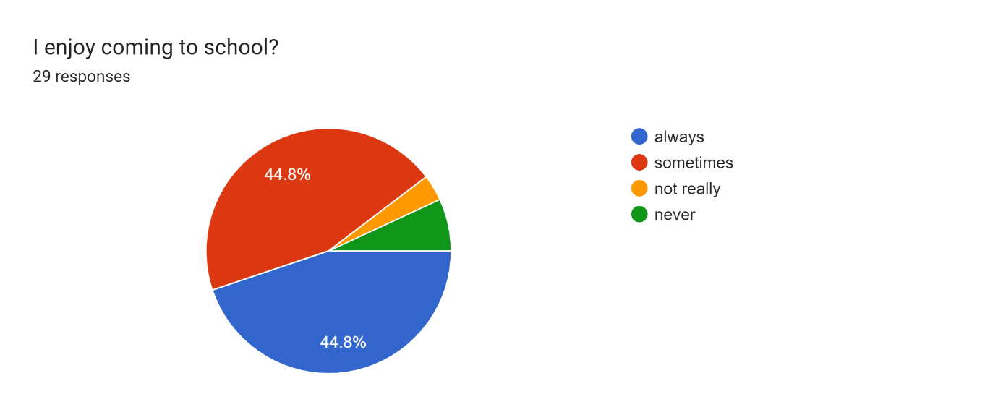
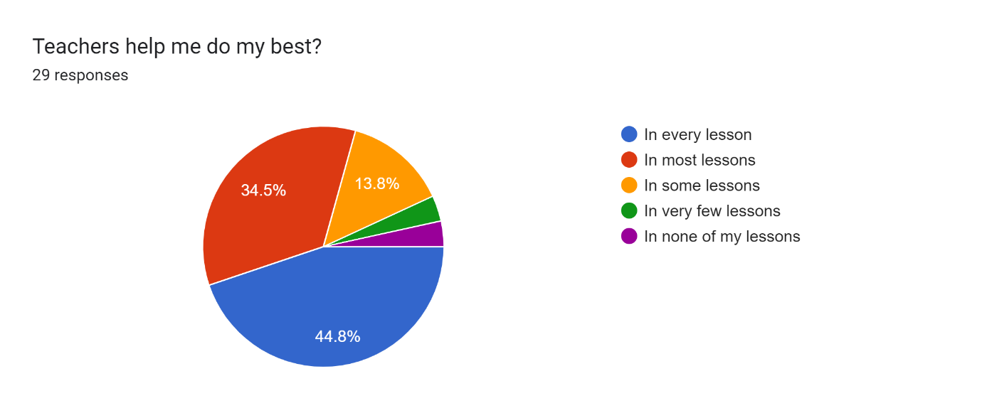
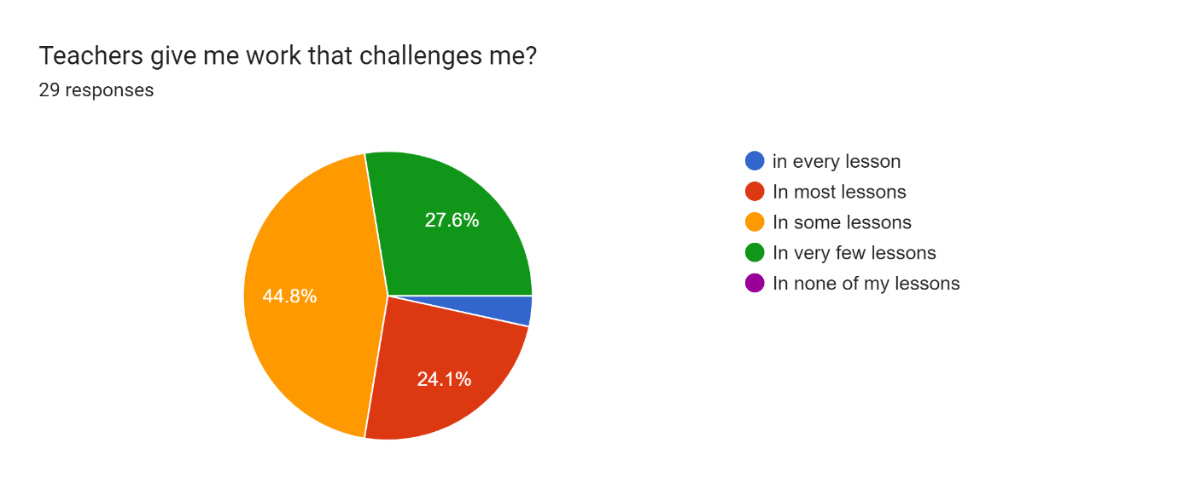
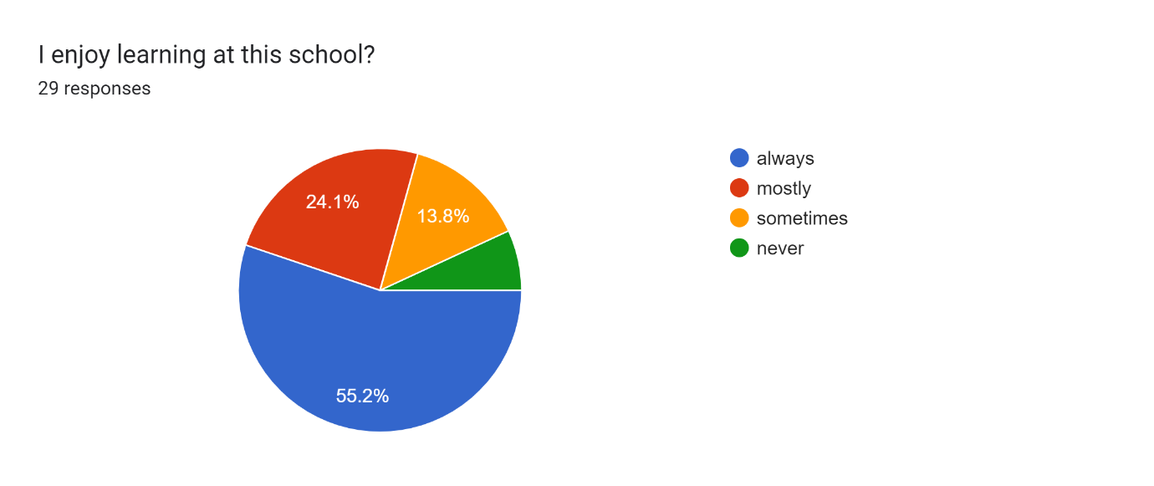
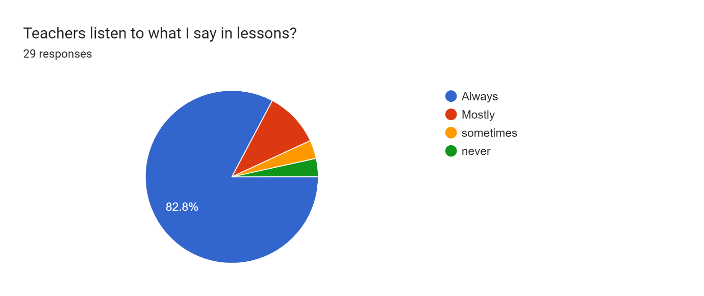
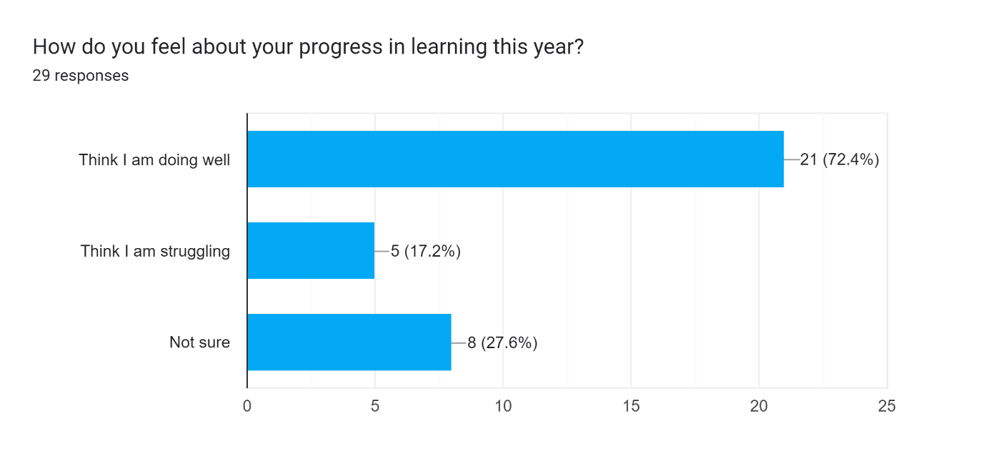
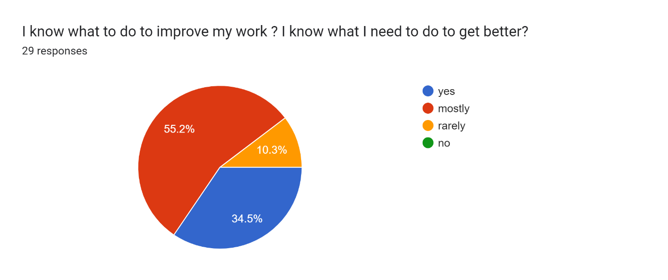
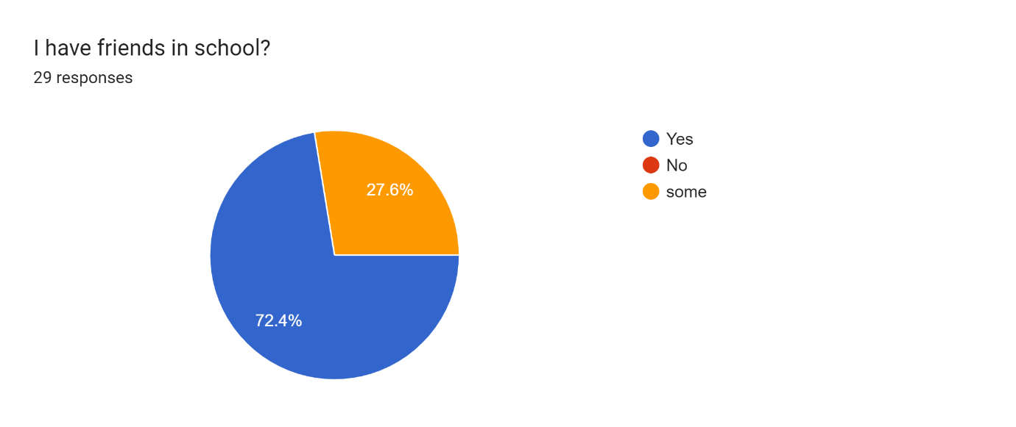
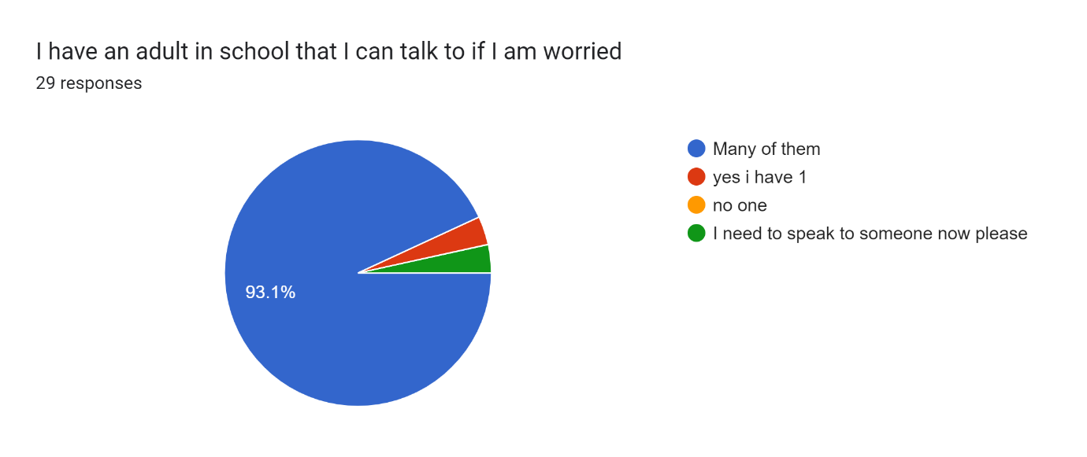
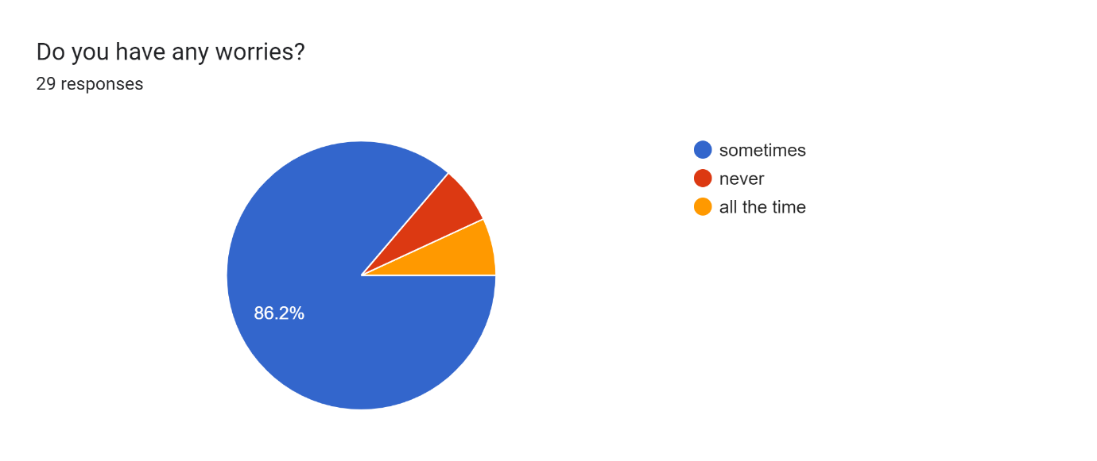
Do you feel that you are listened to in school? if no when are we not listening?29 responses
yes
Yes
yes
Im listened to
all the time .
every lesson in school
mostly.
yes I do.
yes always.
most of the time yes
yes they lissn
yes I feel listened to in school my friend and teachers.
I feel that I am listened to in school.
yes always
Yes I feel that I'm listened to in school
I don't realy know
yes i am listend to.
sometimes in school.

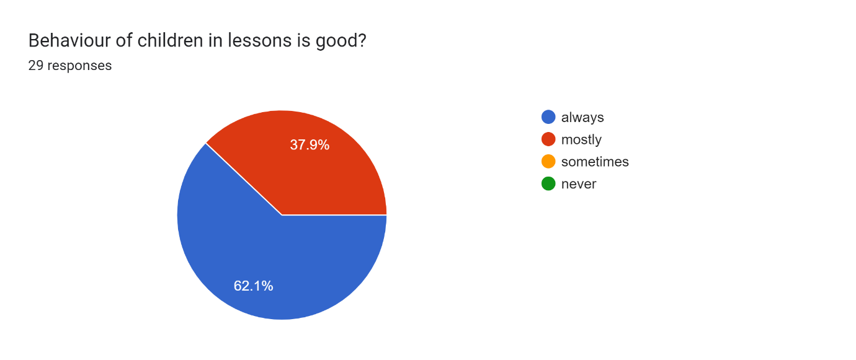
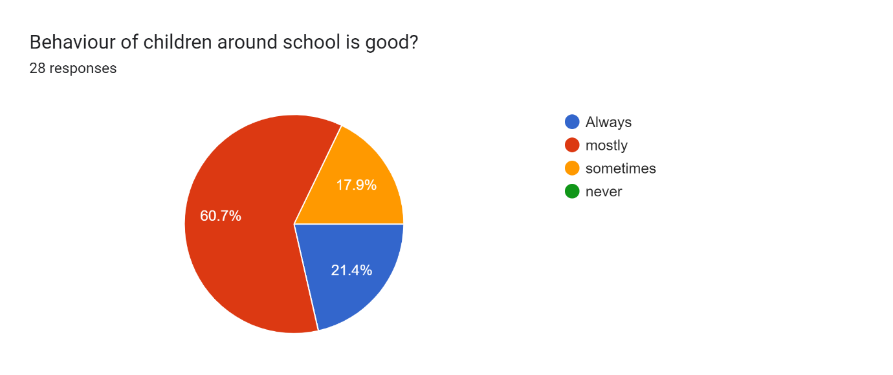
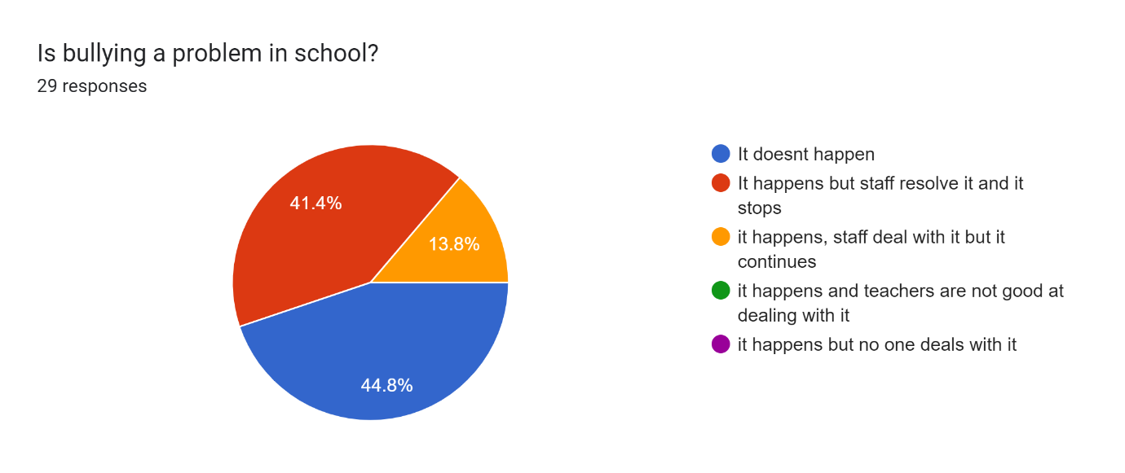
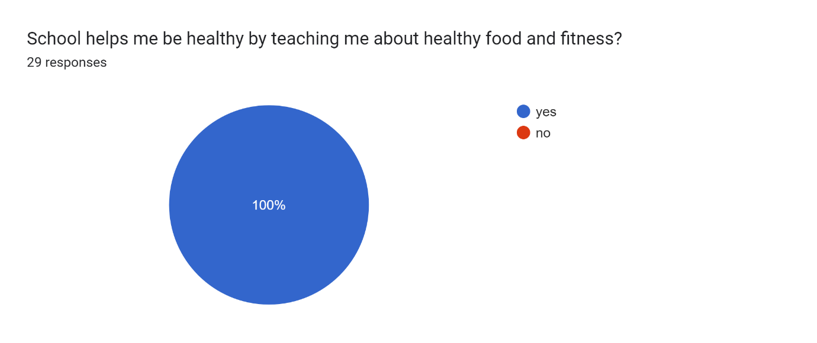
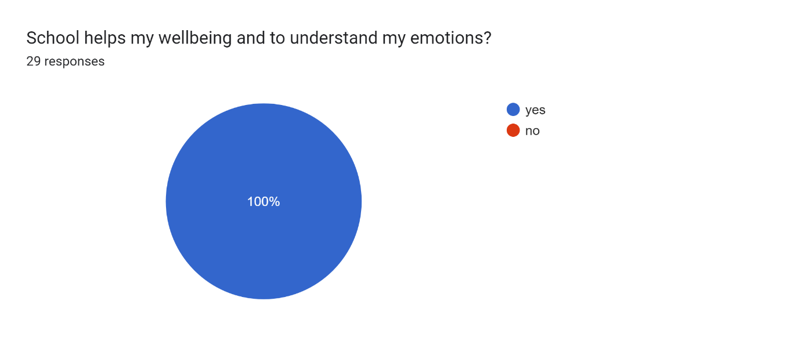
How does school help you with your wellbeing?28 responses
by calming me down
because they make me happy
yes
by my friends.
be helfey
They talk to us about
yes because they teach me how to be kind.
They will talk privatly with you
By learning
They teach me not to be worried about my emotions.
it helps me by using the chime in PSHE.
because the pshe lessons can help us to calm down like the chime
It makes me happier and joyful.
they help with my emotion
they say not to be worried.
yes a lot
they hellp mea
School helps me to read and understand things.
Kindness
School respects my
by asking if you are okay and sometimes talks with us.
we have P.S.H.E to calm us down
School would help me by calming me down.
yes by helping us
look after me and help me calm down.
we can talk to a teacher and they can help us .
They would calm us down.
They make me feel calm.

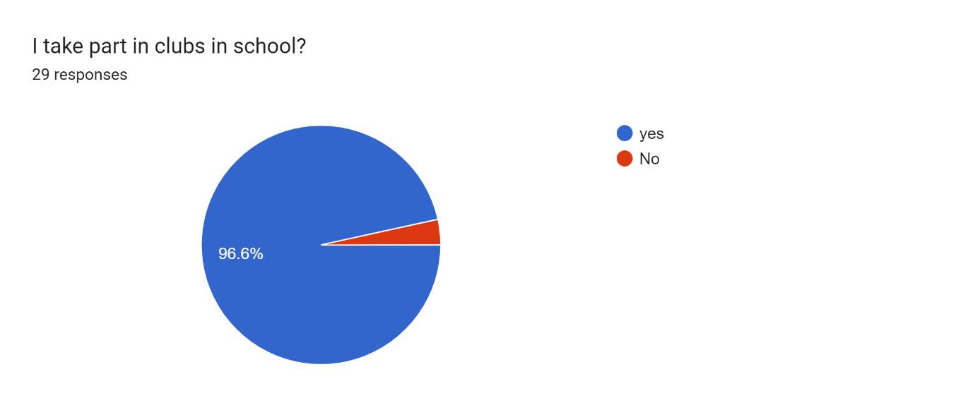
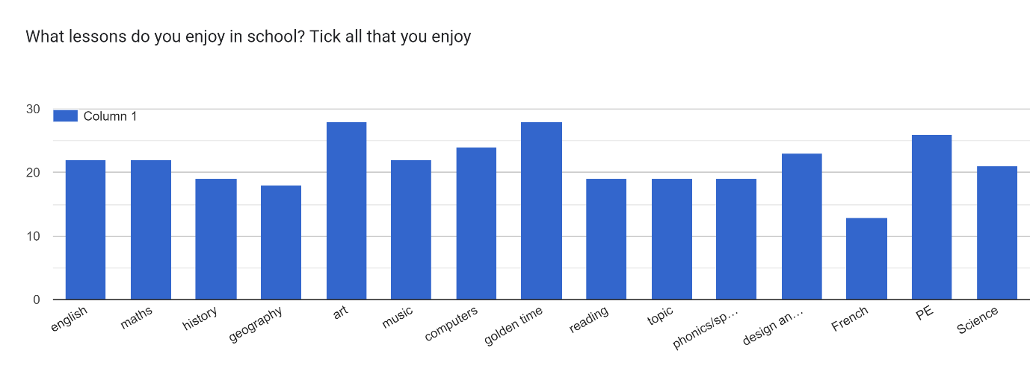
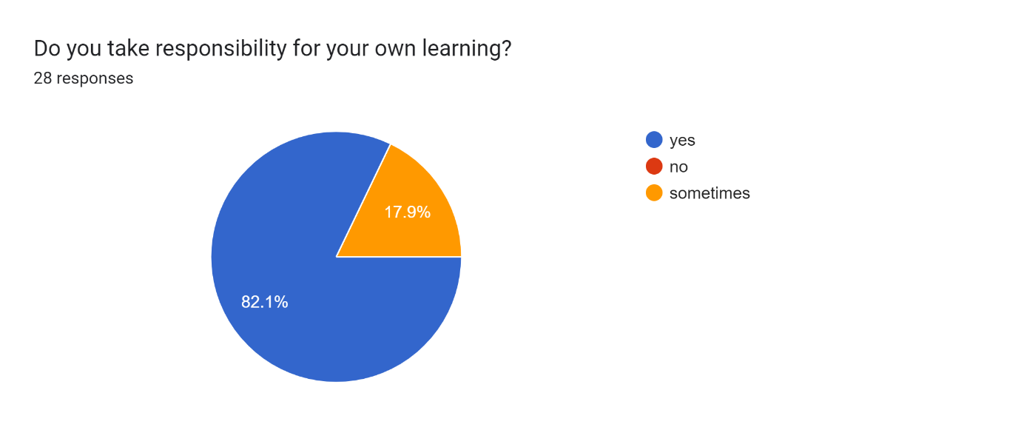
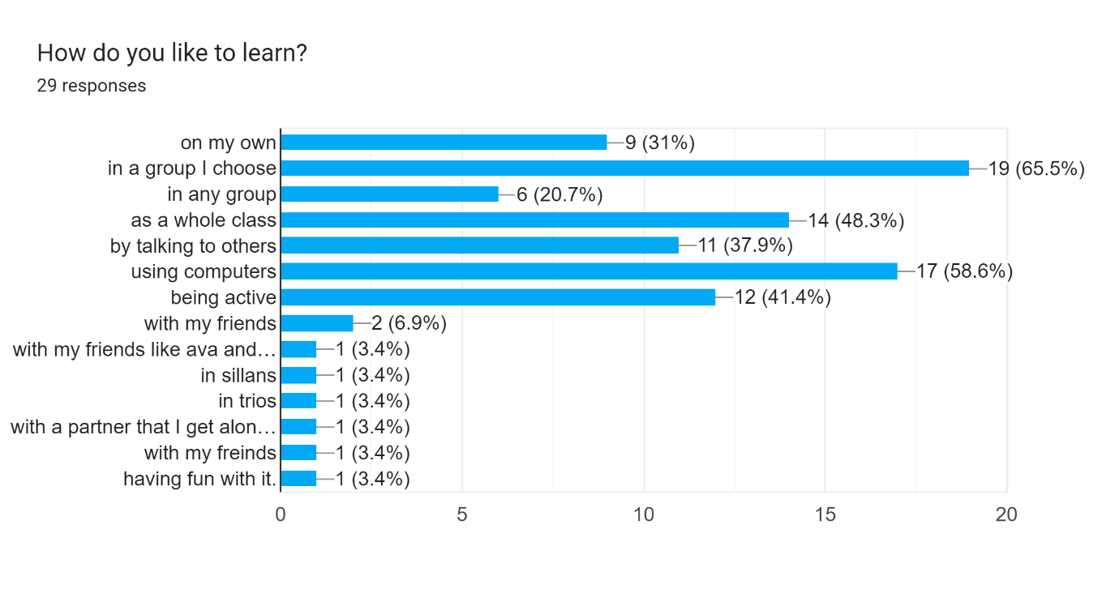
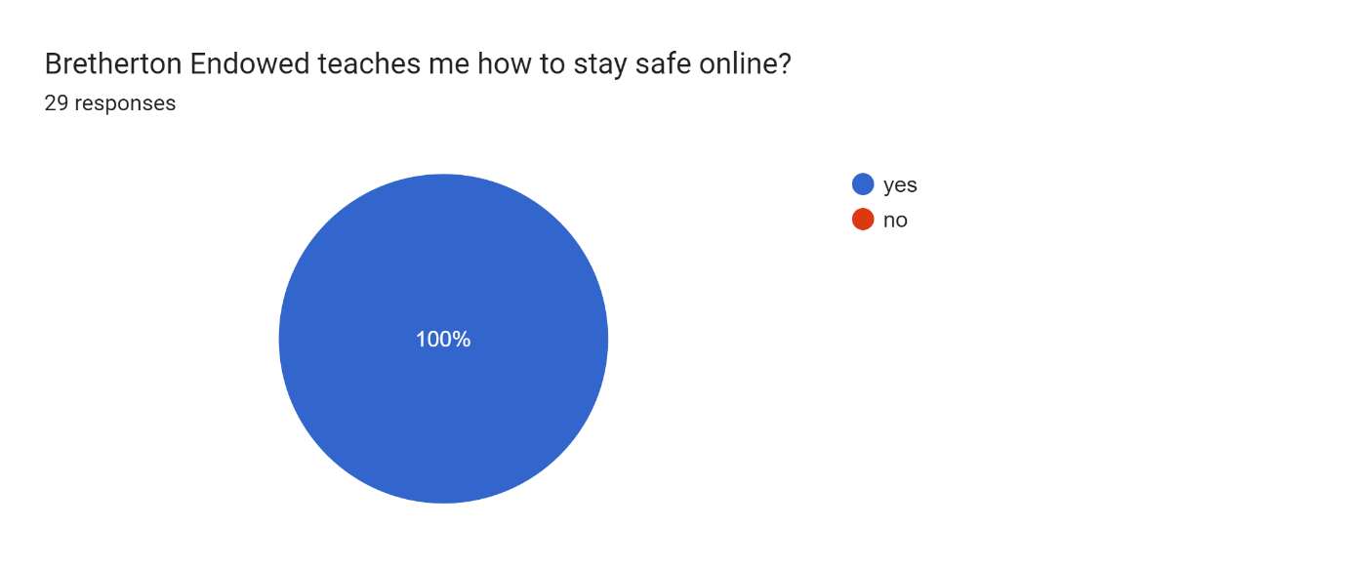
Do you have a job in school and if not why not and what would you like to do?28 responses
I do fairtraid and I am allso a frut moniter
yes white bord
staking chair's
dowing robos
yes I do register
ethos because I like sorting things out
chair monitor
I am school cansul and book moniter
yes and I would like ethos
school council and white board pens.
I do not like standing up on stage I would not like to be in a job but I have a class job as water bottle moniter
yes I am am a book monitor so people can work
Yes I normaly be register.
register monitor and book
echo council and pencil pots.
yes defenitly like phonics cards and fairtrade
I am a libarry moniter and a char staker
library monitor
chairs
I do and they are very fun
i do library monitor school council
Yes I have a job
I do School council and pen monitor.
science
I do pencil pots but as well want to do chairs as well as pencil pots.
tidy the corridor monitor
yes i am a book moniter and a science ambassador .
Im a school council.

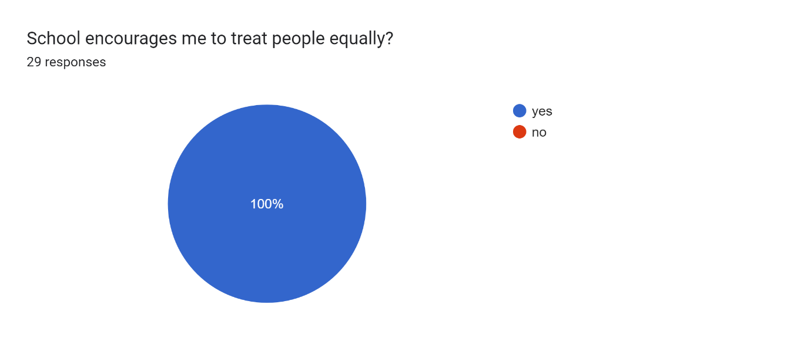
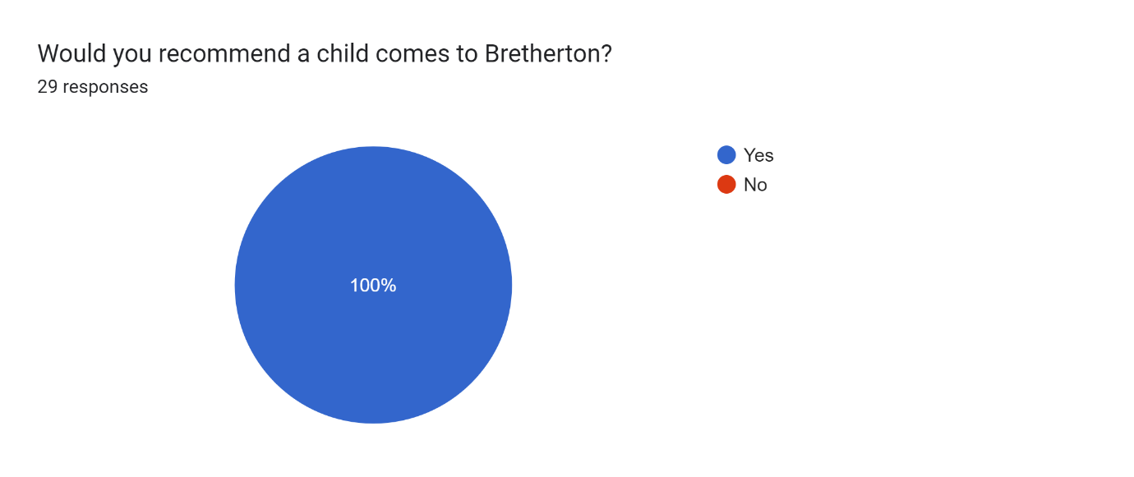
What would you like to tell us about your learning in school?28 responses
i like learning about the romans
I don't rially get when you read some thing and you get the anser
fun
yes
that it is good
I like P.E
I love learning art
It is very good.
I like ever sbject
I am worried about moving up into high school
That i struggle a bit.
It's great!
I quiet like the working with what we do
My favroite is the Romans and Celts.
it is great
It is amazing and we are learning about the Lake district
i find it kinda hard in maths
I like einglish and maths the best
I love learning here because you make it as fun as possible.
maths is good
I like it all because it chalenges me
My favriout subjects are maths , English , french and art .
I find maths chalenging
My faivrote subject
it is to easy
that it's fun.
I love it i love art .
I enjoy art and science.

Any ideas on how to improve your learning opportunities?24 responses
no
push me on my writing
with a little bit of help with tring to do chaling things
no
better hand writing
Not realy
No.
Practis
More R.E.
no it's perfect.
More time to do handwriting and maths.
by using counters
werk at home
kinda good
NO I do not
No school is amazing the way it is
having fun with it.
i have no ideas to do
Consantrate

Any other comments13 responses
no
I just wan't to get a nother subject to lern abowt
schools fun
school is fun
thank you
I LOVE SCHOOL
Thank you for all that you have done.
yes i think bretherton school is really good
thank you for these great lessons.
I would like to have a gym club and a coloring club
This school is my most fairvrote school in the whole wide world
no.

