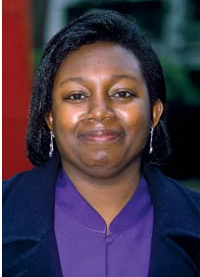
"Reading is an exercise in empathy; an exercise in walking in someone else’s shoes for a while." —Malorie Blackman
This quote is so true. Through reading books, we can get such an insight into people’s lives. This year Norwood have invested in the school’s library nooks, ensuring that books cover topics such as autism, refugees, race, religion, family lives and gender. In order for us to develop empathy, we need to learn about the barriers of others. Reading allows us to break these down and help us all to become more understanding and empathetic to the world we live in.
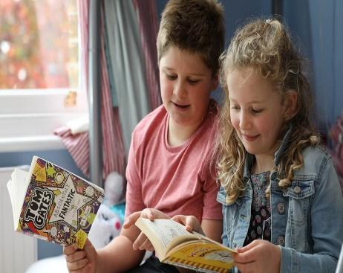
Malorie Blackman is an English children’s author. She writes young adult and children’s novels, short stories, and picture books. She was named the United Kingdom’s Children’s Laureate in 2013.
Support at home
Encouraging a love of reading
This is Norwood’s BIG push this year. We want our children to WANT to read and with your help, we hope to achieve it.
As children get older, with lots of other activities competing for their time, we know that it becomes a struggle to encourage them to make time for reading. Here are some ideas:
- Read yourself! It doesn’t matter what it is – pick up a newspaper or magazine, take a look at a cookery book, read a computer manual, enjoy some poetry or dive into a romance or detective novel. And get your children to join in – if you’re cooking, could they read the recipe? If you’re watching TV, can they read out the listings?
- Give books as presents. And encourage your children and their friends to swap books with each other – it’ll give them a chance to read new stories, and get them all talking about what they’re reading.
- Visit the local library together. It’s always fun choosing new books to read, and keep an eye out for special author events at the library or local bookshops – children love meeting their favourite authors. Jacqueline Wilson and Anthony Horowitz always have signing queues that are miles long!
- Encourage children to carry a book at all times. That way, they’ll never be bored (this is something you can do, too!)
- Have a family bookshelf. If you can, have bookshelves in your children’s bedrooms, too.
- Keep reading together. Just because your children are older, it doesn’t mean you have to stop sharing stories – perhaps you could try the Harry Potter series or A Series of Unfortunate Events.
- Don’t panic if your child reads the same book over and over again. Let’s be honest - we’ve all done it!

Celebrating Reading at home
Each month, we try and share our literary days with you through Dojo. We hope you celebrate these days at home with your children. Please share any work with your class teacher and earn some extra Dojos.
Autumn Term
September
Read a book day - 06.09.
National Comic Book day - 25.09.
October
Myths and Legends day - 11.10.
Dictionary day - 16.10.
November
National family literacy day - 01.11.
National Non-Fiction day - 04.11.
December
Read a new book month - December
Crossword Puzzle Day - 21.12.

Reading skill – Fluency. What does this mean and how can you support at home?
Here is the definition of fluency - Fluency is defined as "the ability to read connected text rapidly, smoothly, effortlessly, and automatically with little conscious attention to the mechanics of reading, such as decoding" (Meyer and Felton, 1999, p. 284).
Sound fun? It is! In far simpler terms, fluency means that your child can read without having to sound out and stop whilst reading. It is the bridge to great comprehension. In other words, the more fluent the Reader the better their comprehension skills.
Fluency training is something all parents can do for their child. It requires little time, minimal expertise, and it invariably works. Fluency develops gradually over time and through substantial practice. A good way to help motivate your child is to use material that is of interest to him. There are many situations in which reading aloud can occur every day (e.g., singing a sound, telling a joke, giving a speech).
Here are some helpful tips to target, as well as maximise, reading fluency to practice at home:
- Select books that are at the child’s reading level so he feels comfortable reading independently.
- Read aloud to your child to provide a good example of fluent reading. Consider reading material that is just beyond their level. Your child will not only enjoy listening to a good model, but it will also foster language development and reading comprehension. Be sure to make it fun by using an expressive voice and intonation.
- Partner Reading - You and your child take turns reading. Be sure to select reading material that is at your child’s success level. You are the model for both fluency and personal expression.
- Choral Reading - You and your child read together at the same time. You should be slightly ahead (i.e., a couple of milliseconds) of your child. Even though it appears that the reading is happening simultaneously, you are actually leading and your child is following. Choral reading allows your child to build up his sight words as he associates the correct pronunciation with each written word. The pace should be slow, yet fluent, for the initial reading.
- Repetition - Once you have complied reading material, encourage your child to reread his favourites. Try to make it fun! This could include reading in a different location or using different voices. Repeated readings not only improve fluency, but comprehension and using intonation as well. Repeated oral reading significantly improves word recognition and fluency (i.e., speed and accuracy). Remember to practice at a level that your child is already able to decode easily. Your child should feel confident and comfortable with the text selected.

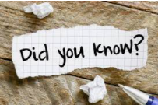
Reading a lot can make you kinder!

Do you know that reading can make you kinder? Researchers at Kingston University in London have found that regular reading makes you kinder and more empathetic. According to these researchers, frequent readers are also more inclined than non-readers to see things from other people’s points of view.

The World’s Fastest Reader Reads 25,000 Words per Minute!

In 1990 “The Guinness World Record Book” recognized Howard Berg for his ability to read more than 25,000 words per minute. But it is a fact that geniuses read much faster than most people. Napoleon, for example, read at a rate of 2,000 words per minute, while the French novelist, Balzac, could read a small novel in just about 30 minutes!

Reading Recommendations from the Norwood Staff
In July, Norwood bought some incredible new books for the library nooks. Each member of staff had to take one of the books home and review it for their library. Here are some of their reviews.
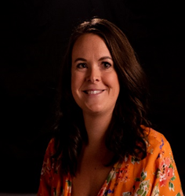
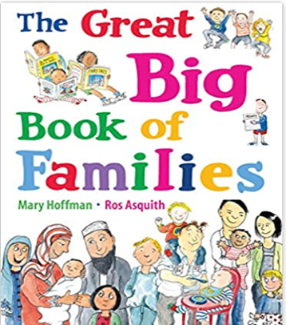
Mrs Plumtree reviewed this book.

Explore a wide variety of families and learn about how they can differ. As you read, we learn that families can have many similarities and differences. This book gets you wondering, what is your family like?

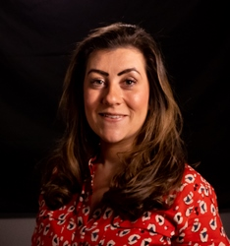
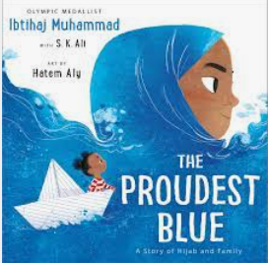
Mrs Watson reviewed this book.

Not only does this book share happy memories of the first day of school, but also explores the difficulties young Muslims can face at school. Asiya and Faizah share what it is like to proudly wear a Hijab to school, despite others around them. A story of pride and faith, a must read to develop our understanding of the world around us.
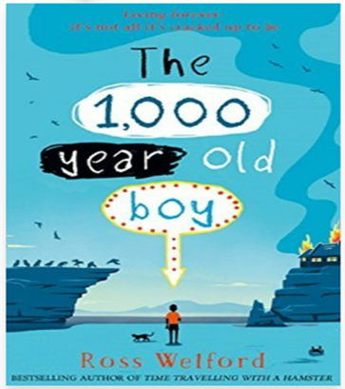

Mr Walsh reviewed this book.

Hilarious and interesting, Alve has lived through hundreds of years of history that WE learn about in Norwood. It is great to read about times in history that we have studied and hear what it was really like. It really makes you believe that someone can live until 1,000 years old!

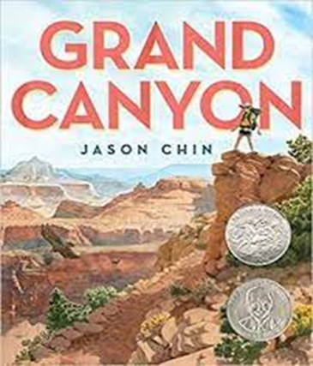

Mr Dempster reviewed this book.

This book is extremely informative, outlining how the Grand Canyon has been formed over millions of years. The different layers reminded me of the Rainforest, and the visuals throughout the book were AMAZING! I chose this book for two reasons – I went to the Grand Canyon back in 2013, and it ties in with our Geography topic in Year 6. I was pleased to have read it, and learnt so much about the history of an incredible Natural wonder

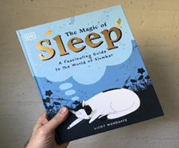

Mr Dumbell reviewed this book.

This book tells you everything you ever wanted to know about sleep – from sleep in animals and people, why we sleep the way we do, dreams and nightmares and loads and loads of really interesting facts to dip into at any time. A great non-fiction book!
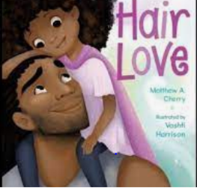
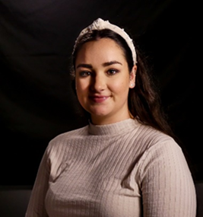

Miss McCallum reviewed this book.

A story of self-confidence and determination. Zuri has different hair to all her friends, which makes her feel different. She wants to feel beautiful and her dad stops at nothing to make it happen.

