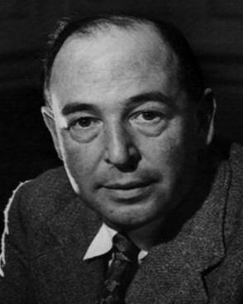
“A children's story that can only be enjoyed by children is not a good children's story in the slightest.”
― C.S. Lewis
No truer word spoken! If the children of Norwood were to ask the Norwood staff their favourite book, the answer would certainly be one from children’s literature. As a parent, there is nothing more rewarding than reading a text to our children that makes us experience the same range of emotions as our children. C.S. Lewis totally understood this. Clive Staples Lewis (29 November 1898 – 22 November 1963), was a British scholar who wrote about 40 books. He was born in Belfast, Northern Ireland. He is famous for his fantasy books, such as ‘The Lion, the Witch and the Wardrobe.’
Let’s read books with our children that create genuine joy and emotion in both generations!
Support at home for reluctant readers
Getting your child to read doesn’t have to be a daily battle.
There are a number of ways you can make reading more enjoyable for your child, and help turn your reluctant reader into a bookworm. And by learning to make reading fun, your child can develop a love for reading that will last a lifetime.
Check out these 13 tips for making reading fun (instead of frustrating) and start making reading more enjoyable for your child.
- Making reading fun starts with selecting a book your child will enjoy reading. Ask your child what kinds of stories he or she likes reading best (Adventure? Fantasy?) Make a list of books in these categories and use it to help your child choose what he or she will read next.
- Reading aloud with your child can add a bit more excitement to any book. Make the story more fun by using different voices for each character and an expressive voice for dramatic parts. You can also take turns reading aloud together, choosing a character you will each provide a voice for.
- Help your child bring some extra excitement to reading by using his or her imagination. Have your child draw pictures of what he or she is reading, act out the scene, put on a character puppet show, or make up alternate endings.
- Reading doesn’t always have to mean picking up a book. Magazines, graphic novels, and newspapers are other great reading materials that feel less like “work” to your child—but they still help your child practice and improve his or her reading skills.
- Make a reading area or fort where your child can read and relax on his or her own. Add blankets, pillows, and a variety of books, and your child will have a reading corner where he or she can read a book whenever the urge to read hits.
- Listen to audio books. For children who find reading frustrating, audio books are a great alternative to help make reading more enjoyable—while still helping your child improve his or her comprehension skills.
- The library is a great resource where your child can find lots of books to read. Take advantage of the selection at your local library by letting your child pick choose a book (or two!) that catches his or her attention
- Book series are a great way to keep your child’s interest in reading high and eliminate the problem of figuring out what to read next. Another option is reading multiple, non-series books written by the same author.
Celebrating Reading at home
Each month, we try and share our literary days with you. We hope you celebrate these days at home with your children. Please share any work with your class teacher to earn some extra Dojos.
Autumn Term
January
National Handwriting Day - 23.01.
National Storytelling week - 30.01.23 - 06.02.
February
World Read aloud Day - 01.02.
International Book Giving Day - 14.02.
March
World Book Day - 02.03.
World Storytelling Day - 20.03.
World Poetry Day - 21.03.
April
National Poetry Month - April
National Children’s Picture Book Day - 02.4

Reading skill – Fluency.
Fluency is defined as "the ability to read connected text rapidly, smoothly, effortlessly, and automatically with little conscious attention to the mechanics of reading, such as decoding" (Meyer and Felton, 1999, p. 284).
Sounds fun? It is! In far simpler terms, fluency means that your child can read without having to sound out and stop whilst reading. It is the bridge to great comprehension. In other words, the more fluent the Reader the better their comprehension skills.

In this newsletter, we would like to give you some prompts that will help you work on this at home. The idea is that you could give your child a score each time they read. Then the next time they read they need to beat their score. There are prompts for four different aspects of FLUENCY.
Punctuation: I use the punctuation to help me know how to read the story, so that it sounds right and makes sense.
1 | 2 | 3 | 4
I don’t pay attention to full stops, commas, exclamation marks, question marks, and quotation marks when I read. My reading doesn’t sound right or make sense.  👎 | Sometimes I use punctuation, but I might use it the wrong way.  🤜 | I usually pay attention to the punctuation. I may make a mistake every once in a while.  👌 | I always pay attention to the punctuation. My reading sounds right and makes sense.  👍

Pace: I read at the correct pace. Not too quickly, and not too slowly. My reading sounds right and makes sense.
1 | 2 | 3 | 4
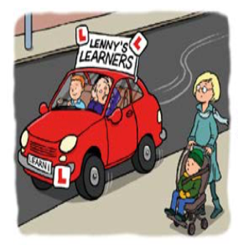  I am really slow and have to figure out each word on the page. I read so slowly that it really does not make sense. | 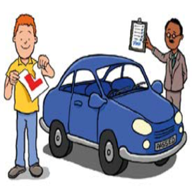  I can be slow because I have to read word-by-word when I don't know the words. I take breaks, pause too much, and repeat words when I read. | 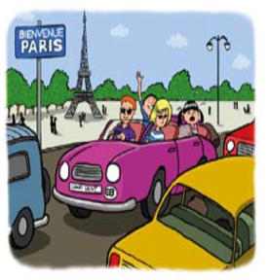  I try to read like I talk. Sometimes I go too fast, or too slow. I might slow down when I am trying to figure out a tricky word. Sometimes I pause or stop when it doesn’t make sense. | I read like I talk. I only slow down, stop, or repeat words when it doesn’t make sense or sounds right.  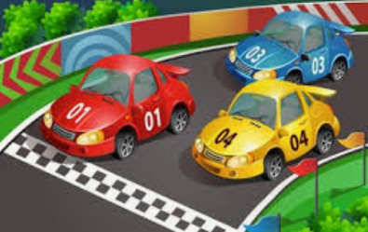

Phrasing: I put my words together so my reading sounds right and makes sense. This means that I am paying attention to my phrasing.
1 | 2 | 3 | 4
I read word-by-word, or one word at a time, like a robot.  I - like - to - read. - It - is - fun. | I am trying to read the way the author wrote the words. Sometimes I read 2 or 3 words at a time. Sometimes I read word by word, like a robot.  I like - to - read. It - is fun. | I am really close to reading the words the way the author wrote them. I usually read in 3 or 4 word groups.  I like to - read. It - is fun. | I put the words together the way the author wrote them. I put the words together so that it makes sense.  I like to read. It is fun!

Expression: I read with expression so that it sounds interesting and makes sense.
1 | 2 | 3 | 4
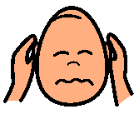  My reading sounds boring and doesn’t really make sense because I don’t read with expression. | I am trying to read with expression, but I may read it the wrong way sometimes.   |   I read with expression most of the time. My reading sounds interesting most of the time. | I always read with expression so it always sounds interesting and exciting.  

You may have heard your child talk about PROSODY.
Prosody is simply a fancy word for expressiveness in speech. Prosody provides context and gives meaning to words, and keeps listeners engaged. Understanding prosody may seem too big a task for little ones, but it’s actually central to their language and social development!
All the above FLUENCY skills will help develop your child’s prosody.
GOOD LUCK!

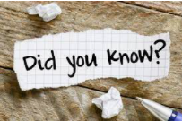
The most expensive book in the world is ‘the Codex Leicester’.
The Codex Leicester is the most expensive book in the world.
You’re not going to believe how much it sold for…
The science book sold for 30.8 million dollars in 1994. It was Leonardo da Vinci’s science diary!
If you read 20 minutes a day, you would have read 1.8 million words in a year.
All it takes is 20 minutes a day. If you read for this long every day, for a year, then you would have read 1.8 million words. You will be like a human dictionary!
Johannes Gutenberg invented the printing press.
We need to thank Johannes Gutenberg for the books we have today. He invented the printing press, which prints words onto paper. This was in 1440. It meant that thousands of books could be produced very quickly!
The largest collection consists of 1.5 million books!
According to the Guinness World Records, the largest privately-owned collection of books is a massive 1.5 million. They are owned by John Q. Benham who lives in Indiana in the USA. He has to keep them in lots of different places because he doesn’t have enough space in his house. They are in the garage, in his two-storey building and even outside!

