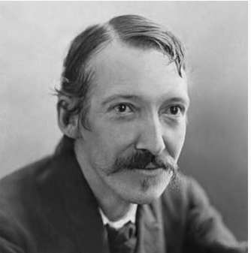
“I kept always two books in my pocket, one to read, one to write in.” by Robert Louis Stevenson.
Robert Louis Stevenson was born Robert Lewis Balfour Stevenson on the 13th November 1850 and died on 3rd December 1894. He was a Scottish novelist, essayist, poet and travel writer. He is best known for works such as Treasure Island, Strange Case of Dr Jekyll and Mr Hyde, Kidnapped and A Child's Garden of Verses. It is clear from his quote that Robert Stevenson understands the connection of a love of Reading and Writing. Reading helps develop our imaginations and vocabulary and allows us to develop into authors, regardless of our audience.
What to read at home?
There are so many different materials that your child can read at home. Sometimes it can be overwhelming.
Try and remember two things about children:
- They love to follow trends.
- They love to read old favourites.
Both of these facts are great. New trends lead to new information. Re-reading leads to books becoming a great comfort. What joy! Here are some TOP TIPS as to the reading materials you can have at home.
- Collect board books or books with mirrors and different textures for babies. Toddlers enjoy alphabet books, rhyming books, and picture books. Primary school age children enjoy fiction, nonfiction, and poetry, plus dictionaries and other reference books.
- Children can understand stories they might not be able to read on their own. If a more challenging book interests your child, read it together. Younger children can look at illustrations in books and ask questions as they follow along.
Besides books, your children might also enjoy:
- Children’s magazines
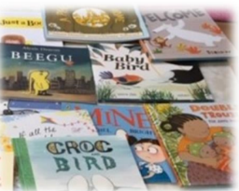
- audiobooks
- postcards, e-mails, and text messages from relatives
- photo albums or scrapbooks
- newspapers
- comic books
- child-friendly websites
- e-readers or e-books

Reading at home
Each month, we try and share our literary days with you. We hope you celebrate these days at home with your children. Please share any work with your class teacher to earn some extra Dojos.
Autumn Term
October
5.11. National Poetry day
16.11. Dictionary day
November
14.11. Young Readers Day
15.11. I Love to Write Day
December
7.12. Letter Writing Day
21.12. Crossword Puzzle Day

Oxford Reading Buddy
We are delighted to tell you Oxford Reading Buddies is still available for our children thanks to FON. Oxford Reading Buddies (ORB) is a digital reading service to support children’s reading development at home as well as at school. Oxford Reading Buddy contains hundreds of digital books and book-quizzes all matched to each child’s reading ability. Children can earn badges for good reading behaviours, be coached in their understanding by their personal ‘Reading Buddy’, take quizzes and record all the reading they do. Everything is captured so that your child’s teacher can see how they’re getting on.
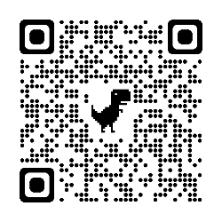
Please log in to Oxford Reading Buddy when your child brings home their sign-in card and have a look around. Do encourage your child to use it regularly and discuss what they are reading with them. You might be interested in watching them reading one or two of the Coaching eBooks because Reading Buddy is a good model of how to support and encourage children’s comprehension skills as they read. When your child is taking a quiz, please try to provide a quiet workspace for them, but resist the temptation to help them because their answers will help your child’s teacher understand their needs. If you don’t have a tablet or PC at home, the service works on smartphones as well.

More information can be found on our school website.
Poem of the Term.
Reading poetry with children brings such joy. There are many positives to reading poems with your children, including helping them develop their speaking confidence and introducing them to new vocabulary and experiences.
I raised my hand in class this morning by Kenn Nesbitt
I raised my hand in class this morning,
sitting in the back.
The teacher didn’t see, I think.
Instead she called on Jack.

I stretched my hand up higher,
but she called on Zach and Zoe.
I started bouncing up and down,
but, still, she called on Chloe.

I waved my arms but, even so,
she didn’t call on me.
She called on Bryan, Brooklyn, Billy,
Bailey, Ben, and Bree.

She called on Taylor, Tristan, Thomas,
Trinity, and Ty.
Then, finally, she called my name.
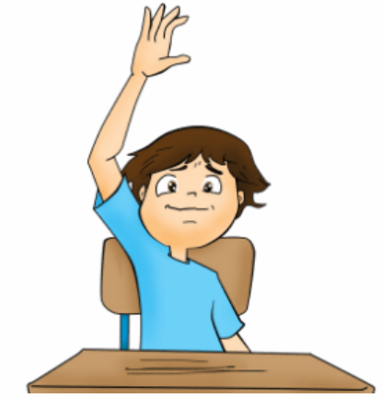
I breathed a heavy sigh.

She asked me for the answer.
I just frowned and clenched my knees,
and said, “I’ve no idea,
but could I use the bathroom, please?”

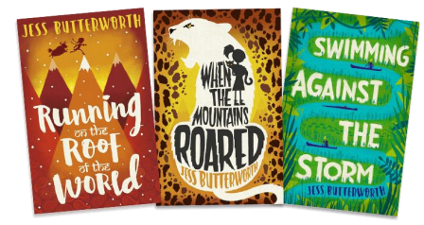

Jess Butterworth
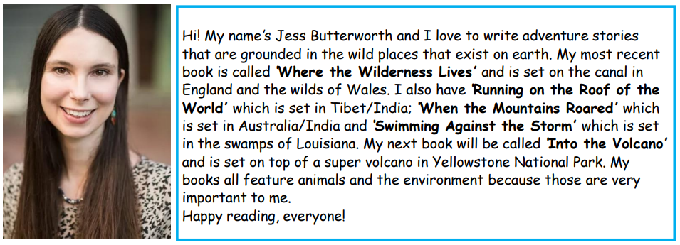

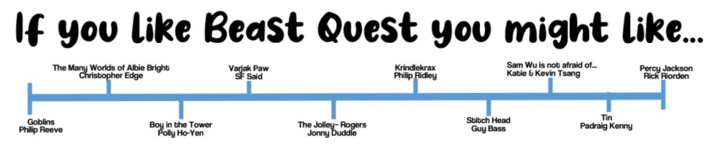
Finally, do your children find themselves reading the same books by the same author? If yes, these grids may help.

