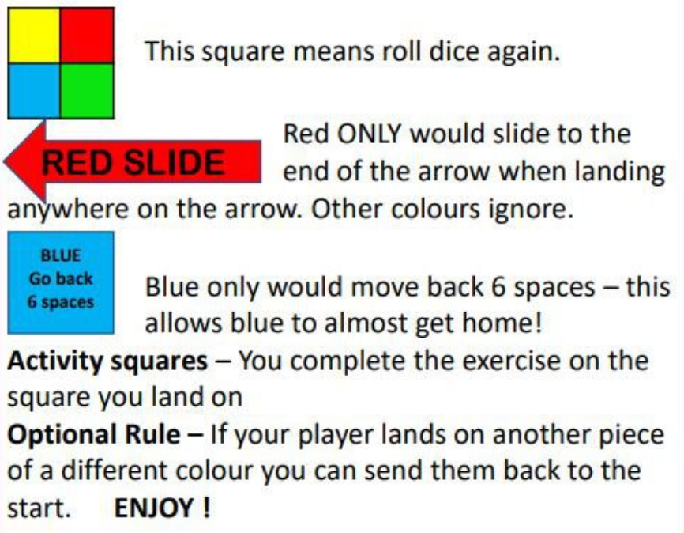
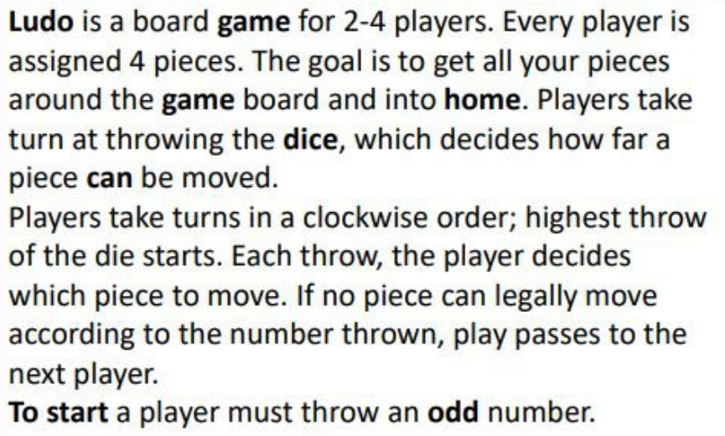
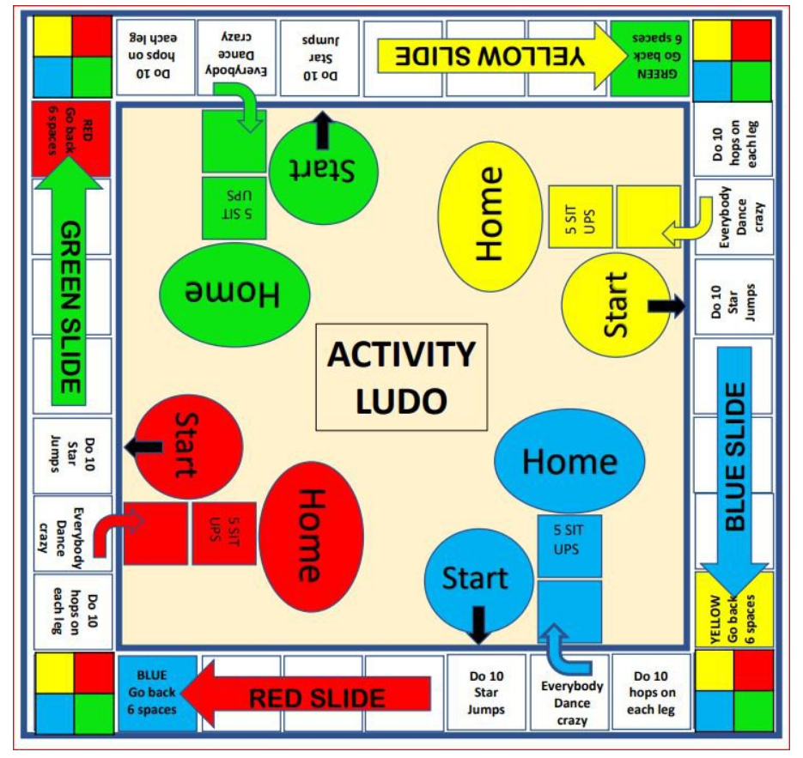

Roll this online dice if you don’t have one at home https://www.online-stopwatch.com/chance-games/roll-a-dice/

