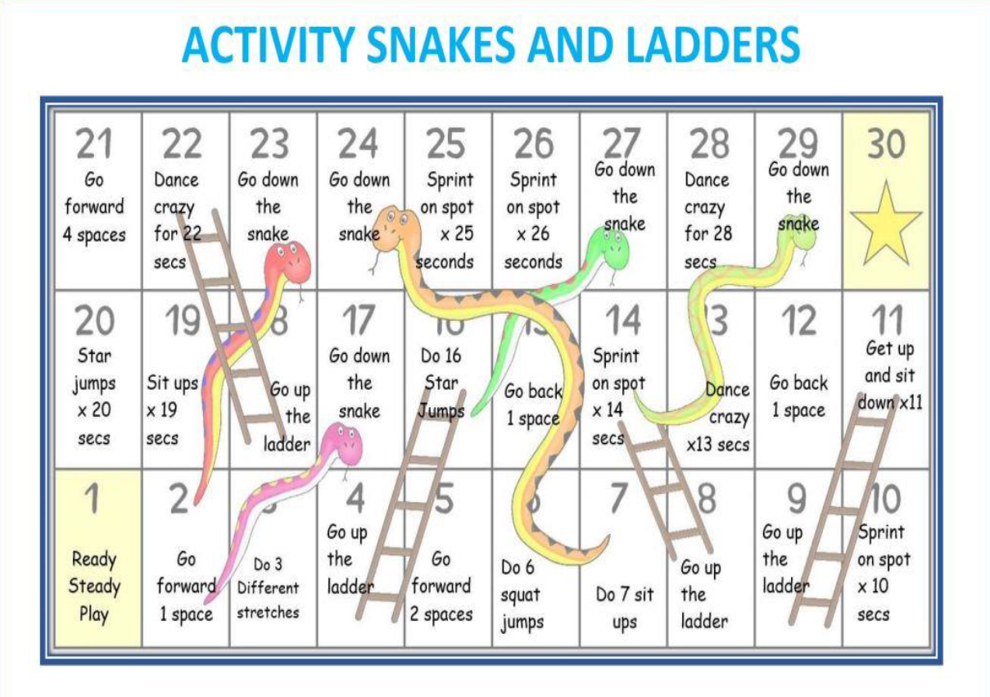
1+ players
How to play:
- Choose a colour counter and place it on tile 1
- Roll a dice (or this online dice https://www.online-stopwatch.com/chance-games/roll-a-dice/ )
- The number you roll is how many spaces you must move
Have fun!

