How can I help my child with Big Maths?

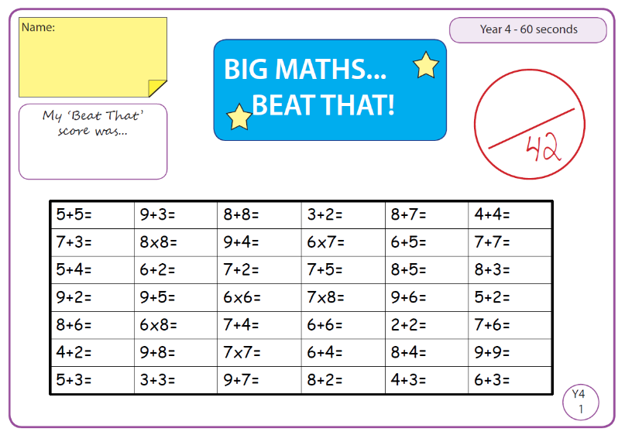
What is Big Maths?
Big Maths is a 60-second maths test. It is fast and exciting, with loud music and dancing! We do Big Maths every Friday.

Why do we do Big Maths?
Big Maths covers a lot of the basics of maths. It is important for children to learn basic number facts and be able to recall them quickly.

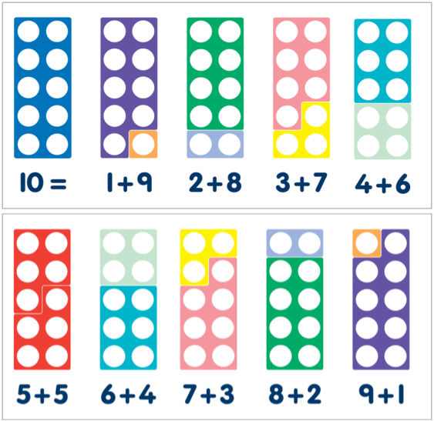
Knowing these basic number facts help children be more fluent in their normal maths lessons and will help them with maths for the rest of their lives!
Number bonds to 10

How do we prepare for Big Maths?
There are lots of ways we prepare for Big Maths.
Here are some of them:
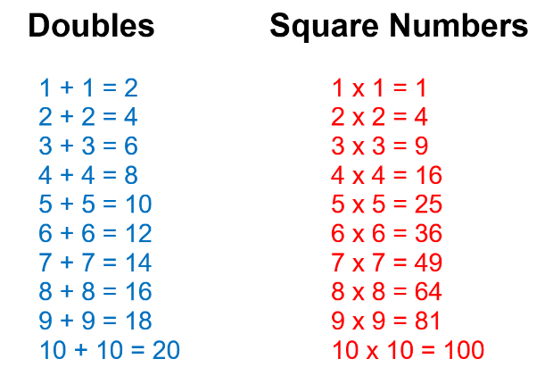
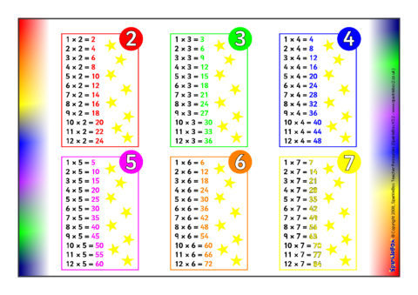

Times table mats
Number lines
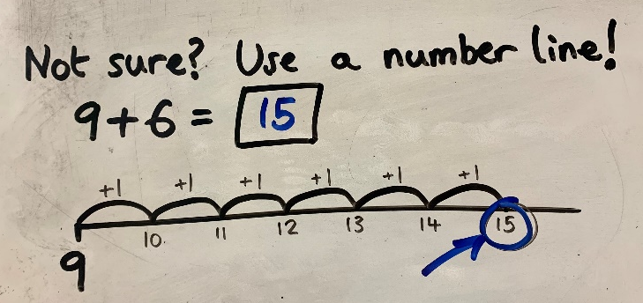
Related number facts

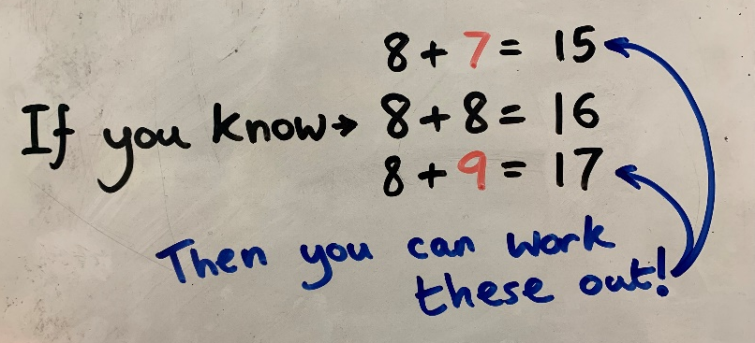

…and you can help by practising all of these at home! – Thank you!

Can you beat your best ever score?

