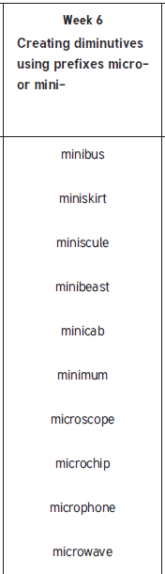
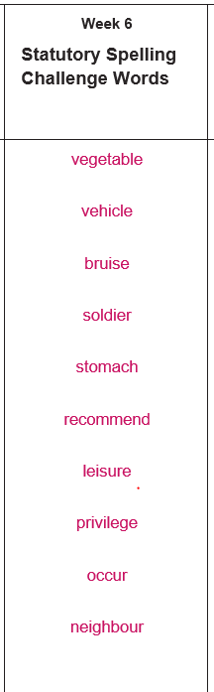
Year 5 & 6
Year 6

