
Miss Chan’s

- What is 1000 more than 2560? 3560
- Order these numbers from smallest to largest:4250, 4307,4505,4805, 4845
- Write the place value of the red digit: 6936 900
- Round 786 to the nearest ten 790
- What is 1000 less than 7870? 6870
- 387 + 275 = 662
- 4,654 – 3,263 = 1391
- Round 4345 to the nearest thousand 4000
- 6 x 9 = 54
- 4,589 + 746 = 5335
- 7² + 64 ÷ 8 = 57
- 27 x 4 = 108
- 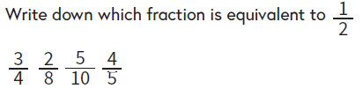 5/10
- 3 x 6 x 8 = 144
- 12 ÷ 1000 = 0.012
- 119 ÷ 7 = 17
- 2 + 3 = 29/5 = 5 4/5
- 236 x 5 = 1180
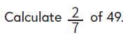
- Round 2.3 to the nearest whole number 2
- 14
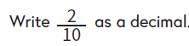
- 27 ÷ 10 = 2.7
- 0.2
- 2.6 x 100 = 260

