
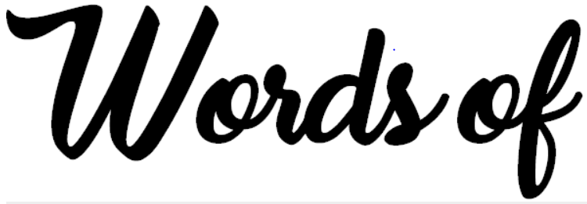

IALT share my interpretation of what wisdom is

Quote is a repeat or copy of words from a text or speech written or spoken by another person
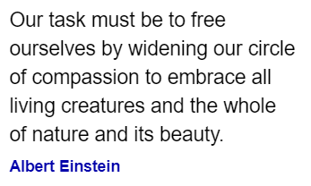
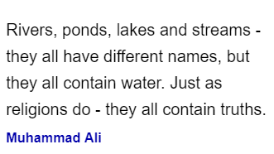
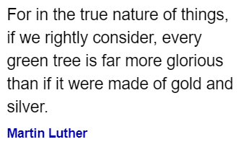

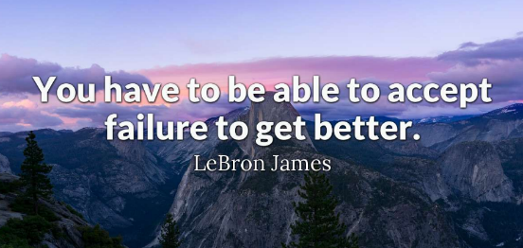
Motto is a phrase or quote that is representative of a person or brand's ideals and values.

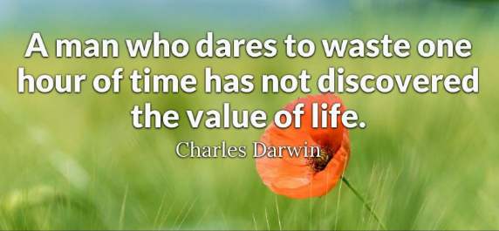

What do these words of wisdom have in common?
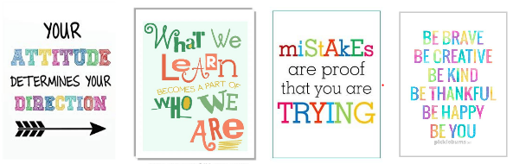

What do these words of wisdom have in common?

Your quotes reflects what is important to you.
Task: Create your own poster of your words wisdom
It can be about: family, friends, animals, working hard, being kind or thinking positively. Anything that is important to you.
What do I believe is important (Miss Chan)?
When something seems hard the first time, persevere and it can be achieved. We shouldn't be ashamed to ask for help because when others need this we can do the same. It is important to work hard to build towards your dreams.
Think of it as if you are giving a friend advice!
Draw a pretty, simple background on the back for your words of wisdom




