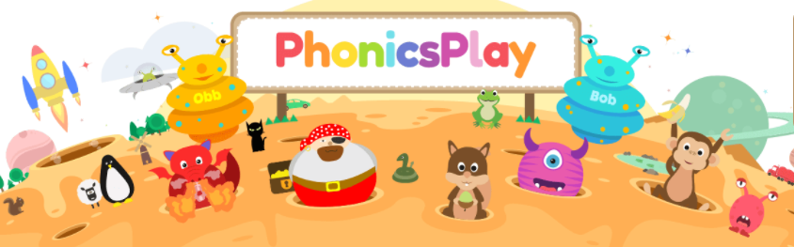
Below are the login details you can use during this lockdown to access for free the many wonderful resources on the Phonics Play website.
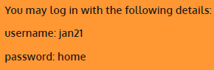
Begin by following this link:
https://www.phonicsplay.co.uk/
Next, type in the username and password as above.
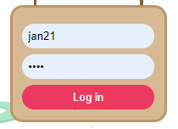
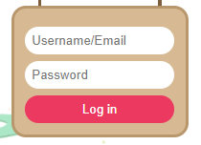



Then, scroll along the top bar and select followed by

There you will find a collection of games suitable for you and your child to play together.
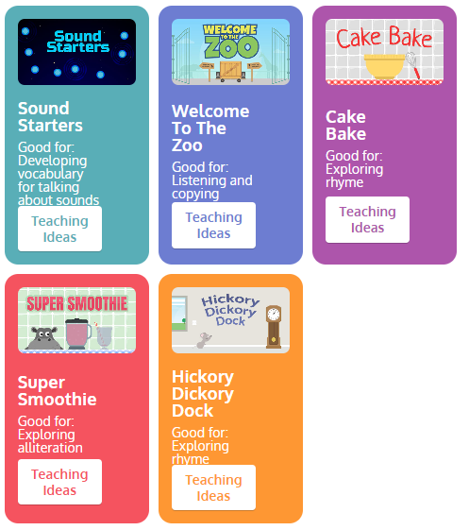


You even have the option to print some resources out.

