Draw and label the boat.
Simpler diagram of a boat.
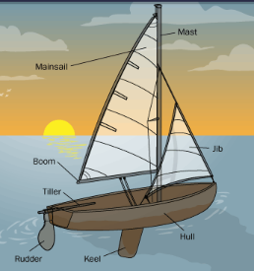

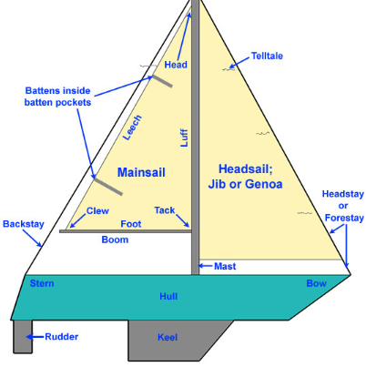
More challenging diagram of a boat.

