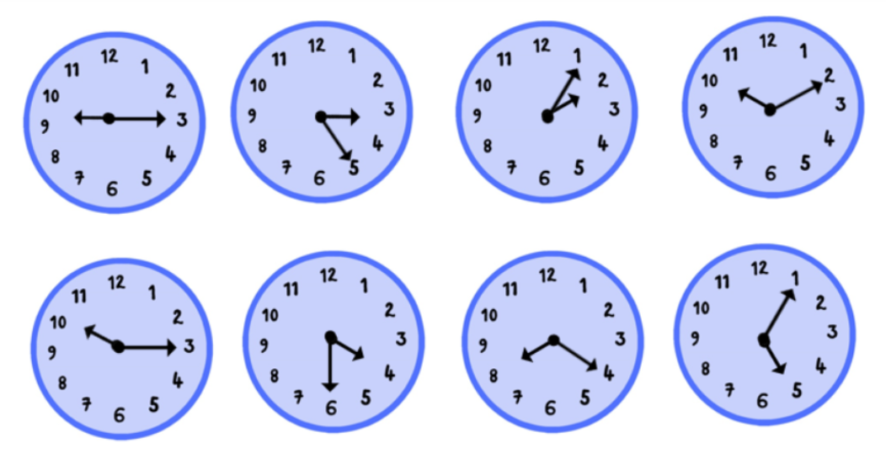
Don’t forget you can email us a photograph of your work to
year5-6b@springfield.sheffield.sh.uk

We would love to see it!
Can you write (in French!) the times shown on these clocks?

