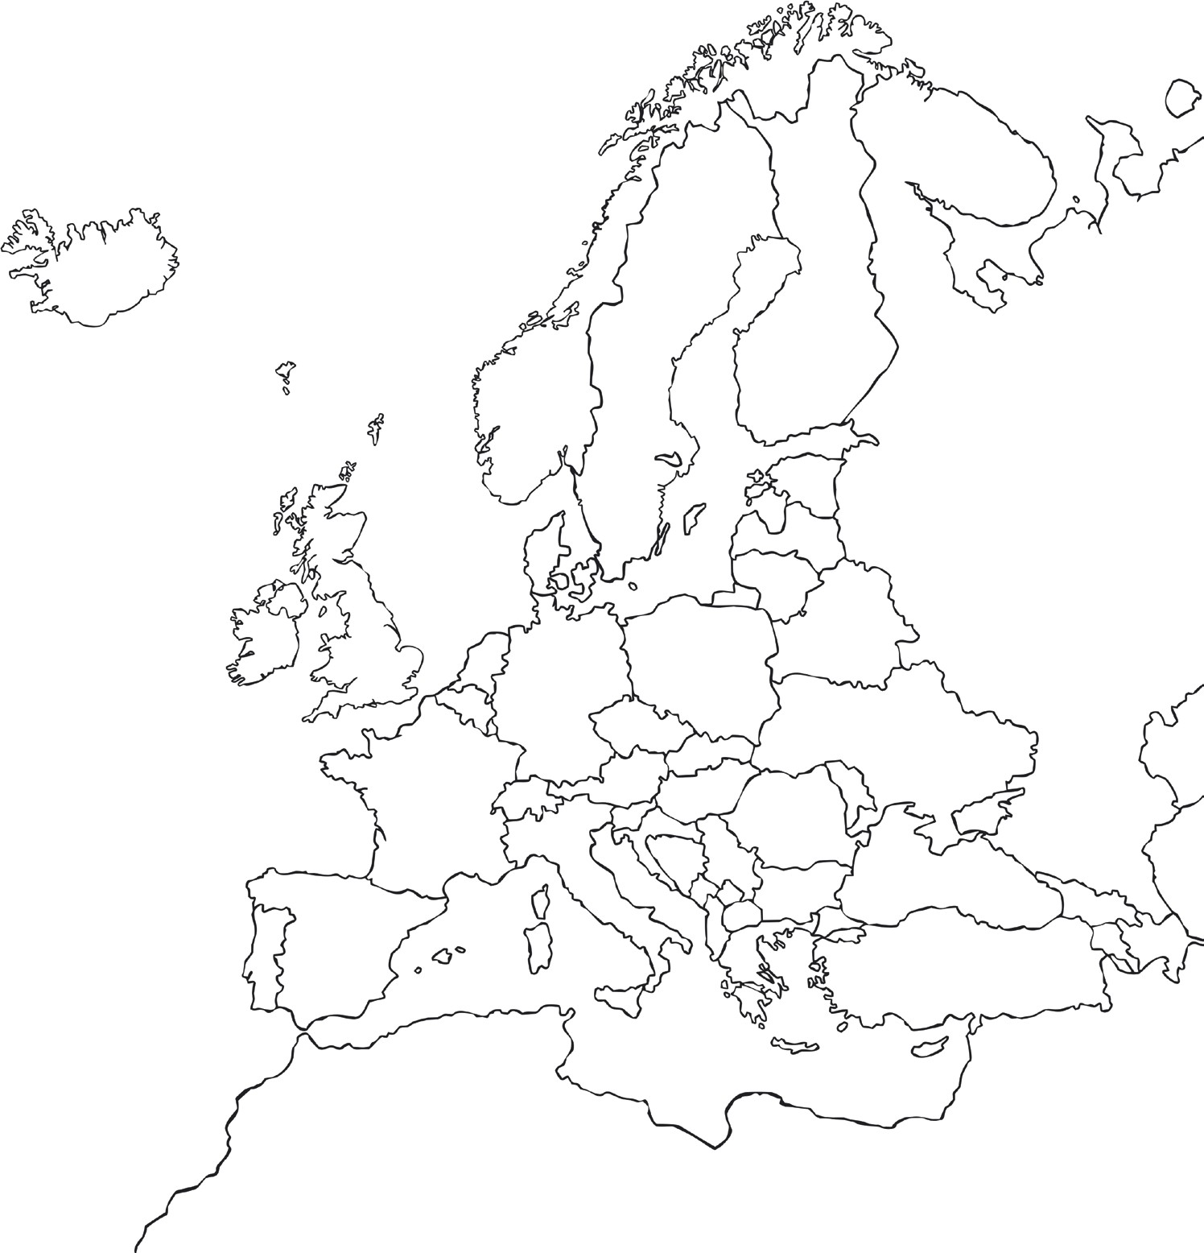
Label and colour 6 European countries on the map and underneath write what “hello” is in their own language.
IAL the importance of European Day of languages
Write a passage about the European Day of languages.

