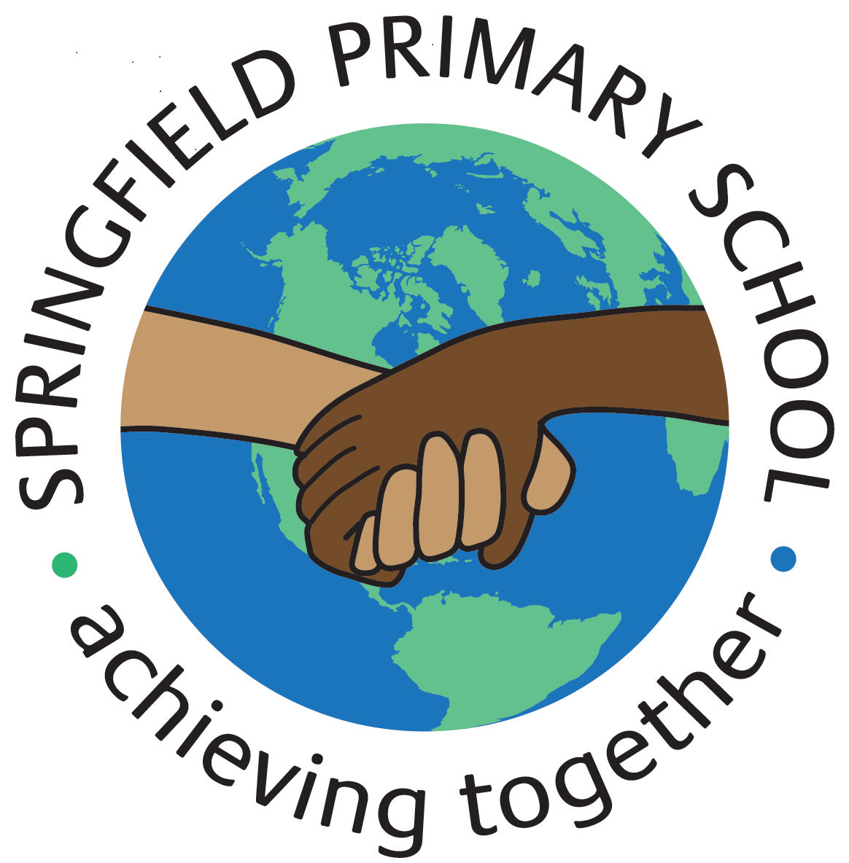
Half Term Curriculum P{an
Term: Summer 1 | Theme: Beowulf and the Anglo-Saxons
Key Questions:  - Where did Anglo-Saxons come from and why did they come to Britain?  - How did the Anglo-Saxons change Britain;  - What was life like for Anglo-Saxons, e.g. where did they live and how did they spend their time?  - What was their religion like and how did this affect how they lived? | Stimulus: (Book/ Visit/ etc.)  Beowulf (one of the earliest pieces of written English describes three epic battles between good and evil).  Children might like to watch a short cartoon of this epic poem (https://www.youtube.com/watch?v=QKjcoFZmKuA&t=952s) |  | 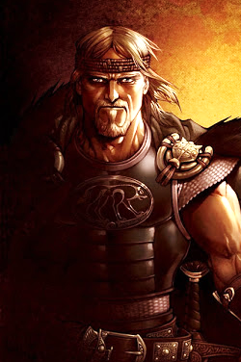  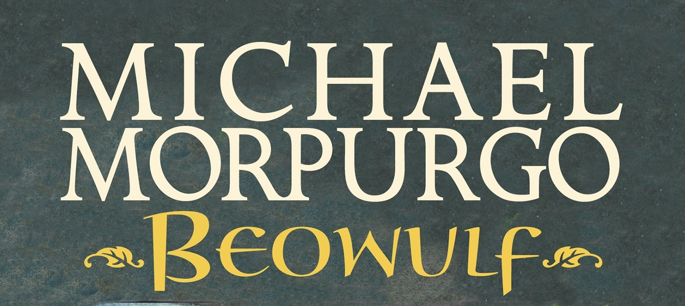
In writing, we will:  - Read the epic story of Beowulf; use the text to link in new topic vocabulary; identify nouns, verbs, adjectives and adverbs  - Write an independent historical narrative using homophones  In Spelling, Punctuation and Grammar (SPAG), we will:  - Learn to the meanings and spellings of a range of homophones | In Design and Technology, we will:  - Learn how to sew cross-stitch and applique  - Design a product and its template  - Decorate fabric using applique and cross-stitch  - Assemble an Anglo-Saxon cushion, demonstrating applique and/or cross-stitch skills | In History, we will:  - Carry out an investigation into the period of British History known as the Anglo-Saxons times  - Understand how our knowledge of the past is constructed from a range of sources.  - Place significant events in chronological order on a timeline  - Understand the great effect the Anglo-Saxons had on life in Britain today, such as place names for example.
In Maths, we will:  - Understand the value of tenths and hundredths and compare decimals with different values;  - Convert analogue and digital time and solve problems involving time;  - Add, subtract and multiply priced items to solve problems representing answers using decimal notation;  - Conduct research and represent results using bar charts and extract data from bar charts, pie charts, pictograms and line graphs. | In French, we will:  - Revise clothing  - Revise months of the year  - Revise colours and food  - Ask simple questions in French. | In Music, we will:  - Learn to sing the song ‘Blackbird’ by The Beatles.  - Play a glockenspiel in the instrumental of Blackbird  - Improvise with the song and compose with the song  - Perform the song with singing and instruments.
In Computing, we will:
- Learn how to change the composition of digital images
- Combine images for a purpose
In Science, we will:  - Investigate what sound is and how it is different, e.g. low and high pitch and loud and soft volumes  - Understand how the human ear hears sound and how sound travels.  - Conduct fair tests to investigate sound-insulating materials. | In Physical Education (PE), we will:  - Learn bouncing and catching skills  - Learn tennis racquet skills  - Be able to vary the speed and direction of the ball.  - Work with a partner to keep a rally going  - Take part in swimming lessons | In Religious Education (RE), we will:  - Learn what happened to the early followers of Jesus  - Learn about the concept of the Trinity  In Relationships, Social, Health Education (RSHE), we will:  - Learn about gender stereotyping  - Learn about disability, sexism and diversity.

