Term: Spring 2 |  | Theme: Abbeydale Industrial Hamlet, Rivers, Food Chains and Food Webs
Key Questions:  - How and why has Sheffield changed over time?  - What natural events caused the locality to change?  - What man-made processes and events caused Sheffield to change? |  | 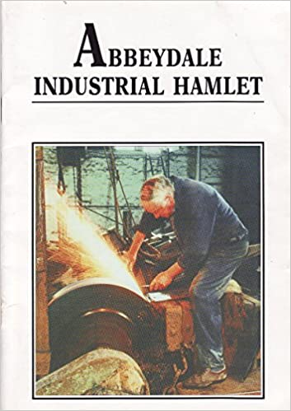  Stimulus:  - Abbeydale Industrial Hamlet  - YouTube video From Forge to Field  - Meet Me By The Steelmen book  Photos from our class  information text | 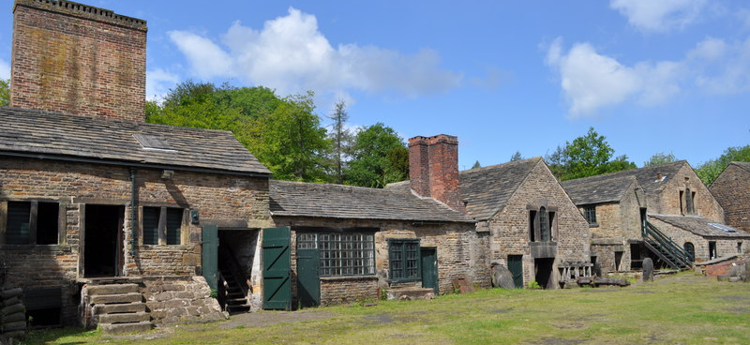
As Writers we will:  Fiction:  - Recap speech, speech marks and related punctuation  - Use expanded noun phrases and prepositions in our story writing  Non-Fiction:  - Creating a non-chronological report into a specific aspect of Abbeydale Industrial Hamlet, organising paragraphs around a theme. |  | As Artists we will:  - Use curved lines to suggest 3D shapes  - Investigate 3D wire sculpture  - Explore how shapes can be formed with wire  - Create a sculpture in the style of Sokari Douglas Camp. | In RHSE we will:  - Look at our mental wellbeing  - Understand our feelings  - Ask ourselves ‘Are we happy all the time?
As Mathematicians we will:  - Look at finding the area of a shape by counting squares  - Calculate area of rectilinear shapes and compare areas of shapes  - Recap unit and non-unit fractions  - Recap tenths, count in tenths; recap equivalent fractions  - Learn about fractions that are greater than 1 and count in fractions  - Add two or more fractions; subtract fractions  - Calculate fractions of a quantity. |  | As Computer Engineers we will:  - Change the composition of digital images  - Change images for different uses  - Learn about re-touched images and fake images  - Make and evaluate a text (Non-chronological report). | As Geographers we will  n/a
 |  | As French Speakers we will:  - Learn how to say the date and ask about birthdays; we will also look at how to describe physical features. | As Musicians we will:  - Enjoy and learn songs from ‘Out of the Ark’ songs for a Healthy Happy Life at School
As Scientists we will:  - Explore how environments change  - Construct food chains, adding scientific vocabulary  - Choose a habitat and construct a food web, carrying out own research | As sportspeople we will:  - Swimming: Perform safe self-rescue in different water-based situations  - Swimming: Swim competently over a distance of at least 25 metres  - P.E.: Play competitive attack and defence games  - P.E: Learn how to communicate and work as a team | As Historians we will:  - Begin to conduct an in-depth historical enquiry by asking questions  - Understand the historical concept ‘process of change’, looking at how Abbeydale Works developed over many years  - Note connections over time (Benjamin Huntsman and connections with (for example) The Crucible Theatre. | In RE we will:  - Learn from the world’s great religious leaders in today’s world  As Citizens we will:  - Talk and write about our opinions  - Recognise our worth as individuals  - Use our imaginations to understand other people’s experiences and reflect on our actions

