Homework Grid Year 1 Spring 2

We would like you to choose some of the homework ideas from this grid to do at home over the 5 week term. We will have time in school to talk about the homework we have done that week. You can bring your homework to school, or a photo of you doing an activity from the grid.


Weekly Homework
Reading 5x per week (school book or Bug Club)
Maths practise on SumDog
Spellings and key words www.sumdog.com/user/sign_in www.activelearnprimary.co.uk/login
Literacy  Speaking and Listening | Write about your favourite animal.  What habitat does it live in?  What type of animal is it?  What does it eat?  What characteristics does it have? | 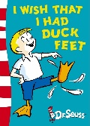  Imagine you could be an animal for the day. Write about what you would do. | Choose your favourite book to read at home. Can you write a letter to someone explaining why they should read it too? | 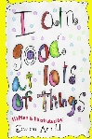  Write a list of the skills and talents you have. How many can you think of? What are you really good at?
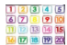  Maths and problem solving | Practise writing your numbers from 0-20.  How many number bonds to 20 can you find? | Can you complete the weekly SumDog challenges to practise what we have been learning in class? | Find 10 items in your house. Can you sort them into heavy or light? | 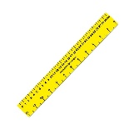  Find lots of different sizes of books. Can you arrange them from shortest to tallest? How many centimetres tall are they?
Science and    Topic |   Can you draw a picture of a spring scene? What is the weather like? What colour are the trees? What plants or animals might be in the picture? | Can you keep a weather diary for one week? How does the weather change? When in the day is it hot? When is it cold? | 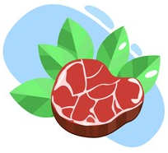  In science, we will be looking at different animals. Can you find out what these words mean?  Herbivore  Omnivore  Carnivore | Can you give an example of a mammal, reptile, amphibian, fish, bird and insect?

