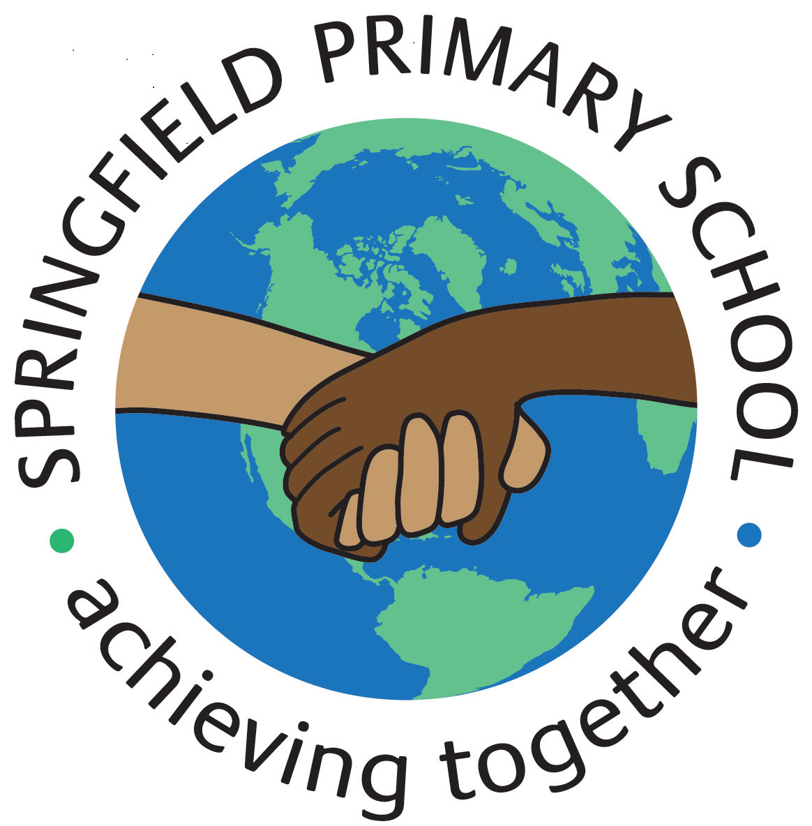
Half Term Curriculum Plan
Term: Spring 2 | Theme: Animals
Key Questions:  What do you call the young of various animals?  What is it like where I live? | Stimulus:  Text:  Jasper’s Beanstalk  Titch  I Wish That I Had Duck Feet
As Writers we will:  Write to inform by:  Finding and writing facts that tell us about an animal.  Showing our information in the format of a double page spread.  Identify and write personal pronouns as subjects.  Identify and write personal pronouns as objects. | As Sportspeople we will:  Learn how to throw, catch, hit, roll and track a ball.  Learn how to send a ball using a racket.  Learn how to hit a ball over a net  Learn how to play against an opponent and keep the score.  Learn how to send and receive a ball with our feet.  Learn how to develop throwing and catching skills over different distances. | As Computer Engineers we will:  Learn to organise and understand data and information through labelling, matching, grouping, counting and comparing.
As Mathematicians we will:  Learn place value between 20 and 50, grouping numbers into tens and ones.  Organise, count and estimate on a number line to 50.  Compare and measure lengths and heights in centimetres.  Measure and compare mass, capacity and volume.  Understand the difference between heavier and lighter.  Understand the difference between full and empty. |  | As Musicians we will:  Explore rhythm patterns.  Understand that ostinato is a repeated pattern.  Copy and create simple rhythm patterns.  Keep a steady beat.
As Scientists we will:
Discover animal families.
Learn the differences between different animal families.
Discover the types of food living things eat.
Explore the difference between wild animals and pets.
As Geographers we will:  Learn how the weather affects our lives.  Name and locate the worlds 7 continents and 5 oceans, using world maps to identify them.  Identify daily and seasonal weather patterns in the UK. | As learners of Religion we will:  Learn about who Christians believe made the world.  In RSHE we will:  Understand what mental wellbeing means.  Understand my feelings and where they come from.  Understand who I am. | As Artists we will:  Learn what a sculpture is and what it means when something is 3D.  Learn how to apply paper-shaping skills to make an imaginative sculpture.

