
Half Term Curriculum P{an
Term: Spring 1 Theme: Living Things and their Habitats (Science: Local Environment) and Jungles and Deserts (Geography: South America)
Key Questions:  - What positive and negative changes take place in the local environment? (Science)  - Why are jungles so wet and deserts so dry? (Geography) | Stimulus: (Book/ Visit/ etc.)  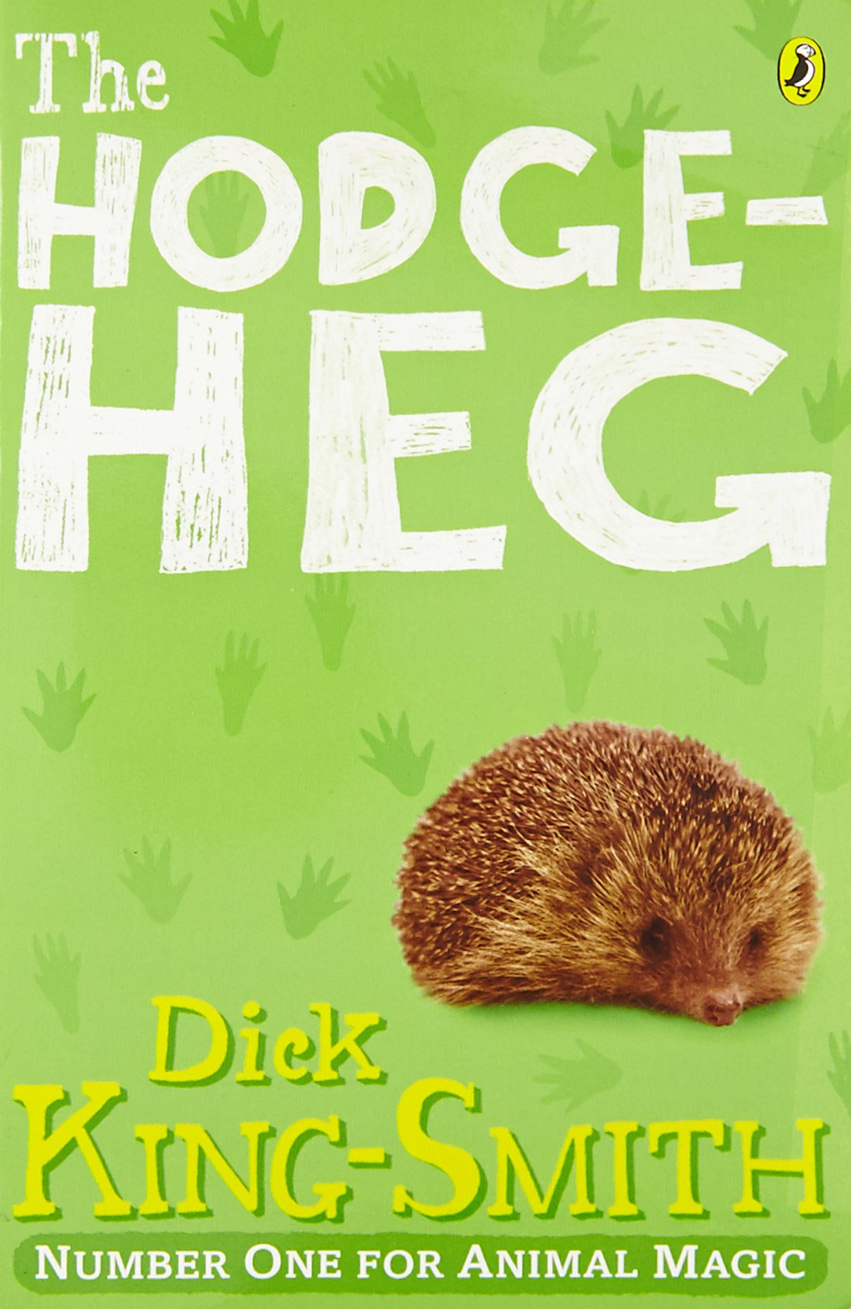  Stimulus for English and Science:  Hodgeheg is the story of a hedgehog called Max who gets knocked over and then tries to find a safe way for his fellow hedgehogs to cross the road. |   Stimulus for Geography:  We have a wide range of books, photos and video clips on the Atacama Desert and the Amazon Rainforest which we will be studying.
In writing, we will:  - We will be writing to inform: Writing a Recount of Princess Cinnamon in the jungle.  In Spelling, Punctuation and Grammar (SPAG), we will:  - Laying out and punctuating speech more effectively  - Learning to write expanded noun phrases + prepositions  - Learning to use fronted adverbials at appropriate places within a narrative  - Learning how to use the plural possessive apostrophe. | In Design and Technology, we will:  - Program micro:bit computer chips to display timers  - Design a ‘mindfulness timer’ product  - Design, make and develop a prototype  - Begin to develop brand identity. | In Geography, we will:  - Explain the difference between weather and climate  - Identify and describe the location and features o the main climate regions of the world  - Identify and describe the physical features of the Atacama Desert and the Amazon rainforest.
In Maths, we will:  - Learn the 11 and 12-times tables  - Solve worded problems involving the 11 and 12-times tables  - Learn about the ‘Associative Law’ when multiplying three numbers together  - Look at factor pairs and efficient multiplication methods  - Divide 3-digit numbers by a 1-digit number, with remainders  - Investigate the area of rectilinear shapes  - Adding and subtracting fractions. | In French, we will:  - Continue practising the names for food  - Continue practising counting  - Continue practising simple verb forms in the present tense.  - Learn dates, birthdays and day names. | In Music, we will:  - Listen to and discuss classical music that could accompany images and videos of water, rivers and flooding, for example The Sorcerer’s Apprentice.
In Computing, we will:
- Identify that accuracy in programming is important.
- Create a program in text-based language
- Decompose a task into small steps.
In Science, we will:  - Learn how to classify animals by their characteristics  - Use Venn diagram and Carroll diagrams  - Make classification keys  - Recognise positive and negative changes to the local environment and endangered species. | In Physical Education (PE), we will:  - Take part in gymnastics lessons  - Develop the range of shapes we use in a sequence  - Develop strength in bridge and shoulder stands  - Take part in swimming lessons, learning to swim 25m with a range of strokes. | In Religious Education (RE), we will:  - Learn what it means to be a Hindu in Britain today  - Learn how and why Hindus perform Puja.  In Relationships, Social, Health Education (RSHE), we will:  - Learn how to recognise and manage our feelings.

