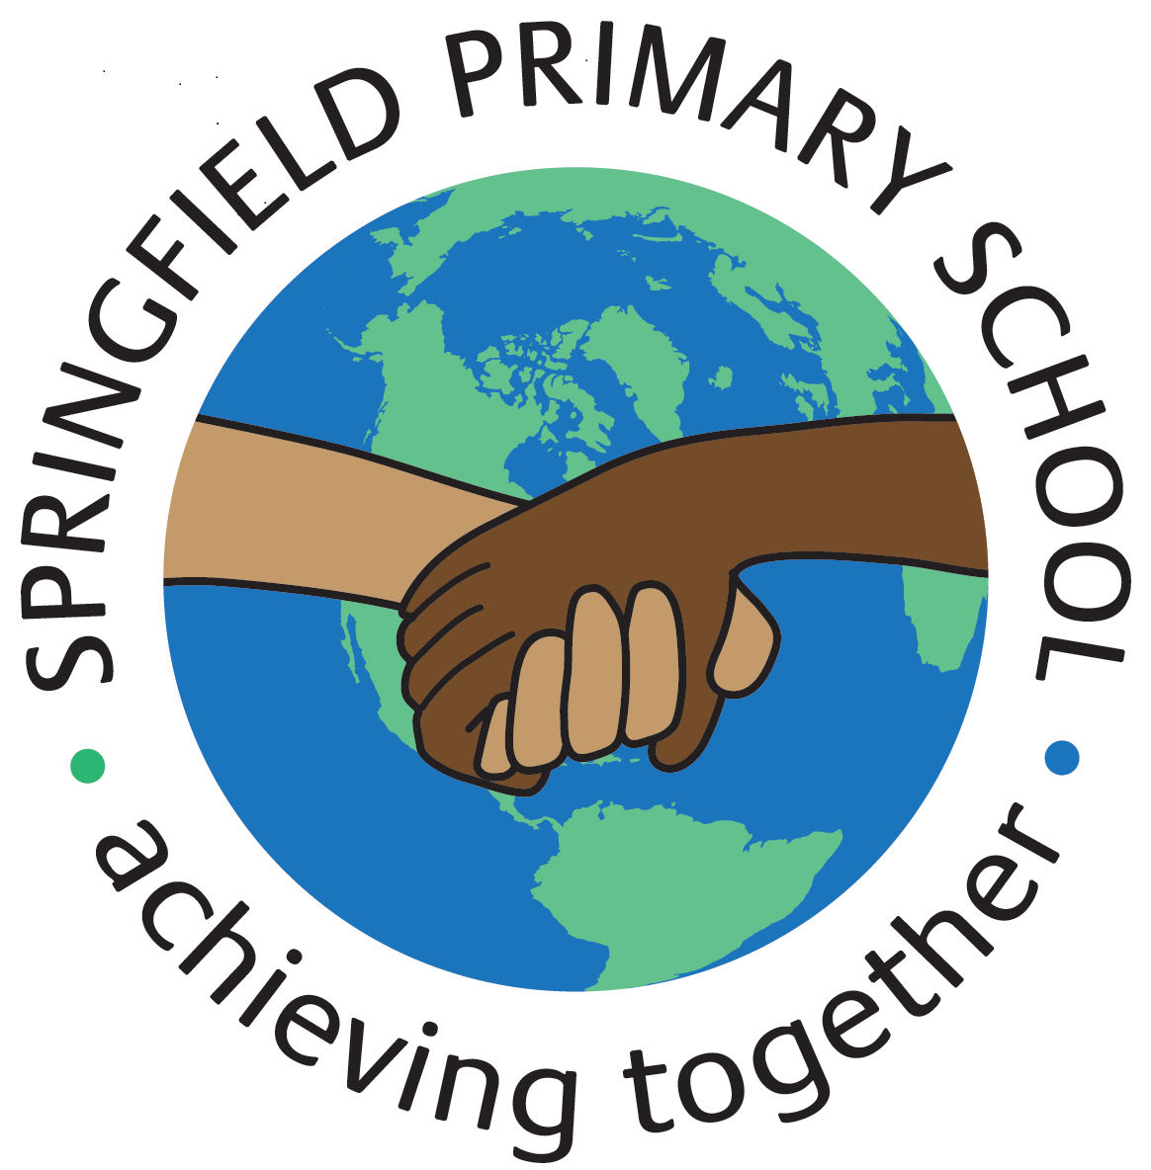
Half Term Curriculum Plan
Term: Autumn 2 |  | Theme: The Iron Man
Key Questions:  - Are all monsters bad?  - What makes people good or bad?  - What causes different behaviour? |  | 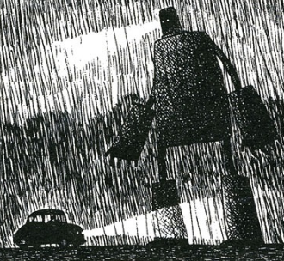  Stimulus:  Text: The Iron Man by Ted Hughes  In groups, children will design models of the Iron Man, complete with light-up eyes. This will be used a stimulus for writing.  Children are asked to bring in cardboard cereal boxes (or similar) and other materials from home – please save your card cereal boxes for Week 4.
As Writers we will:  - Read a range of newspapers  - Investigate the key features of newspaper articles  - Role-play as newspaper reporters interviewing people at the scene of an incident  - Learn how to lay out our writing in the style of a newspaper front page  - Write using direct quotes from our interviews alongside using reported speech  - Write an independent newspaper article  - Investigate homophones. |  | As Artists we will:  N/A | As Designers we will:  - Learn about how electrical products work  - Analyse and evaluate electrical products  - Design a product to meet a specific set of specific user needs  - Make and evaluate an Iron Man head desk lamp | As Computer Engineers we will:  - Explain that sound can be recorded  - Explain that audio recordings can be edited  - Recognise the different parts of creating a podcast project  - Apply audio editing skills independently  - Combine audio to enhance a podcast project  - Evaluate the effective use of audio.
 |  | As Artists we will:  N/A |  | As Musicians we will:  - Listen to a song / appraise a song / learn a song / perform a song: Stop! by Joanna Mangona  - Listen to Gotta Be Me by Secret Agent 23 Skidoo, Radetzky March by Strauss, Can’t Stop The Feeling by Justin Timberlake, Libertango by Astor Piazallo and Mas Que Nada by the Black-Eyed Peas
As Mathematicians we will:  - Investigate area by counting squares, making shapes and comparing areas of shapes  - Learn multiples of 3  - Multiply and divide by 6; multiply and divide by 9  - Multiply by 1 and 0  - Divide a number by 1 and itself  - Multiply three numbers. |  | As Artists we will:  N/A
 |  | As French speakers we will:  - Learn about French adjectives  - Learn about food  - Learn how to give an opinion about food  - Learn how to shop for food in French |  | As Scientists we will:  - Make simple circuits and test to see if a material is an electrical insulator or conductor  - Make a variety of switches  - Apply knowledge of circuits and electricity to make an Iron Man head desk lamp (links with DT).
As Geographers we will:  - Explain what sustainability means  - Draw up an action plan to help the school become more sustainable  - Learn how wind turbines and solar panels generate electricity. | As Historians we will:  N/A | As Sportspeople we will:  Indoors:  - Copy and create actions; choose actions that relate to a theme  - Develop dance using matching and mirroring  - Develop a dance phrase to use as part of a class performance  Swimming  - Learn to swim competently and confidently over a distance of 25m  - Use a range of strokes effectively, such as front crawl and back stroke and perform safe self-rescue techniques in different situations. |  | As learners of Religion we will:  - Learn how people express their religious and spiritual ideas on pilgrimages  - Explain what Muslims believe about pilgrimages  - Present the main events of the Hajj  - Explain what Jews believe about pilgrimages  - Explain why pilgrimages are special  In RSHE we will:  - Learn about keeping friendships healthy  - Ask are friendships always fun?

