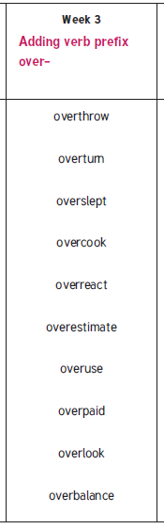
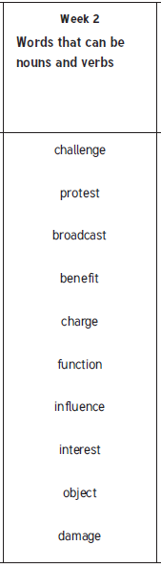
Year 6
Year 5 & 6

