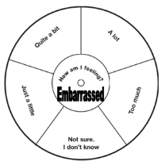
Relationships –Resource Sheet 4 –Situations II

Embarrassing Situations II

