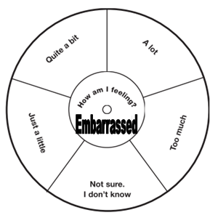


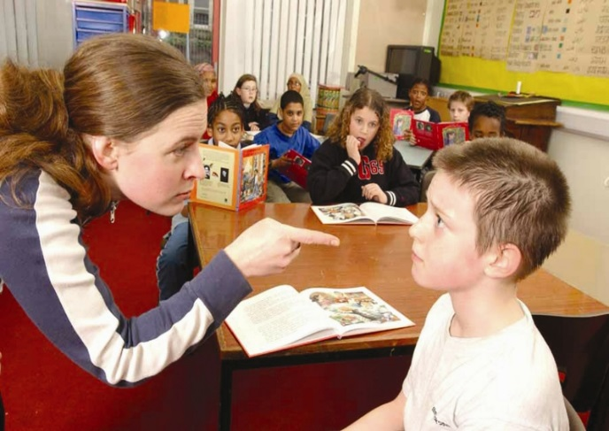
Lesson 2
IALT tell you about a time when I felt embarrassed and what it felt like.
IALT know some things to do when I feel embarrassed that will not make things worse.

Embarrassing...
Write about the reasons for you choices.
Relationships –Resource Sheet 2 –Blushometer

