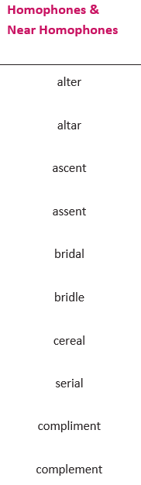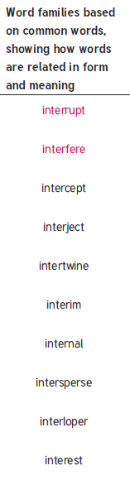
Year 5 & Year 6
Year 6

