Springfield Primary School.

Term: Summer 2 | Theme: Carnival
Key Questions  What is Fable?  What does the moral of a story mean?  What is Carnival? | Stimulus: (Book/ Visit/ etc) Childrens Library, Botanical Gardens  Text: Aesops’ Fables, Brave Little Turtle, Carnival of the animals  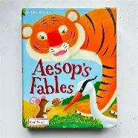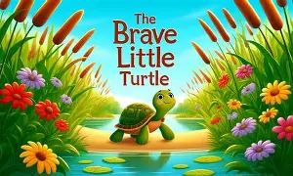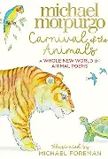
  In English we will be writing to Inform and
  Writing to Persuade:
  Use a story plan (Story mountain)
  Write the stories with morals.
  Write rhyming poems based on Carnival of the
  Animals.
  In Geography we will:
  Locate Carnivals around the world. e.g. Trinidad and Tobago, Brazil and UK.
  In Computing we will:
  Learn how to move a sprite in different directions and
  explore movement within the context of a maze.
 | In Design and Technology, we will:  Design and make masks to celebrate carnival.
  In Mathematics we will:
  Add and Subtract fractions
  Partition fractions
  Understand unit and Non-unit fractions
  Find fractions of amounts.
  Recognise turns and right angles.
  Measure and draw polygons.
  In PSHCE we will:
  Discuss where do you feel like you belong? Understand that we are all part of a wider community
  In French speakers we will:
  Learn how to say and use conjunctions in french.
  In Music we will:
  Practise our skills when playing the violin
  Perform a mini performance to an audience
 | In History we will:  Look at the history of carnival. |  | (Outdoor) Physical Education  Take part in Athletics leading to Sports Day  .
  In Scientists we will:
  Learn how to recognise that shadows are formed when light from a light source is blocked by an opaque object.
  In RE we will:
  Learn how and why do people try to make the world a better place.
  In Physical Education we will: Learn a variety of dance techniques, taking inspiration from Carnival of the Animals by Camille Saint-Saëns.

